INTERNATIONAL BALKAN UNIVERSITY
Self-Evaluation Report
2021-2022

Skopje, 2022

Content

1. INTRODUCTION 5
2. HIGHER EDUCATION IN THE NATIONAL AND INSTITUTIONAL CONTEXT 7
2.1. Major characteristics of tertiary education in the country 7
2.2. Distribution of responsibilities 8
2.3. Licensing, quality assurance and accreditation of institutions and /or programs 9
2.4. Historical overview 10
2.5. Organizational structure 15
2.6. Teaching and learning during the pandemic in the academic year 2019 / 2020 16
2.6.1. Toward better online teaching environment 18
3. FACULTIES, PROGRAMMES AND FACILITIES 18
3.1 Faculties 18
3.2 Other Schools 19
3.3 IT office 20
3.4 Library 20
3.5 Graphic Design Laboratory 20
3.6 Laboratories for Engineering 21
3.7 Research Center 21
3. 8 Extra – Curricular Activities 21
3.9 Guidance for Students 26
3.10 Finance 27
3.11 Management 27
4. INSTITUTIONAL NORMS AND CORE VALUES 27
4.1. What is the University trying to do 27
4.1.1. Chairman’s Statement 27
4.1.2. Vision 28
4.1.3. Mission 29
4.1.4. Principles 29
4.1.5 Core Values, Norms and Strategies Objectives 29
4.2 Teaching and learning 31
4.2.1. First Cycle Studies 31
4.2.2 Second cycle studies 31
4.2.3 Third cycle studies 31
4.3. Constraints 32
4.3.1 Selection and appointment of academic staff 32
4.3.2 Selection and appointment of administrative staff 32
4.3.3 Selection of Students 32
4.3.4 Teaching and Learning Constraints 32
4.3.5 Research constrains 34
4.3.6 Finance constrains 34
4.3.7 Job Opportunities 34
4.4 How is the University Trying to Do? 35
4.4.1 Academically Related Activities and Bodies 35
4.4.2 Administrative Activities 36
4.4.3 The Electronic Transformation System in Administrative Processes 36
5. QUALITY MONITORING AND QUALITY MANAGEMENT 37
5.1 National Higher Education Quality Monitoring Policy 37
5.2 Student Feedbacks 37
5.3 Academic Staff Evaluations 37
5.4 Student Success Report (Course success report) 37
5.5 Administrative Staff Evaluation 38
5. 6 Independent Finance Auditing 38
6. HOW DOES THE INSTITUTION CHANGE IN ORDER TO IMPROVE? 38
6.1 International memberships of IBU 39
6.2 List of European projects 39
6.3 List of Enterprises with signed cooperation under Erasmus+ 40
6.4 List of Active Mevlana Agreements 68
6.5 List of Active Bilateral Agreements 70
7. CONCLUSIONS 73
8. REFERENCES 74
9. APPENDIXES 75

INTERNATIONAL BALKAN UNIVRESITY

Rector
Prof. Dr. Mehmet Dursun Erdem

Vice -Rectors
Assoc. Prof. Dr. Mevludin Ibish
Prof. Dr. Aleksandra Ristovska
Prof. Dr. Serdar Serdaroglu

Coordinator of Self-Evaluation Committee
Asst. Prof. Dr. Katerina Mitevska Petrusheva

Address
Makedonsko- Kosovska Brigada bb, 1000 Skopje, Republic of Macedonia

Contact details
Tel +389 2 55 15 000
Email: rector@ibu.edu.mk; info@ibu.edu.mk

Istanbul Branch Office Address
Millet Cad. Selcuk Apt. 87/7 Istanbul, Turkey
Tel +90 212 584 26 27
Fax +90 212 584 26 37
Email istanbulofis@ibu.edu.mk
www.ibu.edu.mk

1. INTRODUCTION

The role and mission of higher education institutions is establishment, protection and communication of knowledge with the ultimate goal to prepare students for professional engagements that need implementation of scientific achievements and expertise, cultural and language diversification, stimulating technological progress, development of art, technical culture and sport, as well as provision leading to the social and economic stability, and prosperity of the society. These goals shall be achieved through:
- Organizing studies arranged within the frame of study programs at first, second and third cycle of studies.
- Realization of fundamental, developmental and applicative research and applicative activities.
- Transfer of scientific and professional knowledge.
- Education under the equal conditions.
- Provision of the system of lifelong learning.
- Establishing cooperation with domestic and foreign institutions of higher education, scientific institutions, and other forms of international collaboration.
- Starting other forms and ways of improving the educational level and encouraging constructive competition between different approaches and ideas.
- Involvement of students in management, particularly in matters related to the quality of education and student issues.

In the process of achievement of goals and aims, higher education institutions, among which International Balkan University (IBU) as well, need to establish a system of quality assurance that provides an evaluation of the quality of the institutions, their study programs and academic staff.
In accordance with the Law of Higher Education (Official Gazette of R. Macedonia, No. 82 from 08.05.2018), the evaluation process includes the following aspects: external evaluation, self-evaluation, and a system of evaluation of the quality of academic staff.

The external evaluation aims toward assurance of the unified quality of higher education in Europe by the application of previously determined and approved standards, procedures, and directions applied by the European Association of Quality Assurance in Higher Education (ENQA) and other institutions, organizations, and associations responsible for quality assurance in higher education. The external evaluation is carried out by external evaluators, as determined by the Law in Higher Education of R. Macedonia.

Self-Evaluation process is administered by the Commission of self-evaluation, established by the Senate of the University. Method and conditions for self-evaluation are determined by the Statute of the university and university units.
Currently, IBU has conducted the self-evaluation process, and the findings are summarized in this Report and necessary Appendices. The self-evaluation process is a collective institutional reflection and an opportunity for quality enhancement of any aspect that is part of the self-evaluation process.
Self-evaluation process of IBU serves as a tool for achieving the following:
a) Presentation of current and concise comprehensive statement of IBU view of quality management and strategic planning;
b) Analysis of strengths and weaknesses of IBU with aim to propose a specific action plan;
c) Analysis of students’ opinion about the overall quality of the work of IBU, covering quality of education process, academic staff and student services and
c) Establishment of a framework based on which IBU will be assessed by the external evaluation teams.
The self-evaluation report will provide information to the external evaluation team, highlighting the activities concerning IBU’s strategic planning and management of the quality. The goal is to create a basis for continuous improvement of the University in the fields of education and research.
The self-evaluation addressed four strategic questions: What is our mission? What we are trying to do and how? Who are our students? What do the students value? What is our plan for improvements? The self-evaluation has started four months ago and resulted in the presented report, which is believed to provide necessary information about IBU. More importantly, it has provided the opportunity for a critical reflection of how IBU manages itself and handles quality as a central value in the establishment of decision-making strategies. The Self-Evaluation Report tries to assess strengths and weaknesses in the context of constraints, opportunities, and threats and to show the relation of the various elements of strategic planning and quality management. The analysis takes into account the changes of the recent past and those anticipated in the future.
Given the fact that IBU exists only 16 years, every year the tables of the teaching staff evaluation have been prepared, and seven completed self-evaluation reports have been done for the following periods: 2007-2011, 2012-2013, 2013-2014, 2015-2016, 2016-2017, 2017-2018, 2018-2019, 2019-2020 and 2020-2021. This is the tenth self-evaluation report for the period of 2021-2022 and it is a result of the self-evaluation process performed at the International Balkan University, Skopje. The self-evaluation report of the IBU has been compiled according to the EUA methodology, focusing mainly on university norms and values, monitoring of the quality and management, strategic planning, and opportunities for further improvement of the IBU. The report includes an analysis of strengths and weaknesses, opportunities, and threats (SWOT analysis) as a basis for the development of an action plan for strategic changes at IBU.
During the preparation period of the self-evaluation report, there were some problems especially in reaching the desired data, correct resources, and timing. These problems indicated the importance and need of starting archive units in the future that would be responsible for gathering the data from all university units, as well as their statistical analysis.

Members of the self-evaluation Committee of IBU are:
1. Assoc. Prof. Dr. Mevludin Ibish, Vice-Rector
2. Asst. Prof. Dr. Katerina Mitevska Petrusheva
3. Asst. Prof. Dr. Delco Leshkovski
4. Assoc. Prof. Dr. Ljuleta Sadiku
5. Asst. Prof. Dr. Sead Dzigal
6. Asst. Prof. Dr. Vladimir Gjorgieski
7. Asst. Prof. Dr. Mare Uskovska
8. Asst. Prof. Dr. Fjolla Kapoli
9. Berkan Imeri, Secretary General
10. Sara Bayram, Student Affairs Officer

2. HIGHER EDUCATION IN THE NATIONAL AND INSTITUTIONAL CONTEXT

2.1. Major characteristics of tertiary education in the country
Higher education in the country has been provided by six public, fifteen private Universities and professional schools, and several public and private research institutes. In accordance with the legislation, public universities can be established by the Parliament of R. Macedonia. Private, profitable, or non-profitable higher education institution have been established with the financial contribution of international donors or by the aid of foreign higher education institutions.
Universities establish academic or professional studies. Academic studies are organized in the first, second, and third cycles of studies, while professional studies can be arranged within the first and second cycles of university studies. In addition, universities are encouraged to open a short cycle of studies and courses, but they can also realize research and applicative activities. The first cycle of studies lasts 3 to 4 years and acquires 180 to 240 credits. The title of the qualification in the national language is diplomiran + profile or in English Bachelor + profile.
The duration of the second cycle of studies (Master’s Degree) is one to two years which accounts for 60 to 120 credits. The name of the qualification in the national language is magister + profile or in English Master + profile.
In accordance with the Law on Higher Education, the third cycle of studies lasts three years and provides 180 ECTS. After successfully defended doctoral thesis, a student acquires a qualification entitled доктор на науки или доктор по уметности + profile, in Macedonian language. In English, the title is a doctor in sciences (dr.sc) or doctor in arts (dr.art).
The Quality Agency of Higher Education with its bodies, the Board of Accreditation and the Board of Evaluation, is responsible for the quality assurance and quality control in higher education in North Macedonia. Besides, the participation of the academicians, professors, the participation of students, and employers’ representatives in the decision-making bodies of the universities, and the quality assurance process have been encouraged. International cooperation in the quality assurance process with the quality assurance organizations and associations is crucial for the quality assurance of higher education. Since 2011 Boards of Accreditation and Evaluation has been a member of the European Agency for Quality Assurance in Higher Education (ENQA).
Reforms in the higher education system in North Macedonia have started in 2003, as Macedonia became a member of the Bologna process which aims to transform the higher education system in European countries into a more compliant and recognizable international context. In accordance with the requirements of the Bologna process, European Credit Transfer System (ECTS) in a higher education system in Macedonia has been introduced. The reforms of the first and the second cycle study programs have been accomplished in the academic year 2008/2009, while the implementation of the reformed third cycle studies started in the academic year 2011/2012. Higher education in Macedonia is organized into three-cycle studies, and in accordance with the European credit transfer system of transfer and accumulation of credits, one year of studies amounts to 60 ECTS. Along with the Diploma of finished studies, issuing a diploma supplement is required.
As a part of the reforms in the educational system in general, a National Qualification Framework (NQF) was adopted in 2013. Being compatible with the European Qualification Framework (EQF), the Macedonian Qualification Framework (MQF) relies on the following principles:
- Every level and sub-level of MQF contains descriptors, explaining the learning outcomes clustered in three categories: knowledge and understanding, skills, and competencies.
- Credit transfer system.
- Quality assurance during the processes of development and obtaining the qualification.
- Easier recognition of qualifications.
- Supporting the process of lifelong learning.
- Easier recognition of non-formal and formal education.

2.2. Distribution of responsibilities

University integrates the functions of the units (functional integration), and through the University authorities (the Rector, Rectors’ Board, and University Senate) insure their synchronized operation by the provision of:
- Unified strategic development;
- Adopting standards;
- Norms and rules for the organization and implementation of higher education and scientific and research work;
- ECTS;
- Applicative and highly professional activities;
- Compliant activities in the financial sector;
- Investments and plans for development;
- Promotion of scientific research;
- Criteria for selection and promotion in educational, scientific-educational, scientific or support staff careers;
- Cooperation with universities at home and abroad;
- Policy on student, teacher, support staff and administrative staff mobility;
- Rules for rational utilization of human and material resources;
- Development and organization of studies;
- Quality assurance and control system;
- Educational standards;
- Information system;
- Library system;
- Publishing activities;
- Issuing diplomas;
- Organization of symposiums and seminars;
- Allocation of funds to the university units and university organizations for cultural and sports activities;
- Provision of forms and other documentation necessary for students;
- Professional or administrative and technical services;
- University documentation;
- Care and promotion of students’ and employees’ standards;
- Program for exchange of scientific and vocational services and products with domestic and international natural persons and legal entities;
- Insurance of university property and university units’ property by performing other work as laid down in the Law on Higher Education (HE) and the Statute of the University.
The role of the universities and their units is based on the principle of academic autonomy that guarantees intellectual freedom to the members of the academic community, creativity of the researchers and educational process.
Coordination of the issues of mutual importance and interest for public universities is aided by the Rectors' Conference of public universities, which are co-organized by the rectors of the public universities in the Republic of Macedonia, while the common interests of the private universities and all higher education institutions are promoted by the Conference of Private Higher Education Institutions. Issues of common interest for both, public and private universities, come under the responsibility of the Inter–University Conference.

2.3. Licensing, quality assurance and accreditation of institutions and /or programs

Based on the Law of Higher Education of R. Macedonia, Quality Assurance System (QAS) considers the following areas:
- Approval, verification and recognition of the higher education institution and study programs, within the framework defined with the LHE, accomplished through the accreditation process;

- Assessment of the quality in the following areas:
- Performance of the activities
- Management
- Financing

- Evaluation system for academic and other related activities

- Other activities and mechanisms that develop and maintain the quality of higher education as determined by the Law and the regulations of the bodies (agencies) that carry out the quality assessment of higher education.

The evaluation (Quality Assessment) of the HEIs is realized through:
- External evaluation (external quality assessment);
- Self-evaluation (internal quality assessment);
- System of evaluation of the quality of the academic staff
The external evaluation and the overall assessment of the academic staff at the universities and the other types of higher education institutions in the Republic of Macedonia is carried out by the Higher Education Accreditation and Evaluation Board.

2.4. Historical overview

The International Balkan University (IBU) is a private university, founded in 2006, initially with two faculties: the Faculty of Economic and Administrative Sciences and the Faculty of Technical Sciences. One year later, in 2007, three new faculties were accredited by the Ministry of Education and Sciences: the Faculty of Communication, the Faculty of Fine Arts, and the Faculty of Languages. In 2009, IBU study programs were recognized by the Turkish Council of Higher Education (YÖK). In the academic year 2013-2014, the University consists of five faculties with seven different study programs in the first cycle and two study programs in the second cycle. At the beginning of 2014, IBU accredited new 18 first cycle study programs, and 6 second cycle study programs, and at the beginning of 2015 one additional study program, Legal Studies, within a frame of one new Faculty-Faculty of Law was established. In 2017 new study programs in the second cycles of studies were accredited: Architecture, Clinical Psychology, English Language Teaching, and Administrative Law, and in 2019 new study programs in the second cycle of studies Structural Engineering, Turkish Language and Literature, and in the third cycles of studies, Turkish Language and Literature were accredited. The changes made for the academic years 2014 / 2015, 2015 / 2016, 2016/2017, 2017/2018, 2018/2019, 2019 / 2020 and 2021/2022 are given in Tables 2.1.a-2.1.f.
The General Board for Higher Education of the Council for Higher Education of the Republic of Turkey, on its meeting held on 02.05.2013 has decided to enlist the faculties, programs and scholarship contingents of the International Balkan University in Skopje in the Booklet of Programs and Contingents of the Student Selection and Placement System (ÖSYS). IBU becomes the first university from Macedonia to be enlisted in ÖSYS.
All faculties and the Rectorate are concentrated in the locality of 'Kasarna Ilinden' in Topansko Pole, covering an area of 20 000 m². Campus consists of these units:
- One Rectorate building
- Two Faculty buildings (connected to one another through bridges)

There were some constrains including infrastructure, number and quality of academic staff at the establishment stage of IBU. Some of these constrains still exist, but University makes efforts to overcome them:
- Constrains with the library, technical labs, and social activity center, are expected to be overcome soon.
- Academic and administrative staff is selected with care to provide the best possible contribution in teaching and research. The academic staff recruited comes from Macedonia, Turkey, and other countries in Balkan region.

As a “foundation university” (foundation supported, state recognized, non-profit, public legal entity), IBU is a unique Macedonian University with English-based curricula and the teaching process is going on in English language. This makes the education at our university compatible with international demands. Therefore, many international students select our university to continue their education. Also, English speaking environment gives a good opportunity to our students and academic staff to take part in student and academic staff exchange programs like Erasmus+ and Mevlana.

Table 2.1a. Accredited study programs in the period 2007 – 2013
Faculties
 | Faculty of Technical Sciences | Faculty of Economics and Administrative Sciences | Faculty of Communications | Faculty of Languages | Faculty of Fine Arts
First cycle study programs | Industrial Engineering | International Economic Relations | Public Relations | English Language and American Studies | Graphic Design
First cycle study programs | Information Technology | Management in Public Administration
Second cycle study programs | Industrial Engineering | Business Administration

Table 2.1.b. Accredited study programs in the period 2014 – 2016
Faculties
 | Faculty of Engineering | Faculty of Economics and Administrative Sciences | Faculty of Communications | Faculty of Art  and Design | Faculty of Humanities and Social Sciences | Faculty of Education | Faculty of Law
First cycle study programs | Industrial Engineering | International Economic Relations | Public Relations | Graphic Design | Psychology | Psychological Counseling and Guidance | Legal Studies
First cycle study programs | Computer Engineering | Management | New Media and Communications | Visual Arts | Political Sciences | Turkish Language Teaching
First cycle study programs | Electrical and Electronic Engineering | Business Administration |  | Visual Arts and Media | Religious Studies | English Language Teaching
First cycle study programs | Civil Engineering | Banking and Finance |  |  |  | History Teaching
First cycle study programs | Architecture
Second cycle study programs | Industrial Engineering | International Economic Relations | Public Relations | Graphic Design
Second cycle study programs | Computer Engineering | Business Administration

Table 2.1.c. Accredited study programs in the period 2016 – 2017 and 2017 – 2018

Faculties
 | Faculty of Engineering | Faculty of Law | Faculty of Humanities and Social sciences | Faculty of education
Second cycle study programs | Architecture  (2016 – 2017) | Administrative Law  (2016 – 2017) | Clinical Psychology  (2017 - 2018) | English Language Teaching  (2017 - 2018)

Table 2.1.d. Accredited study programs in the period 2018 – 2019 and 2019 – 2020.

Faculties
 | Faculty of Engineering | Faculty of Education
First cycle study programs | Industrial Engineering Management | English Language Teaching
First cycle study programs | Industrial Engineering Management | Turkish Language Teaching
Second cycle study programs | Industrial Engineering | Turkish Language Teaching
Second cycle study programs | Structural Engineering
Third cycle study programs |  | Turkish Language Teaching

Table 2.1.e. Accredited study programs in the period 2020 – 2021.

Faculties
 | Faculty of Engineering | Faculty of Economics and Administrative Sciences | Faculty of Communications | Faculty of Art  and Design | Faculty of Dental Medicine | Faculty of Education | Faculty of Law | Vocational Medical School
First cycle study programs | Computer Engineering | International Economics Relations | Public Relations and Marketing Communications | Graphic Design | Dental Medicine | Psychological Counseling and Guidance | Legal Studies | Nursing
First cycle study programs | Architecture | Management | New Media and Communications | Visual Arts |  |  | Political Sciences | Midwifery
First cycle study programs |  | Banking and Finance |  | Fashion Design
First cycle study programs |  | E-Business
Second cycle study programs | Computer Engineering | International Economic Relations | Public Relations | Graphic Design |  | English Language Teaching | Administrative Law
Second cycle study programs | Architecture | Business Administration |  | Visual Arts |  |  | International Law
Third cycle study programs | Computer Engineering | Economics

Table 2.1.f. Accredited study programs in the period 2021 – 2022.

Faculties
 | Faculty of Engineering
First cycle study programs | Civil Engineering

2.5. Organizational structure
Foundation for Culture and Education – Üsküp
Foundation assembly
Foundation for Culture and Education – Üsküp
Foundation Executive Board and University Executive Board
University Council
University Council
International Balkan University
Rector
Rector’s Board
Istanbul Branch Officer
Secretary
Vice Rector in charge of Educational Affairs
Vice Rector in charge of Administrative and Promotional Affairs
Secretary General
Library Officer
Student Affairs Officer
English Preparatory Program Coordinator
Deans
Faculty of Economics and administrative Sciences
Faculty of Engineering
Faculty of Communications
Faculty of Humanities and Social Sciences
Faculty of Education
Faculty of Art and Design
Administrative Affairs and Purchasing Administrator
Accounting Administrator
Deputy General Secretary
Legal Affairs Administrator
University Management System Administrator
Driver
Phone Operator and Archive Officer
IT Officer
Security Staff
Cleaning Staff
House Master
Faculty of Law
Figure 2.1. International Balkan University Organizational Chart

The organizational and functional integration of IBU enables the harmonization of its operations and provides the university with a unique approach towards its joining institutions and the attainment of the projected strategic goals, such as change in organizational norms and regulations to bring higher education in line with ECTS norms; developing and organizing programs of study; developing a system for securing quality control; maintaining teaching standards; increasing the selection and improvement of syllabuses; refining the criteria for the attainment of academic titles and credentials of full-time and part-time academic staff; cooperation activities with universities within the country and abroad; in the financial domain - investments and development plans; regulations to utilize human resources and tangible assets rationally; Information Technology (IT) and library resources and much more (Appendix 9.1).
The organizational structure of the University is presented in Figure 2.1.

2.6. Teaching and learning during the academic year 2021/2022

Since the beginning of the crisis caused by the SARS-CoV-2 virus and the declared state of emergency announced by the Government of the Republic of North Macedonia at the beginning of March 2020 (No. 44-2147/1) which was followed by the lockdown of the country, and which restricted work, schools, travel, leisure, and other aspects of life for more than 2 million citizens, significant changes and adaptations in educational process were introduced. With the regulation enforced by the Government for the application of the Law in Higher education at the time of emergency (No.4-2447/1, 23 March 2020) the transition of classical education to an online format was enforced. In this regard, during the academic 2019/2020 the International Balkan University (IBU) was among the first universities in the country that adopted an asynchronous online mode of teaching, applying real-time video-conferencing and interactive teaching, using the Zoom platform. IBU developed its own Online University Management System (Hello Online System) in 2018, integrating all aspects of the university workflow, including modules for students, teaching staff, accounting and finance, and the student affairs office, too. Access to the online classes has been provided from the links created in the Zoom platform integrated into the Hello Online System. The students and the academic staff needed to log in into their accounts in the Hello system to click on the link and join the classes. Also, the course materials and the assignments for the students, for every course, have been uploaded to the Hello system. Moreover, the university has opened an Online Learning Hub, equipped with technical arrangements to provide real-time lectures, webinars, defense of graduate and master's theses, e-conferences, etc. Not only classrooms are transformed into virtual ones, but the whole communication was done virtually, using e-mails, Viber, WhatsApp, Facebook messaging, Instagram, and other social media applications.
The exams were also performed online. As the university solution for the online examination, Exam.net service was offered, and 80% of the academic staff used it in their courses. The rest 20% of instructors used project-based, take-home exams, oral examinations, etc.
During the academic 2021/2022 IBU adopted the hybrid teaching model, since some of the Covid-19 measures were still in place. The education process was organized through face-to face teaching in the premises of IBU and online teaching in the same time, through the use of the Zoom platform, integrated with the Hello Online System. With this model students which are residents of Republic of North Macedonia attended the lectures with physical presence at IBU, while students residents of other countries could attend online, taking into consideration that some of the traveling restrictions were still in place. For this model to be successful, before the start of the academic year all amphi theatres and classrooms were supplied with the necessary technical equipment like LCD with camera, microphones and smart boards in the amphi theatres. Students who were attending the lectures online, would join the scheduled lecture through the zoom platform where they could see the classrooms in real time and follow and participate in the lectures and exercises simultaneously as the students who were physically present. Throughout the time being in the premises of IBU, all students and academic staff were obliged to follow the guidelines for protection which included obligation for wearing a face mask, 2 meters distance between students in the amphi theatres and classrooms, and regular use of disinfection.
This method has proven to be successful in time of pandemic, since it allowed all students, regardless of the place or country of residence to continue regularly with their studies, but also gave flexibility to shift some of the classes online, if there was need. Still, some difficulties were detected, in terms of decreasing the number of students who were attending with physical presence and moving to online mode.
Regarding the mobility during academic 2021/2022 IBU, as an institution, is considered as one of the most successful institutions in the implementation of the Erasmus+ Program in the Republic of North Macedonia, taking into consideration the number of mobilities being realized, as well as the number of incoming mobilities, for both staff and students, which take place every year. Table 1 shows the number of mobility flows for the KA131 project, while Table 2 refers to the number of mobility flows for the KA171 project (more often referred to as the ICM project). Every year, IBU has parallelly approved 2 types of projects:
1. KA131 Projects – individual mobility between EU Member States and third countries associated to the Programme (all EU Member States, members of the European Free Trade Association (EFTA)/ European Economic Area (EEA): Norway, Iceland, Liechtenstein; and the acceding countries, candidate countries and potential candidates: North Macedonia, Republic of Türkiye, and Republic of Serbia)
2. KA171 Projects – individual mobility between countries not associated with the program (countries from the rest of the world, divided into 14 Regions).

The tables below show the staff and students mobilities during the academic year 2021/2022:

Table 1. Planned and Realized Student and Staff Mobility under the KA131 Project
 | Incoming Students |  | Outgoing Students |  | Incoming Staff |  | Outgoing Staff
 | Studies | Traineeships | Studies | Traineeships | Teaching | Training | Teaching | Training
Planned | 115 | 8 | 30 | 17 | 66 | 66 | 8 | 6
Realized | 52 | 3 | 26 | 12 | 53 | 55 | 8 | 6
Postponed | 0 | 0 | 4 | 5 | 1 | 1 | 0 | 0
*Postponed mobilities are planned for the academic year 2022/2023 as the project is with a duration of 2 years

Table 2. Planned and Realized Student and Staff Mobility under the KA171 Project
 | Incoming Students |  | Outgoing Students |  | Incoming Staff |  | Outgoing Staff
 | Studies | Traineeships | Studies | Traineeships | Teaching | Training | Teaching | Training
Planned | 3 | 1 | 2 | 0 | 0 | 0 | 3 | 2
Realized | 1 | 0 | 4 | 0 | 0 | 0 | 2 | 3
Postponed/ Cancelled/ Transferred to another category | 2  (Transfer to outgoing studies) | 1 (Cancelled) | 0 | 0 | 0 | 0 | 1 (Transfer to outgoing training) | 0

3. FACULTIES, PROGRAMMES AND FACILITIES

Since the foundation IBU implements principles of education in accordance with Bologna declaration. Furthermore, IBU has been one of the first universities that adopted European Credit Transfer and Accumulation System (ECTS) in all study programs. As students pass the course, they are awarded with ECTS Credits and Grades upon successful completion of study subjects and program in general.

3.1 Faculties
IBU has 7 faculties which offer 24 undergraduate programs and 10 programs in the second cycles of studies, and 3 PhD programs in a variety of fields, such as engineering, architecture, economics, administrative sciences, law, fine arts, educational sciences, communication, humanities and social sciences. Besides the accreditation for bachelor’s and master’s studies, IBU is also accredited for doctoral studies. IBU is an English medium university that offers 1100 total hours of qualified language teaching in its English Language School, as a preparatory program. The university offers 24 first cycle study programs in seven faculties: Faculty of Economics and Administrative Sciences (FEAS), Faculty of Engineering (FENG), Faculty of Art and Design (FAD), Faculty of Communications (FCOM), Faculty of Humanities and Social Sciences (FHSS), Faculty of Education (FEDU), and Faculty of Law (FLAW). In addition to this, old study programs are going to exist just for the currently enrolled students to these programs.
In the Faculty of Economics and Administrative Sciences are offered six first cycle study programs: International Economic Relations (IER), Management (MAN) Banking and Finance (BAF) which are previously accredited, and International Economics, Banking and Finance and E-Business as newly accredited study programs. In the second cycle studies the Faculty of Economics and Administrative Sciences has International Economic Relations study program and Economics in third cycle. Within the Faculty of Engineering are the following study programs: Industrial Engineering; Electrical and Electronic Engineering (old accreditations), Information Technology, Industrial Engineering Management, Civil Engineering, Architecture – first and second cycle; and Computer Engineering – first, second and third cycle study programs. Study programs in Public Relations and New Media and Communications are offered at the Faculty of Communications. Within the Faculty of Art and Design are offered the first cycle study programs Graphic Design, Visual Arts and Fashion Design. The Faculty of Humanities and Social Sciences has study programs in Psychology at first cycle and Clinical Psychology at second cycle studies. At the Faculty of Education are offered English Language Teaching, Psychological Counseling and Guidance, and Turkish Language teaching at first cycle, English Language Teaching at second cycle and Turkish Language and Literature at third cycle studies. The Faculty of Law has Legal studies and Political studies at first cycle and Administrative Law and International Law at second cycle studies. (Appendix 9.4.)

There are in total 2442 students in all three cycles of studies, spread throughout these programs. The student/staff ratio for faculties is 25.44 (Appendix 9.4).
To support main activity, pedagogical process of the IBU, there are other special-purpose facilities as three computer labs, three art studios at the Faculty of Arts; and biochemical labs.

3.2 Other Schools – English Language School

The goal of IBU English Language School is to provide future IBU students with skills necessary to pursue academic studies at IBU, no matter their field of study. The objective is not only to enhance proficiency in the language, but also to develop critical thinking skills that will guide the students throughout their career. In order to accomplish these objectives, the English Language School provides reading, writing, grammar and listening classes to beginner, intermediate and advanced-level students of English. Instruction at IBU English Language School is carried out in English language only and is mainly focused on the development and mastery of the following skills:
Reading – extensive / intensive, scanning, skimming, using context clues and vocabulary strategies, recognizing sequence, fact vs. opinion, making inference, identifying main ideas and supporting details, analyzing text, identifying purpose and tone.
Listening – listening for gist and details, learning topic vocabulary to improve comprehension, for verbal clues, understanding speaker’s argument, understanding colloquial language, learning pronunciation, to summarize opinions, recognize lecture language that introduces the topic or the plan, that signals new ideas, transitions, definitions, examples, explanations, causes and effects, comparisons and contrasts, opinions, citations and quotations, non-verbal signals, note-taking.
Writing – how to write a paragraph, topic sentences, supporting details, concluding sentences; the writing process: prewriting, writing editing; organizing information by: time, importance, space; essay writing: introduction, body conclusion; types of essays: process, division and classification, causes and effects, comparison and contrast, problem/solution, summaries, opinion essay, essays for undergraduate and graduate school applications, personal and business letters; punctuations.
Speaking – descriptions, retelling a story, practical English: in a shop, hotel, at the doctors etc. debates, interviews, giving a talk, discussions: show interest, enter a discussion, interrupt, ask for more information, agree and disagree, support opinion, connect your ideas with other people’s ideas, contribute your ideas, keep the discussion focused on the topic, encourage others to participate, bring to a consensus, learn to compromise, pausing, paraphrasing and quoting.
Grammar – from elementary to upper-intermediate (by the standards of CEFR)
Vocabulary – personal information, food, health and medicine, houses and decoration, personality and appearance adjectives, family, body, money and economics, science and technology, education, shopping and traveling, entertainment, music, humor, history and politics, man and women, animals and conservation, crime and punishment, business, word-building, and all relevant specific fields connected to the academic vocabulary.
Study skills – Preparing to study, note-taking, strategies for reading textbooks/novels, using reference sources, oral presentations, projects, managing time, setting goals, preparing oral presentations, managing and participating in group projects, raising awareness, setting self-assessment criteria, developing autonomous learning and language use.

3.3 IT office

The University's IT office enables information technology services for the community of students, faculty members and staff. The important infrastructure parts for students are computer classroom (Appendix 9.4-Part H).

3.4 Library

Regarding the moving from the Building in Avtokomanda, the University is still in the process of establishment of the library. The draft drawing has been prepared. Appendix 9.6.
The library is planned to be supplied with the new books and computers with the access to databases.

3.5 Graphic Design Laboratory

The graphic design laboratory is equipped with 20 computers which keeps the student/teacher ratio low. The laboratory allows instructors to give demonstrations a color laser printer offer student’s quick printing for projects. The graphic design facilities also include a traditional classroom with drawing tables (Appendix 9.7.5).

3.6 Laboratories for Engineering

International Balkan University has taken bold steps to structure a well-designed environment for studying at the Faculty of Engineering (FENG), both at the Industrial Engineering Management (IEM), Computer Engineering (CE) and Civil Engineering (CIV) study programs. Activities began the moment when full time professors were employed at the University, taking the advantage to enhance the laboratory experience of the students. Our commitment to introduction laboratory practice for the students is motivated by the engineering philosophy "Learn by Doing" (for detailed information on laboratories, please refer to Appendix 9.7).

3.7 Research Center

Every university has to be focused on three main areas: teaching, research and contribution to society as three parts of the knowledge triangle. For now, IBU is mainly focused on teaching. In spite of all constrains regarding research premises and equipment, the academic staff at IBU have found a way to continue with their research work. University staff is involved in 6 national and 23 international projects. Cooperation between IBU and Cambridge Assessment English, part of the University of Cambridge has been signed and CELTA centre has started to work. The CELTA is the most widely recognized and accepted TESOL certificate. Agreement of cooperation, for the practical training of the students of the study program Psychology, at the undergraduate and graduate level, is signed with Hospital “Bardovci” and Hospital “Zan Mitrev. Also, for the study programs in the Faculty of Engineering the need of the equipment for some courses is satisfied by the contract with the MAARIF International schools and the Institute of material testing, Skopje.
Published papers in the academic year 2021/2022 are given in the self-evaluation report for 2021/2022 (Appendix 9.3.4, and Appendix 9.3.3). The number of published articles (Original Scientific, Review, Short Scientific Professional, Popular Articles and monographs) in the academic 2021/ 2022 is 726, performed works (Artistic performance, Exhibitions etc.) is 145 and participation in National and International projects 29, or in Total 900 works.

3. 8 Extra – Curricular Activities
During the academic 2021/2022 were organized numerous extracurricular-activities, which included: conferences, seminars, workshops, webinars, presentations, Erasmus + activities, panel discussions, competitions, exhibitions, field visits, and clinical teaching and guest lectures by experts from industry or well-known scholars, were organized in the frame of every faculty. The complete list of activities in included in Appendix 9.4., whereas some of the activities are given in the table below:

No. | Activity | Target groups | Period of realization
I. | Conferences  International
1. | International Conference on Economics, Education & Technology (ICEET 2022), May 12-14, 2022 – IBU as Co-organizer |  | 12-14 May, 2022
2. | INTERNATIONAL CONFERENCE ON SOCIAL SCIENCES AND HUMANITIES (IBU-ICSSH22) "Post Covid-19 Era: Challenges and Opportunities"  International Balkan University & Universiti Teknologi MARA (Malasia) |  | June 2022
II. | Seminars, Workshops
1. | "Fair of Creative Industries" Printmaking workshop and work presentation. City Mall, Skopje |  | November
2. | Winter School “Gender Issues: Culture/Media and Politics” in partnership with International Balkan University and Association for the Promotion of Women (AAG) –IBU Co-organizer |  | 02.12.2021 – 05.12.2021
3. | "Developing students' critical thinking skills and intercultural competence in EFL textbooks" by Dr. Pawel Sobkowiak, workshop held by visiting professor from Adam Mickiewicz University, Poland. |  | 11 May 2022
4. | ArchiWorkshop 22: Sustainability & Sustainable Design, Inspiration from Nature, Restorative Environmental Design, Biophilic Design |  | 14-16 June, 2022
5. | Yedi Hilal Uluslarüstü Çalışmalar – Kudüs-Endülüs-Balkanlar – Edebi Dönüşümde İslami İzler Balkanlar |  | 30 June 2021
III. | Webinars (online)
1. | The Communicative Approach“ organizing and running a webinar for English teachers |  | 26th March 2021
2. | Webinars on ELT methodology for primary and secondary school teachers.  Literature in the English Language Classroom, Asst. Prof. Dr. Sezen Ismail |  | 2021
IV. | Presentation
1. | Organization of educational fair in partnership with KUNIB - Turkiye |  | 04.07.2022
V. | Erasmus+ activities
1. | Erasmus Days “The New Erasmus+ Era: More Digital, More Inclusive, Greener” | IBU students | 14-16.10.2021
2. | Erasmus+ Days 2022 “LOOKING FOR A LIFETIME EXPERIENCE? GO INTERNATIONAL, GO ERASMUS!” |  | 19-21 October 2022
3. | International Staff Week 2022 Fall Semester |  | 21-25 November 2022
4. | International Staff Week 2022 Spring Semester |  | 9-13 May 2022
VI. | Lectures of IBU staff at other universities
1. | “Online propaganda in the Western Balkans” Asst. Prof. Dr. Sead Dzigal for Daffodil University- Bangladesh |  | 12.10.2021
2. | Virtual lecture on “Interviewing tips and techniques for journalist”, Prof. Dr. Viktorija Kafedziska for Daffodil University- Bangladesh |  | 04.12.2021
3. | A guest lecture for undergraduate students at Biliran Province State University, Lecture title: „Enhancing Speaking English | ELT department from IBU and at Biliran Province State University, School of Graduate Studies, Philippines. | 27.06.2022
4. | A guest lecture for undergraduate students at Biliran Province State University, Philippines, Lecture title: Teaching Grammar to Generation Alpha, delivered by asst. prof. dr. Marija Stevkovska |  | 21.06.2022
VII. | Panel discussion
1. | Keeping Up the Pace: Media Literacy Education in an Accelerating, Prof. Dr. Viktorija Kafedziska |  | February  3 and 4, 2022.
2. | Human Rights Day |  | 10.12.2021
VIII. | Competitions
1. | Student coding competition, IBU Codes, 2021 |  | 24.12.2021
2. | National High School's spring competitions, Skopje |  | Spring 2022
IX. | Exhibitions
1. | "XIII Youth Spring Salon", IBU students participation on group exhibition and competition, organized and curated by Aco Tanevski from the National Gallery of R.N. Macedonia, Mala stanica, Skopje |  | April 2022
2. | Annual Exhibiton of Students of FAD
3. | Annual Architecture Students’ Exibition 2022, 365 Art Galery, IBU |  | 25.05-01.06.2022
X. | Field visit
1. | Institute for testing materials; Introducing the students to Asphalt-Concrete testing, testing of the tensile strength of steel, compression strength |  | 27.10.2021
2. | Visit of the location for the Multiuse Center in Skopje |  | November, 2021
3. | National Bank of the Republic of North Macedonia “Supervisory process and organization of the NBRNM and evolution of the Basel Capital Accords”under the subject Banking Regulation and Basel Capital Standards | Students of FEAS | December 05, 2022
4. | Field visit and practical teaching activities for law students at criminal court | LAW students | 15.12.2021
5. | A visit to Maarif School Skopje with fourth-year students from the ELT department | ELT students | December 2022
6. | Field visit and practical teaching activities for law students at the permanent court of arbitration attached to the economic Chamber of North Macedonia | LAW students | 12.05.2022
7. | Field visit of the Civil court in Skopje | LAW students | 16.05.2022
XI. | Inclusion of the experts from the Industry in the teaching process (Clinical teaching)
1. | Media, Politics and Public opinion, Nikola Spasov, Expert lecturer |  | 20.10.2021
2. | Basel Standards and their implementation in the RNM” under the subject Banking Regulation and Basel Capital Standards, n Mrs. Frosina Celeska, Advisor of the Banking Regulation and Banks Resolution Department at the National Bank. | Students of FEAS | December 13, 2021
3. | Clinical teaching by Velimir Delovski, lawyer in enforcement of judgments |  | 14.04.2022
4. | “Managing the Retail Credit Risk” under subject Bank Risk Management, Mrs. Emilija Stojanova Ivanovska Ph.D., Manager of Retail Credit Division at the Stopanska Banka ADSkopje, | Students of FEAS | May 19, 2022
5. | New Media and Marketing, Darko Nuldioski, expert lecturer
XII. | Guest Lecture/ Invited lecture
1. | Guest lecture by PhD Ali Ahmet Genc from the Faculty of Law, Kocaeli University, Turkey (law of obligations) |  | 09.11.2021
2. | Guest lecture by Rovena Tuyani, attorney at law from Kosovo |  | 22.11.2021
3. | ‘Made in Italy’ – guest lecture on the history of Italian design, delivered by Prof. Dr. Luca Oriandi |  | 23.11.2021
4. | Guest lecture –on Law on Local Self Government with Ph.D. Maja Lazarova, National Program Officer in the Democratization Unit of the OSCE Mission |  | 29.11.2021
5. | GUEST LECTURE ON CONFLICT MANAGEMENT by Dime Ratajkoski (HYBRID EVENT) | Students of FCOM | 14.12.2021
6. | AiOn Bank Belgium – Online lecture from Biljana Simonovska Stefanovska | Students of FEAS | April 2022
7. | Macedonian Stock Exchange – online presentation by Ms. Karolina Karovska Bozhinovska | Students of FEAS | May 2022
8. | Guest lecture in criminal law by M.r. Ilija Ilijovski, Attorney at Law |  | 19.05.2022
9. | Media ethics and journalism, Dr. Marina Tuneva, Executive Director at Media Ethics council
10. | Tanzimat Dönemi Türk Edebiyatı – KORA İnceleme yöntemi – Prof. Dr. Ramazan Korkmaz online

Journals issued by the University:
- TURKISH STUDIES
- TURKISH STUDIES-EDUCATIONAL SCIENCES JOURNAL
- TURKISH STUDIES-SOCIAL SCIENCES JOURNAL
- TURKISH STUDIES-LANGUAGE AND LITERATURE JOURNAL
- TURKISH STUDIES-ECONOMIC-FINANCE-POLITICS JOURNAL
- TURKISH STUDIES-HISTORICAL ANALYSIS JOURNAL
- TURKISH STUDIES-INFORMATION TECHNOLOGY APPLIED SCIENCES JOURNAL
- TURKISH STUDIES-COMPARATIVE RELIGIOUS STUDIES JOURNAL
- IBU JOURNAL OF SOCIAL AND HUMAN SCIENCES
- TRENDS IN ECONOMICS, FINANCE AND MANAGEMENT JOURNAL (TEFMJ)
- JOURNAL OF LAW AND POLITICS
- INTERNATIONAL JOURNAL OF EDUCATION & PHILOLOGY (IJEP)
- INTERNATIONAL JOURNAL OF TECHNICAL AND NATURAL SCIENCES (IJTNS)
- INTERNATIONAL JOURNAL OF INTERDISCIPLINARY STUDIES IN ART AND COMMUNICATION (IJISAC)

3.9 Guidance for Students

For every student in all study programs an adviser from the faculty members has been appointed by the Dean of the particular faculty. The advisor shall guide the student from the start since the enrolment to the study program until the end of her/his university life and help her/him solve her/his problems related to education and university life. Starting from academic 2019 / 2020, a new electronic Student Information System (SIS)- Hello system, offers completely online semester registration process.
Individual Registration Course Form (Appendix 9.11.3) has been issued for every student. This form is kept in three copies: one copy by the advisor, the second copy by the student and the third copy is sent to the Student Affairs Office. The advisor has to guide the student to register within the dates that are specified in the academic calendar; together with the student needs to choose and register the courses, solve the problems related to educational issues and university life. Courses registration is done in accordance to the university regulations. To secure sound execution of supervision service, each student’s academic guidance will be reviewed by the relevant Dean.
Besides that, University has started to establish Career Center which will be a student service. It will provide linkages between students, alumni, and employers as they prepare to meet post-graduate and hiring goals. The IBU Career Center will be committed to providing support to undergraduates, graduate students, and alumni to make informed decisions about their futures by providing comprehensive resources, programs, and counseling on career development, internships, employment, and graduate school. Within the Career Center one Student Support Service is also established. The mission of Student Support Services (SSS) is to enhance the education of IBU University students by addressing their mental health concerns and promoting their healthy emotional and social development. SSS is committed to creating a safe, just and equitable learning environment in the university community.

3.10 Finance
According to the regulations the board of trustees is responsible for any budget related issue. At IBU, the budget is formed according to needs of faculties and administrative departments. Rector fills out budget forms annually and sends it to the board of trustees. The other finance resources are student fees.

3.11 Management
The Rector of International Balkan University is elected by the University Senate. Rector selects two Vice Rectors from the professors. The areas the Vice Rectors are in charge of are: personnel, information technologies, research, relations with industrial and civil institutions, schools, student affairs, culture and sports facilities, and library services, and administrative and financial affairs, construction affairs, strategy development, and international relations. Another unit within the body of the top management is the Office of Secretary General. The Secretary General is responsible for carrying out all the administrative affairs (Appendix 9.1.1).
Top bodies in the university administration are the University Senate. The Senate of the International Balkan University consists of: Rector of the University; Vice Rectors, without the right to vote, Deans of the faculties, one representative from each academic unit (faculties, institutes and schools), students’ representatives, elected by the Students’ Parliament of the University; Secretary General shall participate in the work of the Senate as a reporter, without the right to vote. The Senate meets upon the nominal invitation of the Rector when a decision-making is needed on academic issues and activities (Appendix 9.1.2).

4. INSTITUTIONAL NORMS AND CORE VALUES

4.1. What is the University trying to do

4.1.1. Chairman’s Statement

IBU University’s norms and values are based on principles stated on behalf of the university by the Rector, Prof. Dr. Mehmet Dursun Erdem:

Dear friends,
On behalf of the International Balkan University, allow me to give you a brief introduction to our University. The International Balkan University is founded in 2006 by the Foundation for Education and Culture “ÜSKÜP”. It is a foundation, non-profitable university, one of a kind in the Republic of North Macedonia. Located in the heart of the Balkans, IBU is a gathering point for students from all over the region, including Turkey. This makes IBU a multinational, multi-religious and multicultural institution. If we add the fact that IBU is English speaking, teaching and learning medium, then we can conclude that the epithet “international” fits our University the best.
IBU has accredited programs for both undergraduate and postgraduate studies. In accordance with the trends in modern education, our study programs are specific and responsive to the challenges of today and tomorrow. There is also a Preparatory Programme for English Language for those students who lack sufficient knowledge of English, delivering around 1000 hours of teaching and practice within a year. If you plan to be an expert in a field such as engineering, architecture, economics, administrative sciences, fine arts, educational sciences, communication, humanities, and social sciences – then IBU is the place to be. What makes IBU exceptional is the fact that every academic year, we deliver a significant number of scholarships for students from all over the Balkans. In this way, our donors and supporters invest in successful students, by providing them educational support and great chances for immediate employment right after graduation. In regards to the tuition fees for undergraduate and postgraduate studies, IBU still remains the most affordable university in North Macedonia and wider in the region.
The academic programs of International Balkan University have been accredited by the Board of Accreditation of the Republic of North Macedonia, as well as by the prestigious Turkish Higher Education Council. Furthermore, starting in 2013, our degree programs are enlisted in the ÖSYS Booklet, thus creating an exclusive opportunity for Turkish students to easily enroll at IBU.
Confirmation for our committed work, qualified academic staff, dedication to research and investment, social responsibility and service came directly from the most reputational institution in the world which deals with university ranking. The track record of success saw IBU ranked as the best private university in North Macedonia in 2012 by the world-known Shangai University Ranking, according to criteria specifically designed for ranking world academic institutions.
IBU is proud to have the most modern and equipped campus not only in North Macedonia, but wider in the region. We provide our staff and students with the latest educational and working standards as a ground for grasping new horizons and reaching greater achievements.
In the end, allow me to emphasize once again – our doors are widely open for students from Turkey and the Balkan region, as well as from other countries in the world.
IBU is a guarantee for qualitative and prosperous education. IBU is the most fortified bridge towards a successful career… all this, because we educate the leaders of tomorrow!

Prof. Dr. Mehmet Dursun Erdem
Rector

4.1.2. Vision

The vision of the International Balkan University is to become one of the foremost higher education institutions by graduating well-qualified students, with the aim of contributing to the development of cultural prosperity in Balkans, prosecution of stability and the region's economy.

4.1.3. Mission

As a provider of high quality education, International Balkan University has adopted the mission of educating self-confident, multidimensional, socially responsible and globally competitive individuals. In addition, the university produces high quality scientific research that will contribute to technological and economic development in the region. With this mission in mind, International Balkan University aims to become a renowned international educational institution that sees cultural diversity as an asset, and that contributes to the development and stability of the Balkans by producing the best professional individuals who are ready to compete in the workforce.

4.1.4. Principles

The principles are the basis which determines IBU daily attitude. These principles are internalized by IBU academic and administrative staff and become general rules.
1. Pluralism: To consider different ethnic identities, cultural trends as a whole in the frame of tolerance and synergy, and to work in a multiethnic structure.
2. Equilibrium: To be impartial on every kind of work or process taking into consideration the region's multiethnic and multicultural structure.
3. Quality: To achieve higher standards on the education activities, on selecting academic staff, the technology used documentation, research, projects and publications.
4. Timely manner: To finish the jobs and actions in time, promptly and satisfactory as requested, but without precipitance.
5. Geniality: To be polite, sensitive and genuine on the educational activities, on the relations with the parents and the public.

4.1.5 Core Values, Norms and Strategies Objectives

IBU University was established to develop society, science and knowledge, and work developed in this framework. Creating a modern scientific infrastructure will contribute to human resource development in natural and social sciences, by providing opportunities for contemporary education in accordance with the needs of the country and the world.
Giving the importance of proper product knowledge and technology in university and graduate, and creating opportunities to achieve the most developed technology, will contribute to growth of well-mannered and productive youth. Using international experience, IBU through graduate programs, as and tradition of education and research, will enhance and meet the needs of scientists society in this context.
IBU University, following the institutionalization phase, based on the principles of justice, meritocracy and democratic participation, will create its traditions together with the employees and students.
Having established a knowledge management system in accordance with universally recognized principles, University along with the staff has a dynamic organizational structure.
After identifying the objectives and educational goals, and output with the teaching of all activities will be focused towards outputs, in order to meet the needs of the industry and application of the dynamic and innovative programs.
The University provides student participation through "the University Student Council," in order participation of their representatives in decision-making levels of the institution.
In order to meet the daily needs of its students and employees, the University will operate with a functional and modern technology.
Over the last five years the University has concentrated on the following aspects: establishing new regulations of study which are student-centered and responsive to students’ needs; composing an innovative concept of study according to the principles of the Bologna process by introducing the credit-transfer system; implementing a system of assessment thus securing quality assurance in higher education through self-evaluation, including evaluation of academic staff at the University.
The quality issue in higher education is closely linked to the creation of a common European domain in higher education and, being of utmost importance, occupies a central position in the recommendations arising from the Bologna process. The major goals, which are considered to be of pivotal significance for generating the European domain in higher education, are the following:
- Adopting a system of easily discernible and comparable/compatible degrees; introduction of the Diploma Supplement.
- Introducing a system of study based on three cycles.
- Bringing forward the ECTS (European System for Transfer and Accumulation of Credits).
- Introducing the necessary European dimension in higher education.

Six core areas of the defined strategic priorities defined in 2019/2020 for the next five years are:
1. Development of Physical Capacity of IBU
2. Student capacity, academic / administrative personnel
3. Education Activities
4. Research and Publication Activities
5. International Academic Relations
6. Budget and Finance Plan

The development of the 2021/2022 Strategic Plan has allowed us to collectively explore the many ways in which we will continue to grow and develop the core areas.

4.2 Teaching and learning

4.2.1. First Cycle Studies
Every faculty develops their study programs, consistent with the University’s mission. Being firstly approved by the Teaching Academic Council of the particular faculty, study programs are than validated by Rector’s Board and University Senate. Study programs are accredited by the Accreditation Board and the decision of the start of study programs (licensing) is given by the Board of Evaluation, in conjunction with the Ministry of Education and Science of Republic of Macedonia.
The Faculties designed their programs of study at the first cycle level in order to achieve the following:
- The student overload to be in accordance with the scope of subject material.
- More elective courses in order students to have a greater variety of choices to suit their personal affinities.
- Launch new forms of continuous assessment through homework assignments and seminar papers in addition to the existing midterm and final exams.
- Quantify the scope of knowledge and skills by introducing the system of accumulation and transfer of credits.

The Double Major programs of the university are highly flexible. There are many free elective courses to be taken among different disciplines. This unique approach provides our students with various skills.
Generally speaking, the University favors the interdisciplinary approach in the study programs which engages the involvement of more than one faculty, academic staff and equipment.

4.2.2 Second cycle studies
Study programs in second cycle existing at IBU are International Economics Relations at the Faculty of Economics and Administrative Sciences; Computer Engineering, Industrial Engineering Management, Architecture, and Civil Engineering at the Faculty of Engineering; Study program English Language Teaching at the Faculty of Education, Study program Clinical Psychology at the Faculty of Humanities and Social Sciences and study programs Administrative Law and International Law at the Faculty of Law (Tables 2.1.). The process of preparing proposals for new first and second cycle study programs at all faculties and third cycle of studies at IBU is going on.

4.2.3 Third cycle studies
At the moment, IBU has three study programs accredited in the third cycle of studies- Turkish Language and Literature at the Faculty of Education, Economics at the Faculty of Economics and Administrative Sciences, and Computer Engineering, at the Faculty of Engineering.

4.3. Constraints

4.3.1 Selection and appointment of academic staff

According to the current Law of Higher Education (LHE), universities are free to select and appoint teaching and research personnel. The Board of Trustees gives the ultimate decision about the recruitment of an employee at International Balkan University. Issues about appointment and promotion are discussed by the Executive Board and then approved by the Rector.
After the establishment period, the university adopted a recruitment approach to attract young and successful academicians, not only from Macedonia but from abroad as well. IBU follows current criteria for selection and promotion of the academic staff given by LHE (Appendix 9.11- Bulletins).

4.3.2 Selection and appointment of administrative staff

Another important constraint is the difficulty in finding qualified administrative staff. This difficulty especially impedes the work of Legal and Human Relation Office and Office of Student Affairs.

4.3.3 Selection of Students

The admission of students to Macedonian universities is administered through a central examination system which does not give autonomy to universities.
Freshman quotas are set by IBU based on the number of students stated in the Decision for accreditation of the study program, issued by the Board of Accreditation and the space capacity.

4.3.4 Teaching and Learning Constraints

The official approval procedures of the Higher Education Accreditation Board for new study programs are relatively long, which cause long and tedious establishment and formation processes of new study programs and faculties. During creation of the curricula the Law of Higher Education, as well as the National Qualification Framework is followed. The state administration does not interfere with didactic approaches.
In order to create the bond with the external stakeholders, IBU is organizing so called career days, where companies present themselves, explaining their areas of working, as well as the criteria for the possible employment. In the frame of these career days companies collect CVs of interested students and perform interviews.
COVID-19 crises forced the global lockdowns and abrupt restrictions of all aspects of life, including the education process which in the previous two 2019/2020 and 2020/2021 academic years was conducted online. Virtual classrooms continued to be a significant part of the education in academic 2021/2022 too, but now through the hybrid model which was applied at IBU. This model combined the traditional way of teaching, with face-to-face interaction with simultaneous online teaching. This approach, which emerged from the current pandemic circumstances and removal of some of the previous restrictions, allowed partial normalization of the education process. Academic staff was able to return to the traditional teaching pedagogies and face-to-face interaction, but the knowledge and skills for online teaching and use of digital technologies developed through the online teaching could also be applied. Still, this combining of both approaches created some new challenges and difficulties, in terms of simultaneous coordination and application of the traditional teaching methods and digital technologies at the same time. One of the major issues was having evidence of students’ attendance as well as providing possibility for equal participation in both, physical and online learning environment. On the other hand, the challenge with creating a system for fair and generally accepted assessment approaches in the virtual environment was still present.

4.3.5 Research constrains

Academic staff is encouraged to apply for external, particularly EU funds, but for a project proposal to be evaluated positively, some previous results/papers should be published to support the project proposal. That means prior-submission research activities are needed that withdraw the need for research capacities and funds. On one hand, the academic staff relies on their own relations for establishing some research, but on the other hand, some of the projects and/or prior submission research activities might be financially supported by the University. The fund has not been established yet. To increase research capacities, the establishment of a Research Center needs to be initiated.
Participation of the lecturers in international scientific meetings and projects is limited because they do not have financial support from the University.
During the academic 2021/2022, due to the Covid-19 pandemic restrictions most of the research activities and conferences continued to be conducted online, and this was the practice not just in national, but international level as well. The research activities of the IBU staff for the appropriate academic year are given in Appendix 9.4.

4.3.6 Finance constrains

There are essentially no financial constraints regarding teaching and learning processes. The board of trustees of the foundation is planning investment approaches that are carried out by the administrative staff of the university. However, there is some difficulty securing funds for research and travelling abroad.

4.3.7 Job Opportunities

4.3.7.1. Evaluation of the Current National Job Market

Constraints in job opportunities are dependent on national conditions. Any negative change in economic conditions affects the job market directly. The professional advantage of being equipped with foreign language skills makes IBU especially attractive for candidate students.

4.3.7.2 Evaluation of Constraints of the Infrastructure

The constraints about the teaching infrastructure have been overcome with the movement in the new Campus. But, as the number of student grows, with two building available for educational activities, IBU again will be faced with spacing constrains, unless the additional buildings will not be constructed.

4.3.7.3 Evaluation of Student-Staff Ratio

IBU has a total of 76 permanent teaching staff members (18 full professors, 12 associate professors, 22 assistant professors, 24 teaching assistants) and 21 part-time teaching staff members (6 full professors, 3 associate professors, 7 assistant professors, 5 teaching assistants). In addition, there are a total of 24 lecturers, of which 15 in English Language School (Preparatory Program). The total number of academic staff members is 121 (for detailed information on figures of students and staff, please refer to Appendix 9.4- Program Self Evaluation Report for 2021-2022).
At the moment, there are 2442 students (564 attending the English Preparatory Program and 1730 attending the first cycle program, 121 the second cycle and 27 students attending the third cycle). The student-academic staff ratio for first cycle study is 25.44. Approximately 59% of the academic and teaching staff members are female. The university has a total of about 40 administrative staff members, 30% of whom are female.

4.4 How is the University Trying to Do?

4.4.1 Academically Related Activities and Bodies

According to the LHE, the highest academic position of the university is the Rector. The Vice-Rectors assist the rector in academic issues. The main platform for academic issues is the Senate. In faculties this role is carried out by the Faculty Academic Councils. The Senate usually assigns committees to carry out specific ad hoc and continuing tasks.
Many faculties and departments are organizing academic seminars (clinical teaching) open to the students and the public.
The forthcoming high-priority targets of the IBU will be to increase the quality of education and to emphasize research activities.
The university offers the possibility to publish the academic research and studies carried out by the academic staff of the university in journals issued by the faculties of IBU:
- IBU JOURNAL OF SOCIAL AND HUMAN SCIENCES
- TRENDS IN ECONOMICS, FINANCE AND MANAGEMENT JOURNAL (TEFMJ)
- JOURNAL OF LAW AND POLITICS
- INTERNATIONAL JOURNAL OF EDUCATION & PHILOLOGY (IJEP)
- INTERNATIONAL JOURNAL OF TECHNICAL AND NATURAL SCIENCES (IJTNS)
- INTERNATIONAL JOURNAL OF INTERDISCIPLINARY STUDIES IN ART AND COMMUNICATION (IJISAC)

as well as in the Journals Turkish Studies Series, covering different research areas:
- TURKISH STUDIES
- EDUCATIONAL SCIENCES JOURNAL
- SOCIAL SCIENCES JOURNAL
- LANGUAGE AND LITERATURE JOURNAL
- ECONOMIC-FINANCE-POLITICS JOURNAL
- HISTORICAL ANALYSIS JOURNAL
- INFORMATION TECHNOLOGY APPLIED SCIENCES JOURNAL
- COMPARATIVE RELIGIOUS STUDIES JOURNAL

4.4.2 Administrative Activities

The highest administrative body of the university is the Board of Trustees, directed by the Chairperson of the Board. The Rector is a member of the board and reports directly to the Chairperson. The Rector is also a member of the Board of Rectors of the Conference of the private higher education institutions in North Macedonia and a member Inter-University Conference (consisting of 6 state and 7 private universities).
Two Vice Rectors and the Secretary General assist the Rector. The first Vice Rector is concerned with academic issues. The second one is concerned with financial and administrative matters. The Secretary General is responsible for all other administrative issues.
The Vice Rectors and the Secretary General, as well as the Rector himself, are members of the Senate, which is the central governing body of the university. Members of the Senate are selected professors from the faculties and the two co - Presidents of the Students’ Council.
A Dean is assigned by the Rector. The Dean may assign up to three Vice Deans. At this moment only Deans of the faculties are assigned. The Dean, all professors and all assistants are member of the Faculty Council.

4.4.3 The Electronic Transformation System in Administrative Processes

IBU have prepared automation system (Hello system) that accumulates information, but also facilitates the functioning of the Students Affairs Office in a productive way through providing the annual auditing reports that are requested from the university by official institutions.
Hello system includes also students’ information system that enables precise analysis of the students’ registrations and success, also other segments such as information about teaching process, academic staff etc.

5. QUALITY MONITORING AND QUALITY MANAGEMENT

5.1 National Higher Education Quality Monitoring Policy

In the Republic of North Macedonia the quality management approach for academic issues is based on regulations for academic promotion and appointments.
The Ministry of Education and Science administratively inspects all universities on an annual basis. Therefore, the university should prepare all documentation (Appendix 9.1) and before the inspection visit of a group Inspection body. During the inspection visit, the board carries out an assessment process and reports findings directly to the Ministry of Education and Science.
In May 2018 the Government of the Republic of Macedonia accepted a new Law on Higher Education, according to which three bodies needs to be established: Board for accreditation, Boards of Evaluation, and National Quality Agency.

5.2 Student Feedbacks

As the most important stakeholder of education, the students are given questionnaires to obtain their comments on the existing practices of teaching and education and their level of satisfaction about the services provided by the University.
The data gathered by the questionnaires of 2021/2022 are analyzed and conclusions are used in redefining the mission and vision statements of IBU (Appendix 9.6) and are also taken into consideration in updating of the strategic planning practices of the University. The University is determined to conduct these surveys in a more regular fashion in the forthcoming years. Student performance may also be estimated through the dropout rates in the first year.

5.3 Academic Staff Evaluations

IBU has an evaluation form to measure and track the performance of faculty members in teaching and research. (Appendix 9.12-Templates: 9.12.1 Academic’s Yearly Performance Report- AYPERs).
As was mentioned before in this report, research is the natural responsibility of all members of the academic staff. The number of publications in referred journals, the number of externally funded projects, participation in the scientific meeting, number of internally and externally funded projects are the major indicators for research. Annual Activity reports are collected from all units and statistics on research and teaching are meticulously kept (Appendix 9.4).

5.4 Student Success Report (Course success report)

In order to follow students’ success, the academic staff prepares report every semester, for every course taught. These reports are evaluated by Rector’s board (Appendix 9.11.6). The IBU needs to further develop regulations on proposing, accepting and monitoring of student assessments that will help in order to achieve the following:

a. Describe unambiguously the worth, merit, or value of the work accomplished,
b. Improve the capacity of students to identify good work, that is, to improve their self-evaluation or discrimination skills with respect to work submitted,
c. Stimulate and encourage good work by students,
d. Communicate the teacher's judgment of the student's progress,
e. Inform the teacher about what students have and haven't learned,
f. Select people for rewards or continued education.

5.5 Administrative Staff Evaluation

For now, there is not established tool for evaluation of the administrative staff.

5. 6 Independent Finance Auditing

The University was audited by Foundation Audit Committee once per year and this Committee prepares reports.

6. HOW DOES THE INSTITUTION CHANGE IN ORDER TO IMPROVE?

Quality improvement activities in education have been continuing. Double major program opportunities in the faculties, English Preparatory Program, the usage of ECTS studies, possibility of Erasmus+ and Mevlana Exchange mobility programs are good examples. Until now, IBU has signed more than 200 bilateral agreements in total, 159 Erasmus+ agreements and 50 Mevlana exchange program agreements drawing a map of more than 40 countries around the world. These recruitment efforts will continue within the strategic plan.
IBU was ranked as the best private university in Macedonia in 2012, as well as the best university on national level in the category of Teaching and Learning in 2016 by the internationally recognized Shanghai University Ranking.
So far, IBU is an associate member of the European University Association (EUA), a founding member of the Balkan Universities Association (BUA), member of the Eurasian Universities Union (EURAS) and member of the Euro-Mediterranean universities (EMUNI).
All strategic planning activities will be conducted according to the regulations and laws in the Higher Education.
The Institutional planning mechanism involves the participation of all levels of academicians and academic units as described previously. Institutional adaptability to respond to the societal needs and demands should be increased in the next years.
The University is very conscious of the needs of the society and aims to contribute extensively to the improvement of social conditions. Similarly, the University is very eager to improve and increase its relations with international organizations and institutions. It will encourage all academic staff to collaborate with their colleagues abroad at all levels.

6.1 International memberships of IBU

- International Balkan University become a member in the Euro-Mediterranean University (EMUNI University) Association, a network of more than 130 universities from 33 different countries of the Euro-Mediterranean region.

- International Balkan University CELTA Centre has been entitled as an Authorized Centre in the Republic of North Macedonia by the Cambridge Assessment English, part of the University of Cambridge. The Certificate in Teaching English to Speakers of Other Languages (CELTA) is an initial training course in English Language teaching (ELT). It is one of the Cambridge Assessment English certificates and diplomas provided for teachers. As CELTA is awarded by Cambridge Assessment English, part of the University of Cambridge, it is internationally recognized, highly respected and it presents a benchmark for quality. The CELTA is the most widely recognized and accepted TESOL certificate.

So far, IBU is an associate member of the European University Association (EUA), a founding member of the Balkan Universities Association (BUA) and member of the Eurasian Universities Union (EURAS).

6.2 List of European projects

- iTeach project "Improving Teaching Effectiveness in Chemical Engineering Education" –Project No. 539959-LLP-1-2013-1-UK-ERASMUS-EQR
- Student and Staff Mobility (KA103) Project No. 2014-1-MK01-KA103-000029
- Student and Staff Mobility (KA103) Project No. 2015-1-MK01-KA103-002793
- Student and Staff Mobility (KA103) Project No. 2016-1-MK01-KA103-021532
- Student and Staff Mobility (KA107) Project No. 2016-1-MK01-KA107-021621
- Student and Staff Mobility (KA103) Project No. 2017-1-MK01-KA103-035189
- Student and Staff Mobility (KA103) Project No. 2018-1-MK01-KA103-046837
- Student and Staff Mobility (KA103) Project No. 2019-1-MK01-KA103-060222
- Student and Staff Mobility (KA107) Project No. 2019-1-MK01-KA107-060228
- Student and Staff Mobility (KA103) Project No. 2020-1-MK01-KA103-077467
- Student and Staff Mobility (KA107) Project No. 2020-1-MK01-KA107-077597
- Student and Staff Mobility (KA103) Project No. 2021-1-MK01-KA131-HED-000010535
- Twinning Project MK 13 IPA SO 02 15 "Further improvement of the system for development and implementation of the National Qualifications Framework (NQF)"
- Twinning Project MK 13 IPA SO 01 16 R "Developing cooperation between higher education institutions, the private sector and relevant public bodies."
- ELSE – “Eco/logical Learning and Simulation Environments in Higher Education” Project No: 2018-1-IT02-KA203-048006
- “TSAAI – Traversal Skills on Applied Artificial Intelligence” Project No: 2021-1-ES01-KA220-HED-000030125
- “In Digital Transformation, Priority is Nature” Project No: 2021-1-TR01-KA220-SCH-000027847

6.3 List of Erasmus+ Inter-Institutional Agreements with Universities

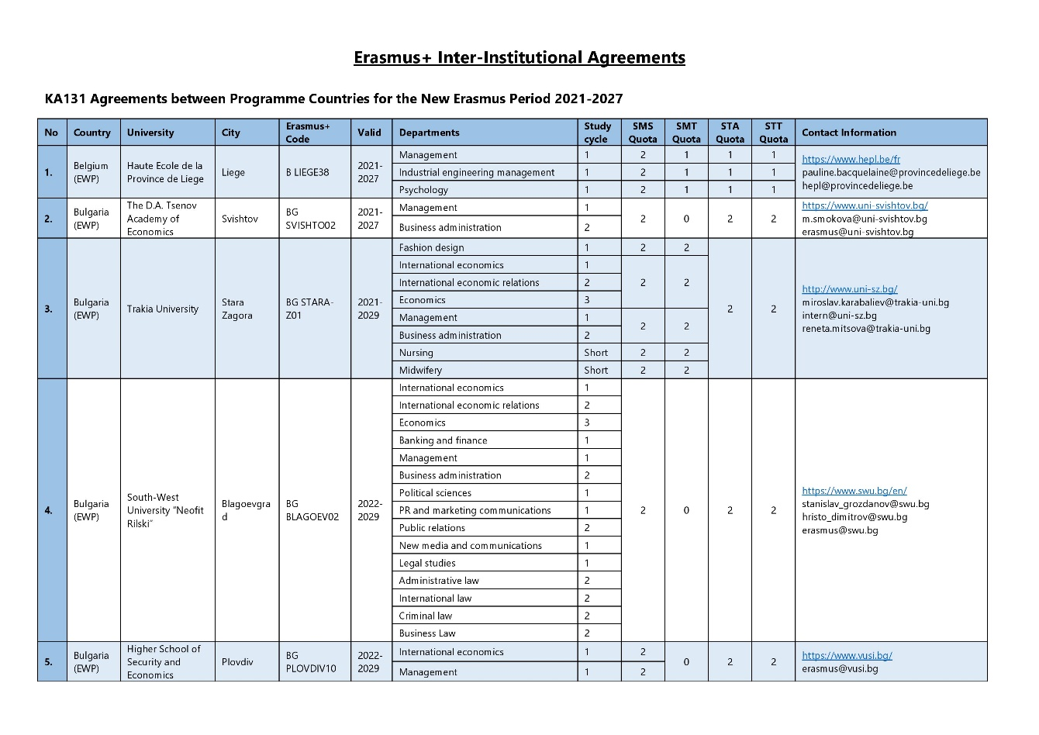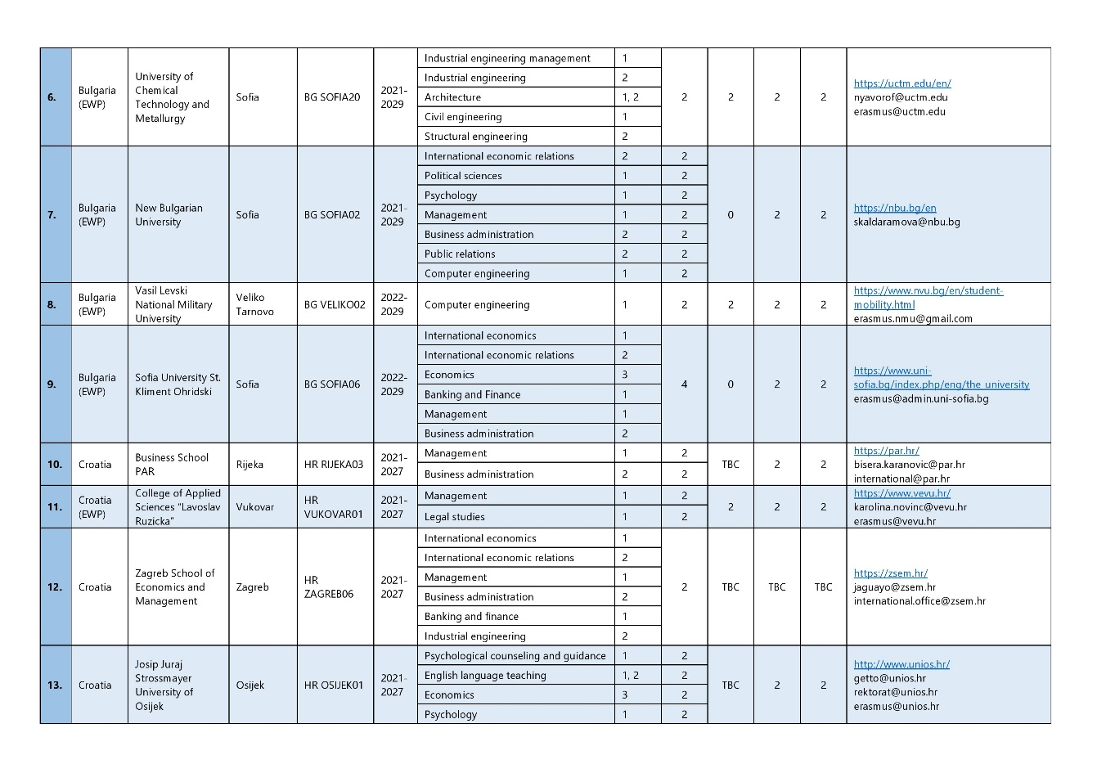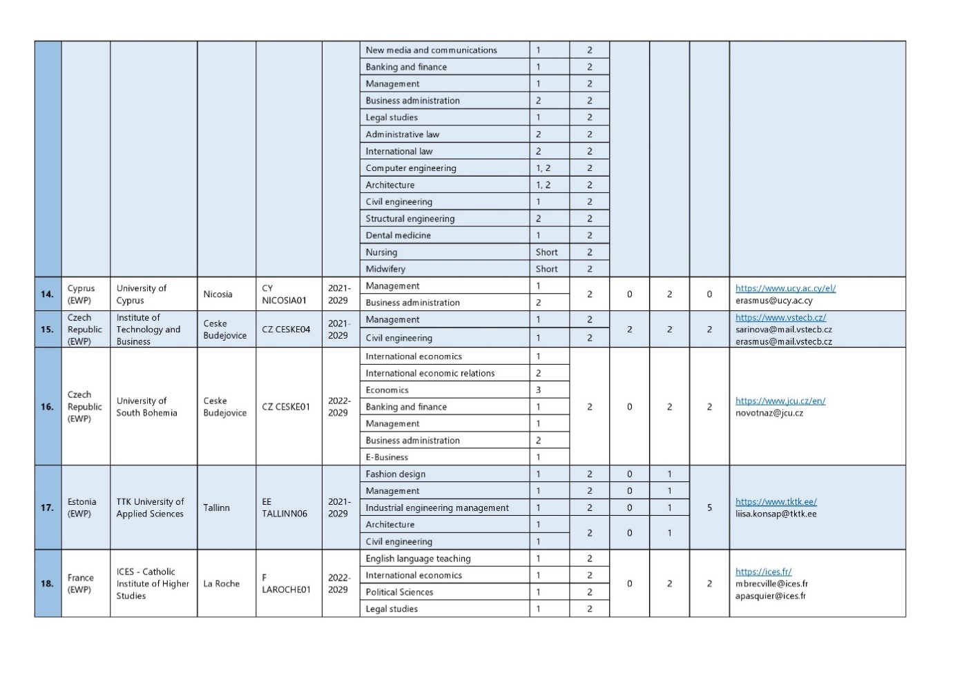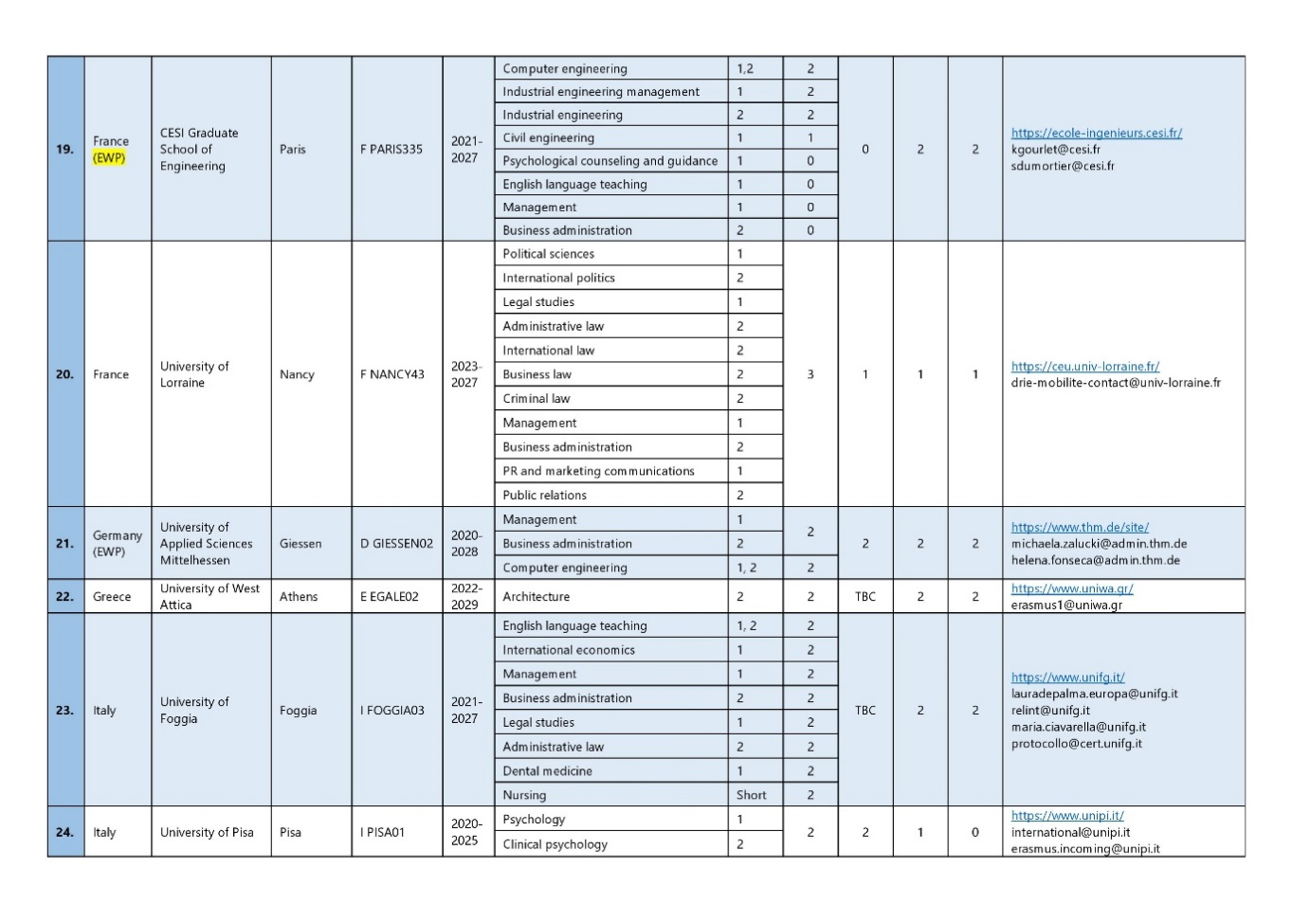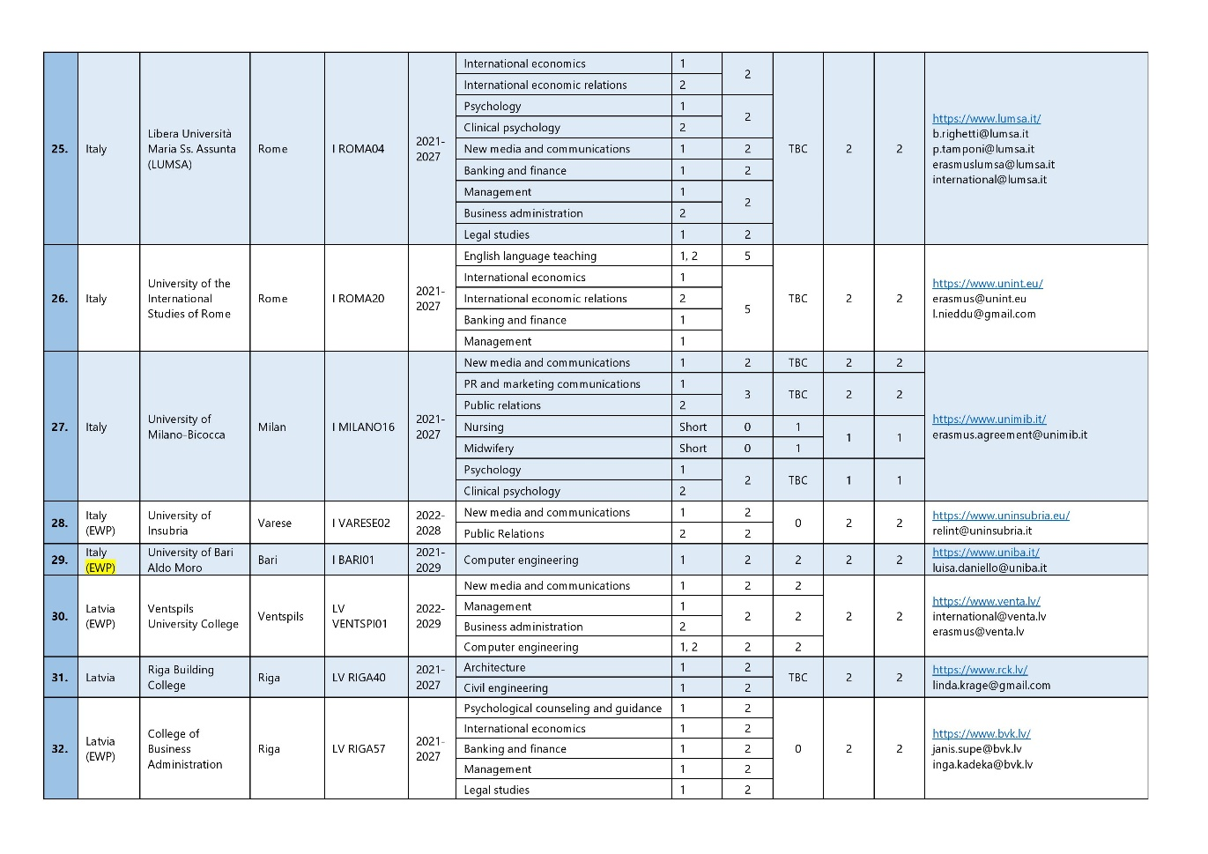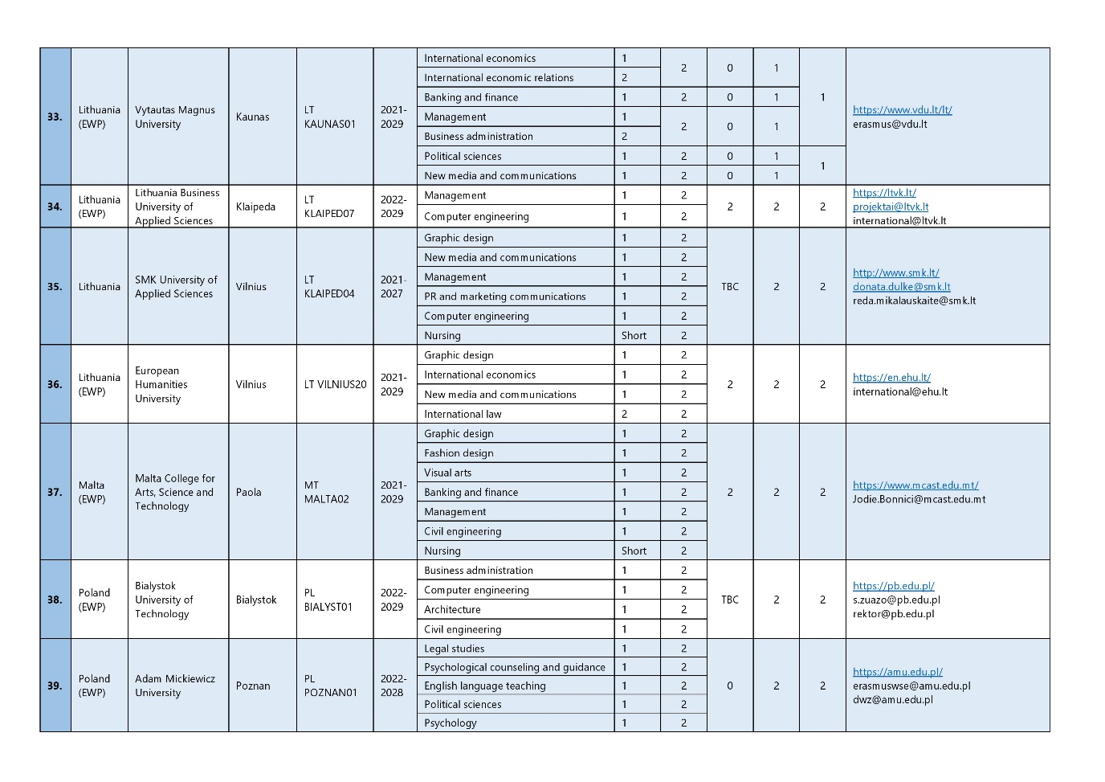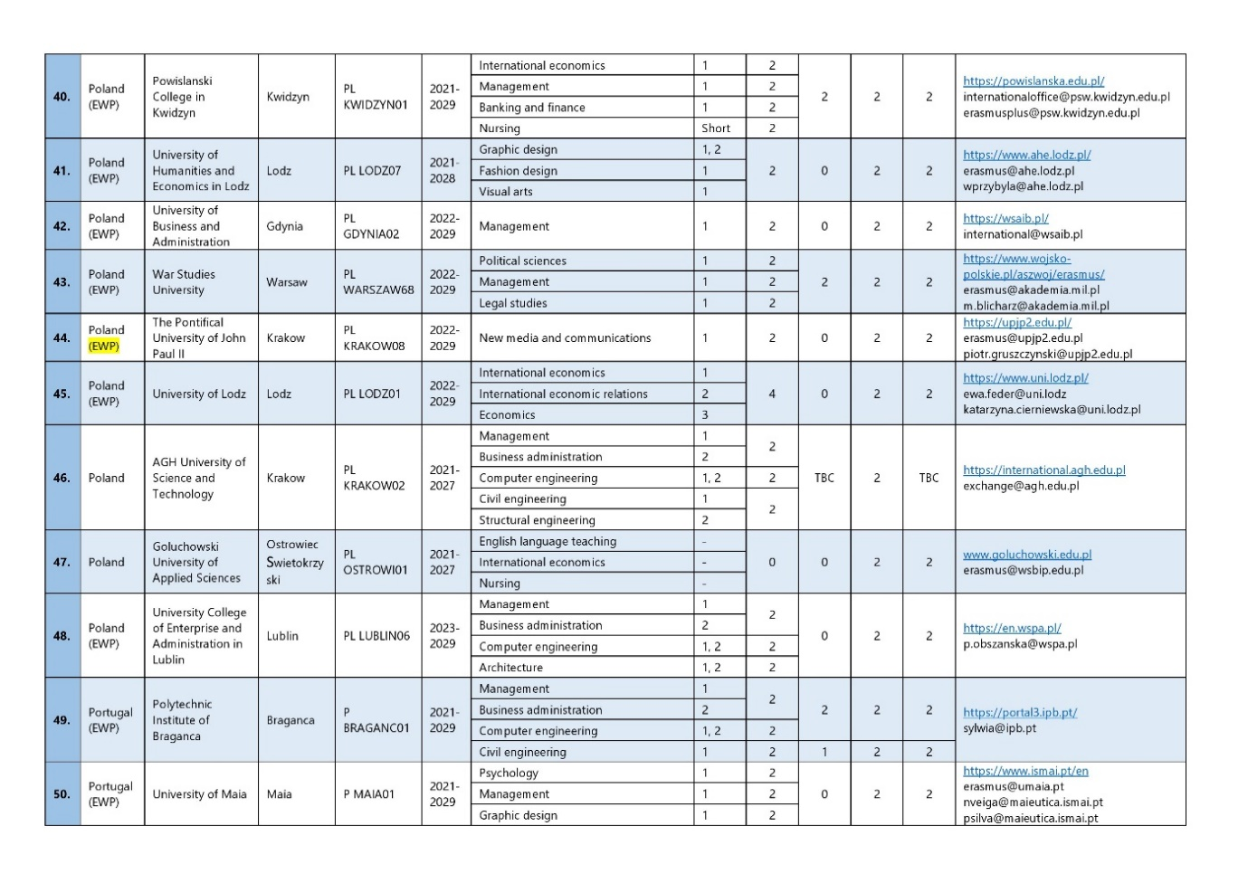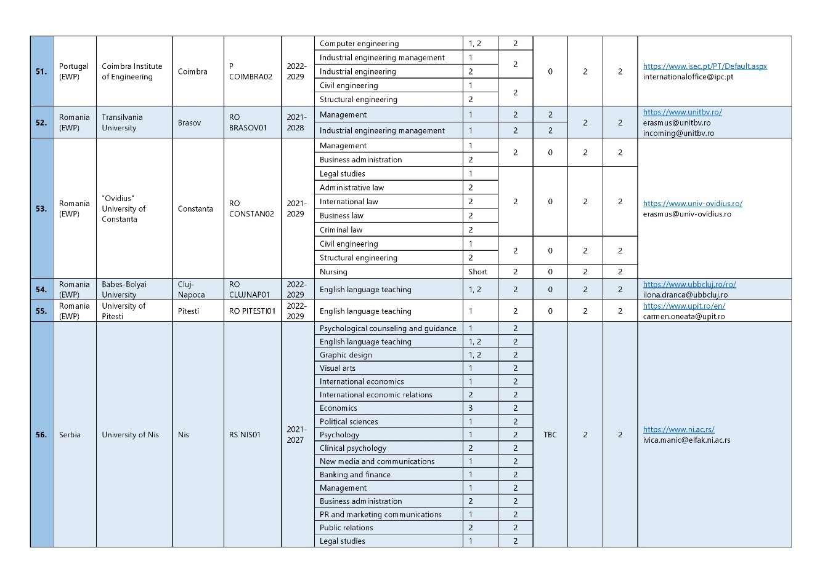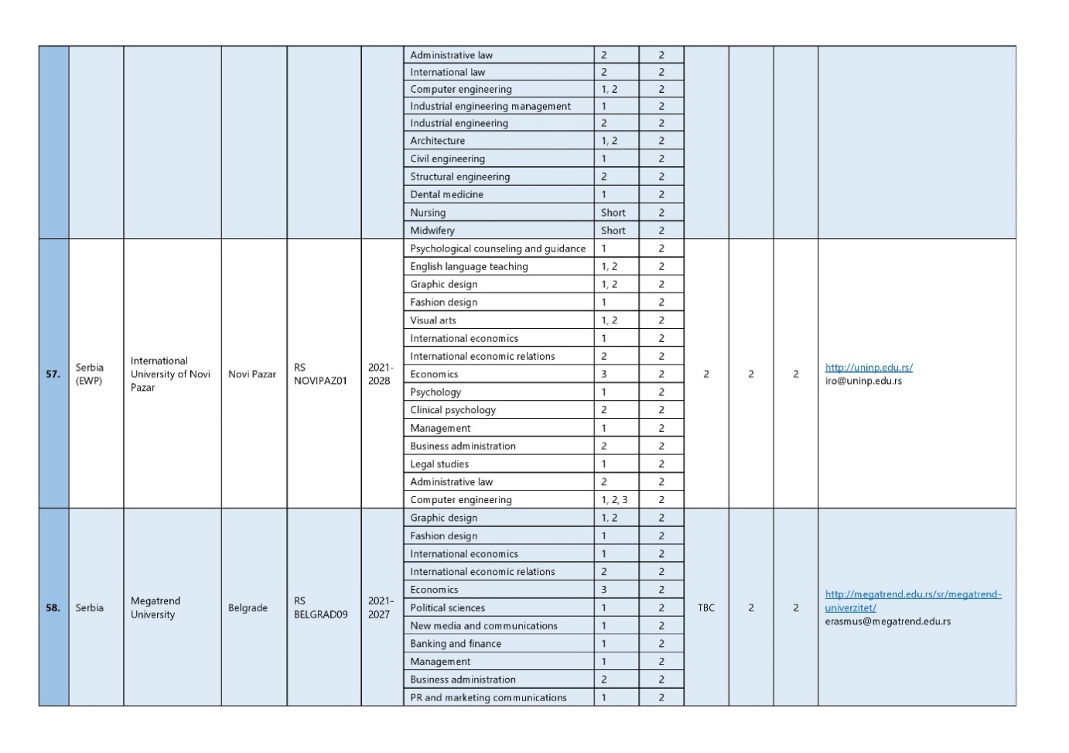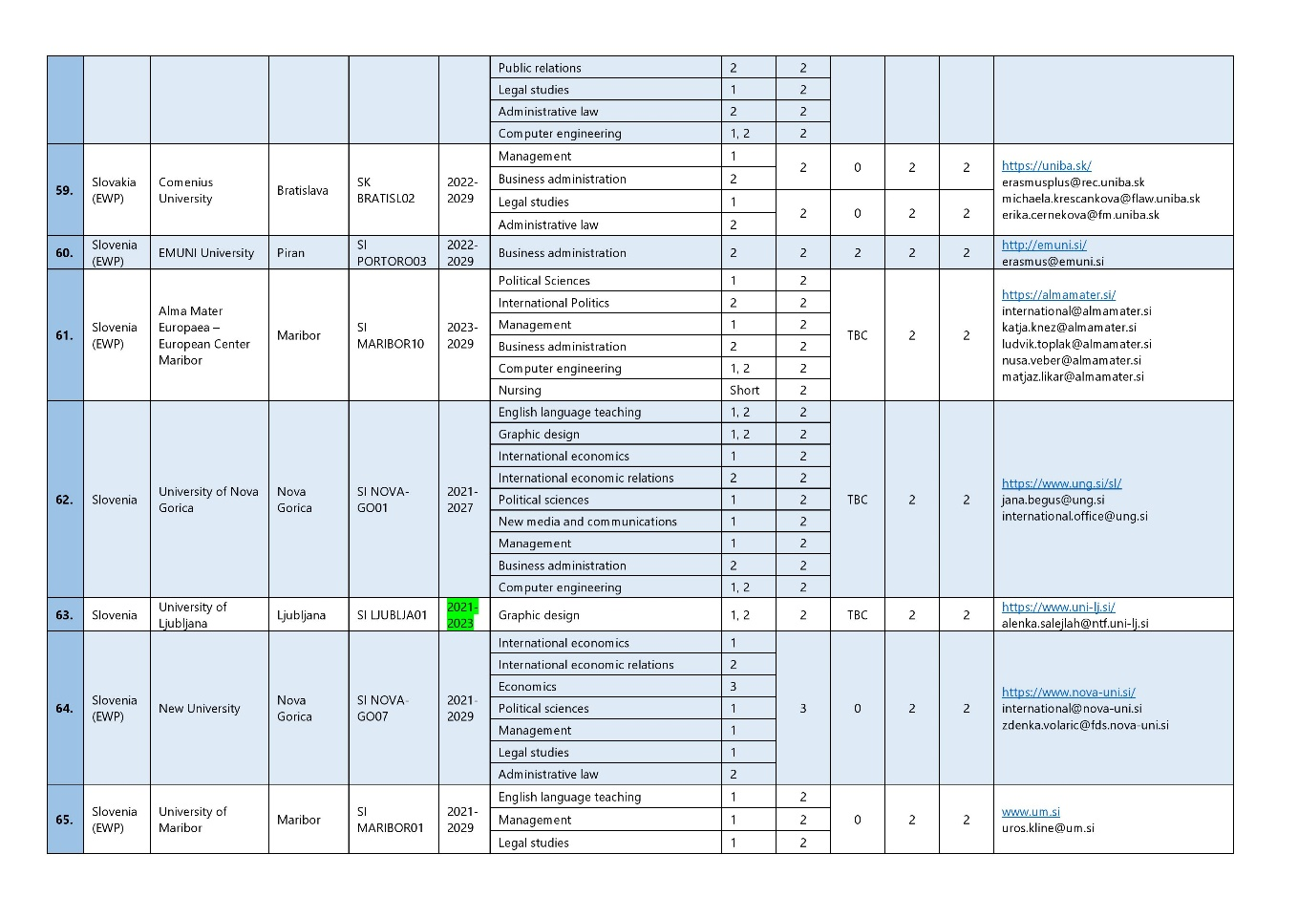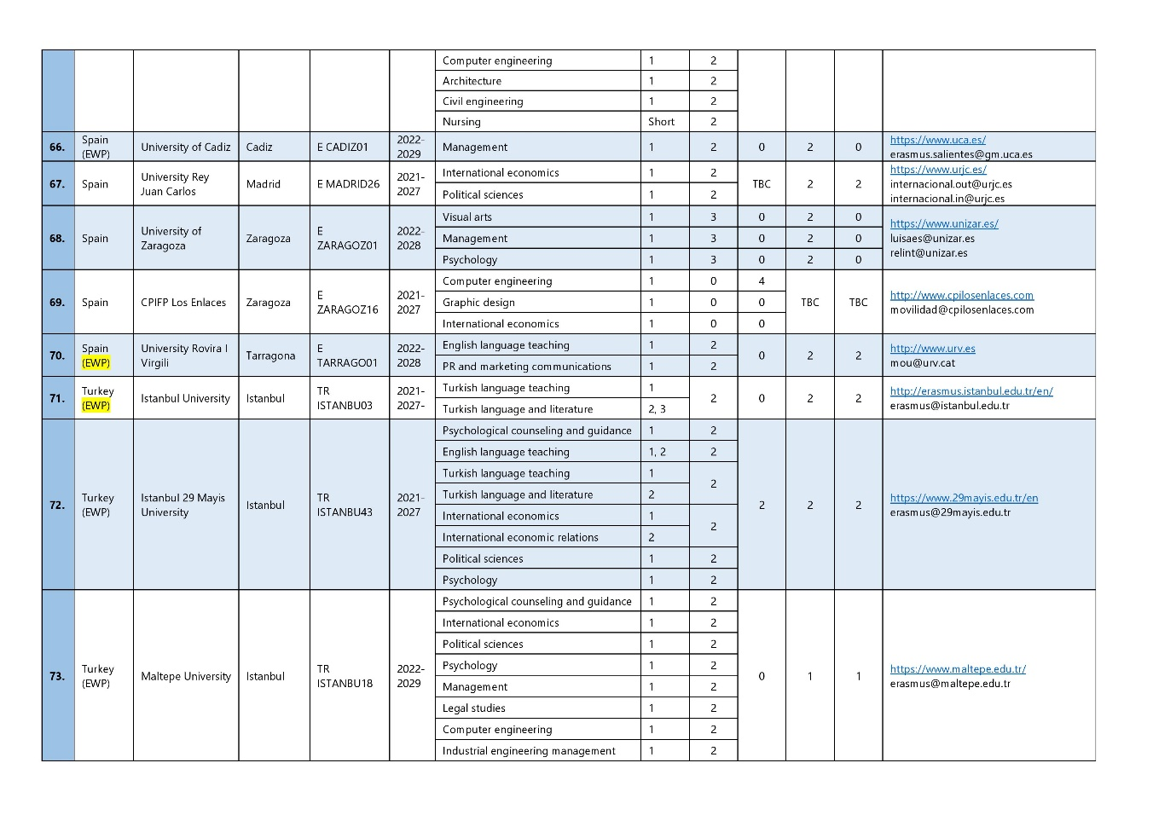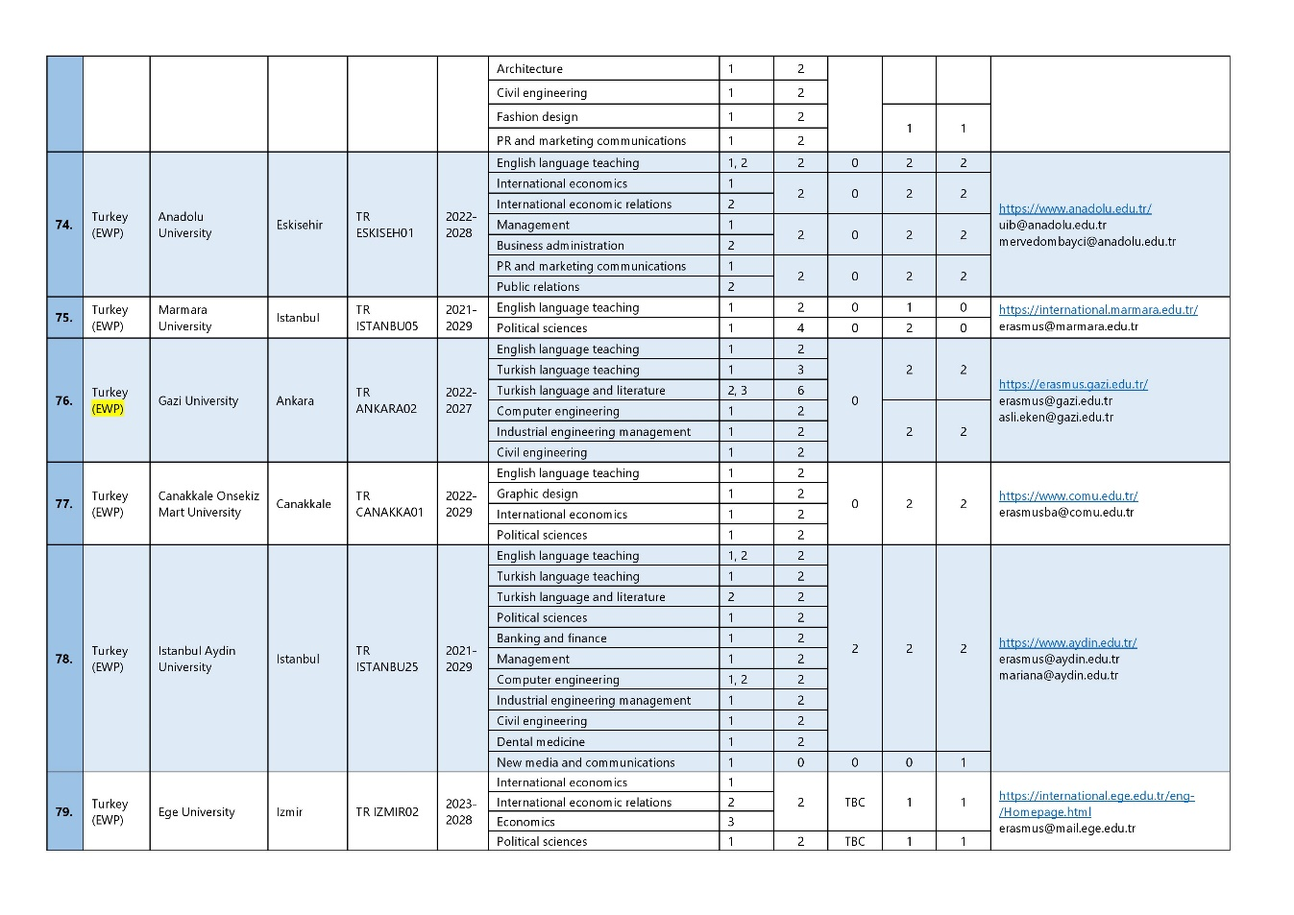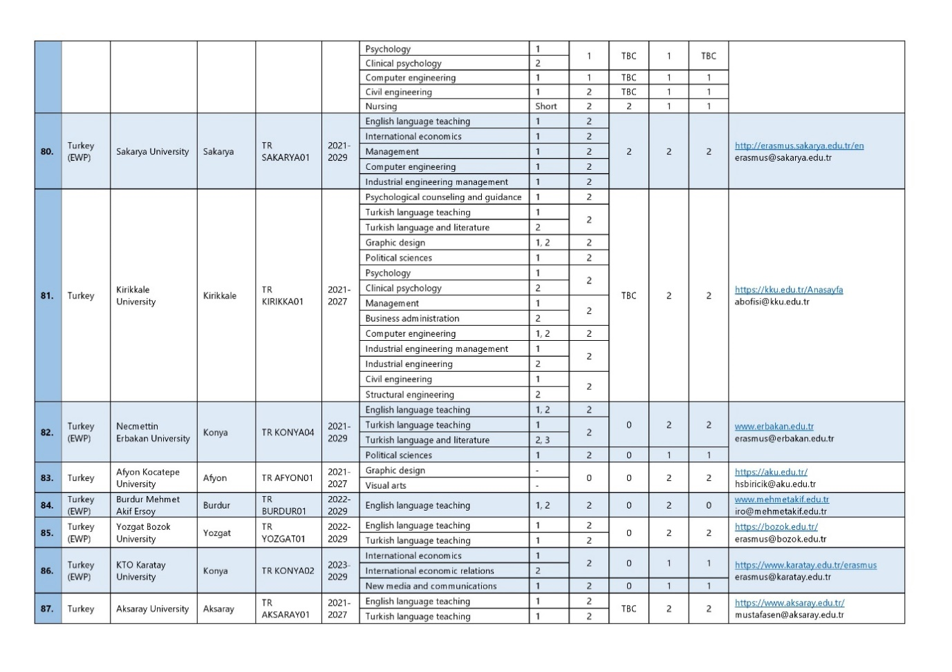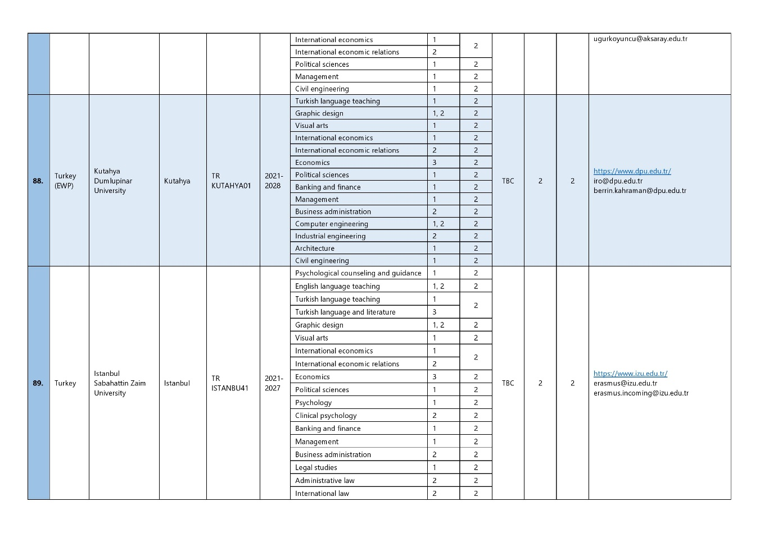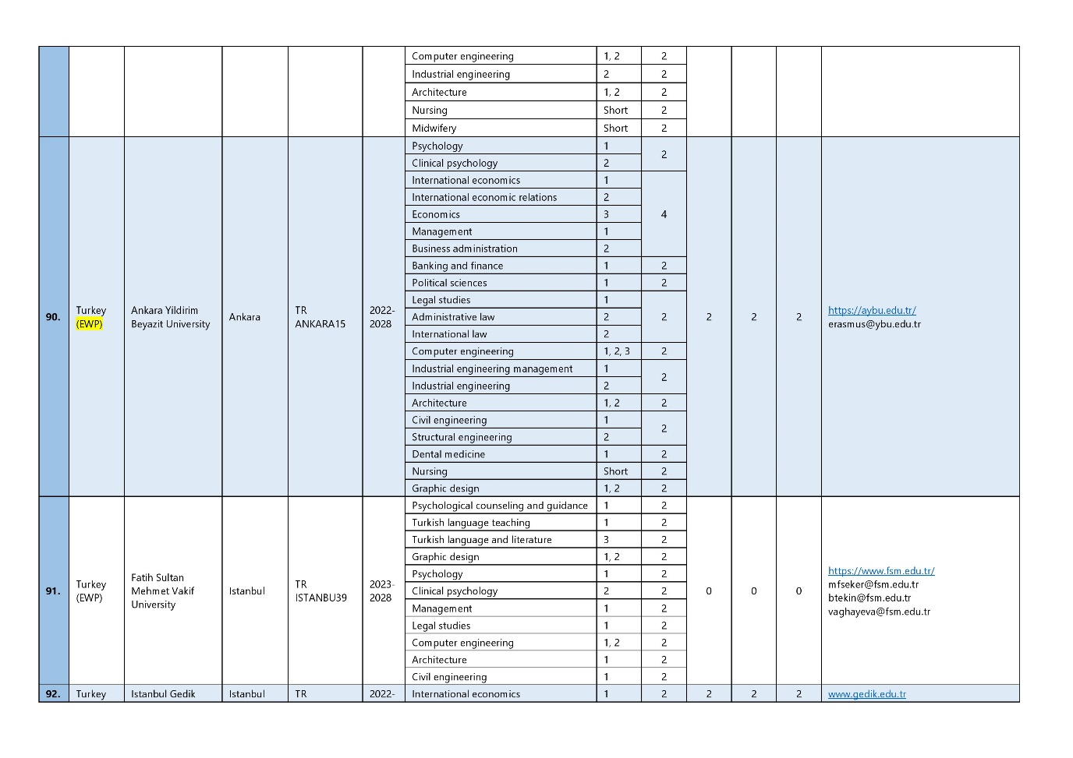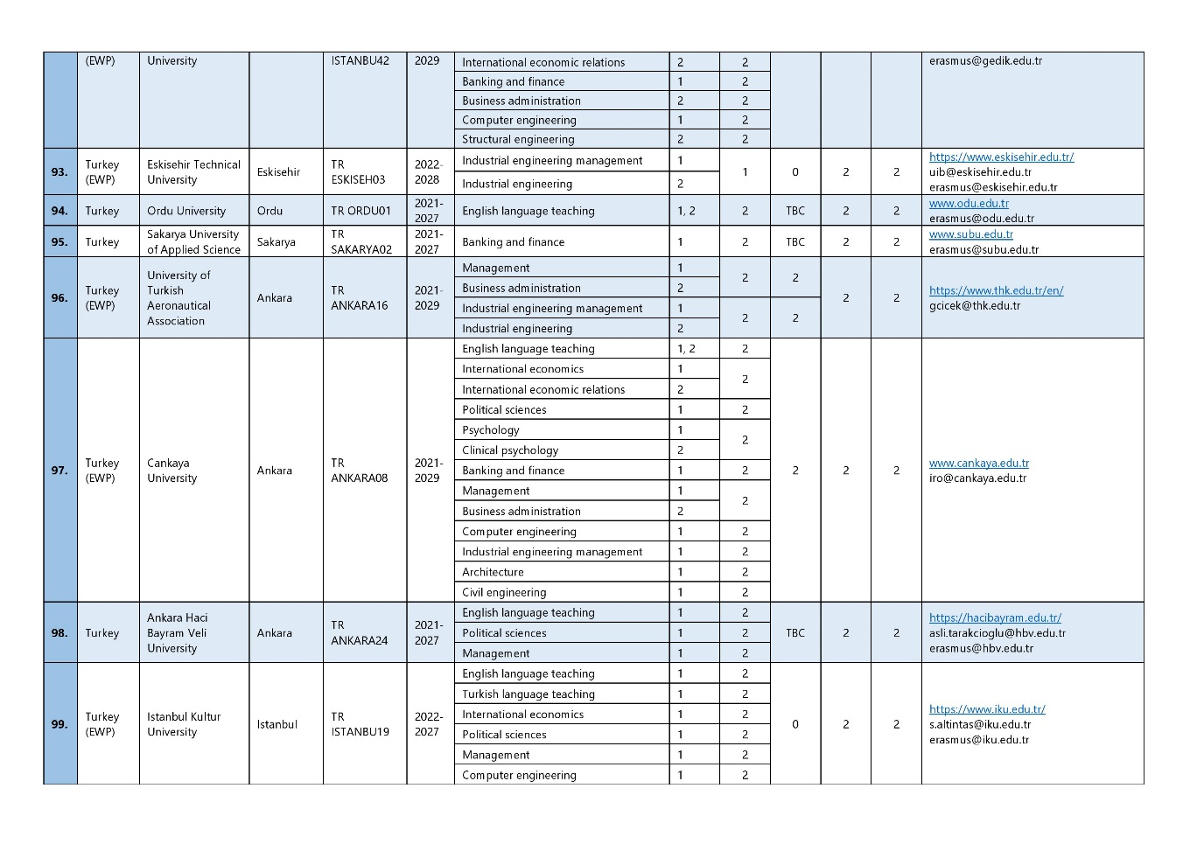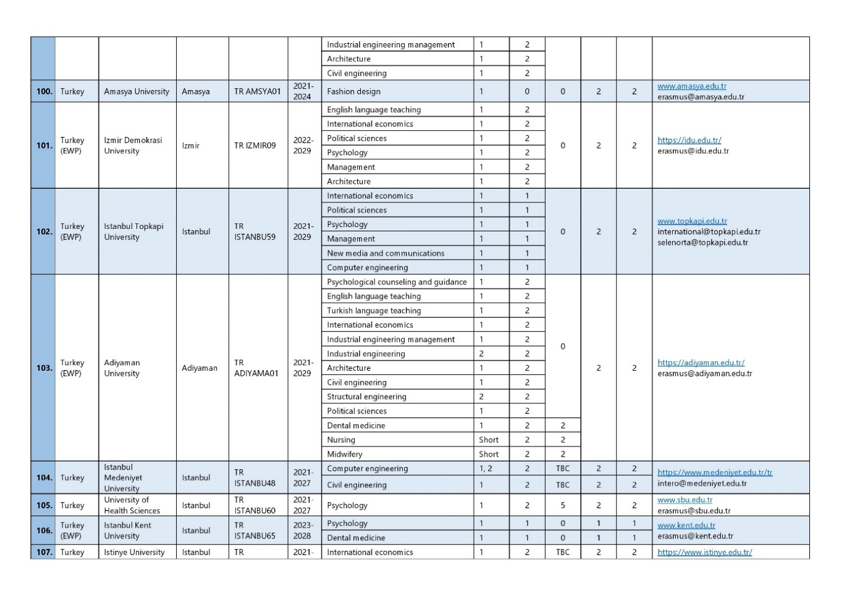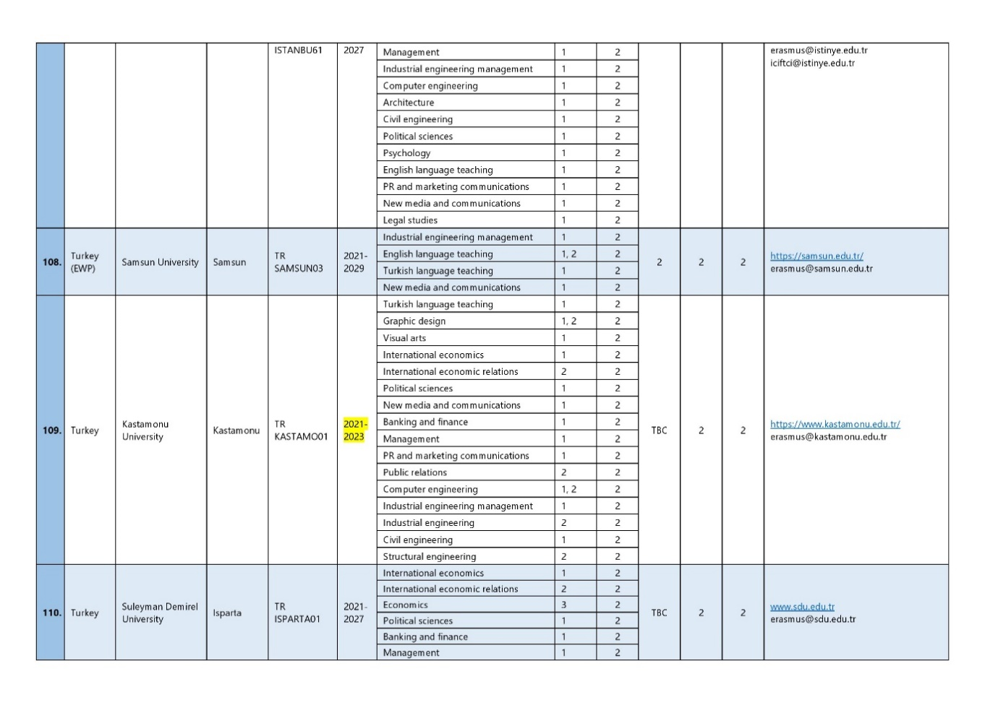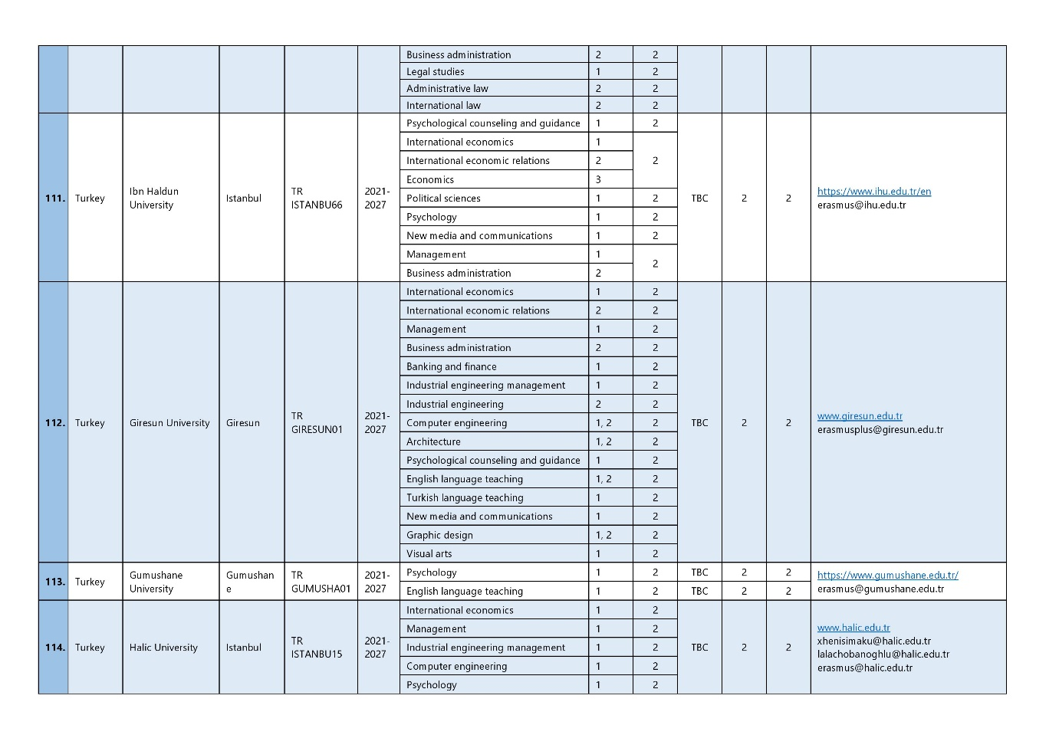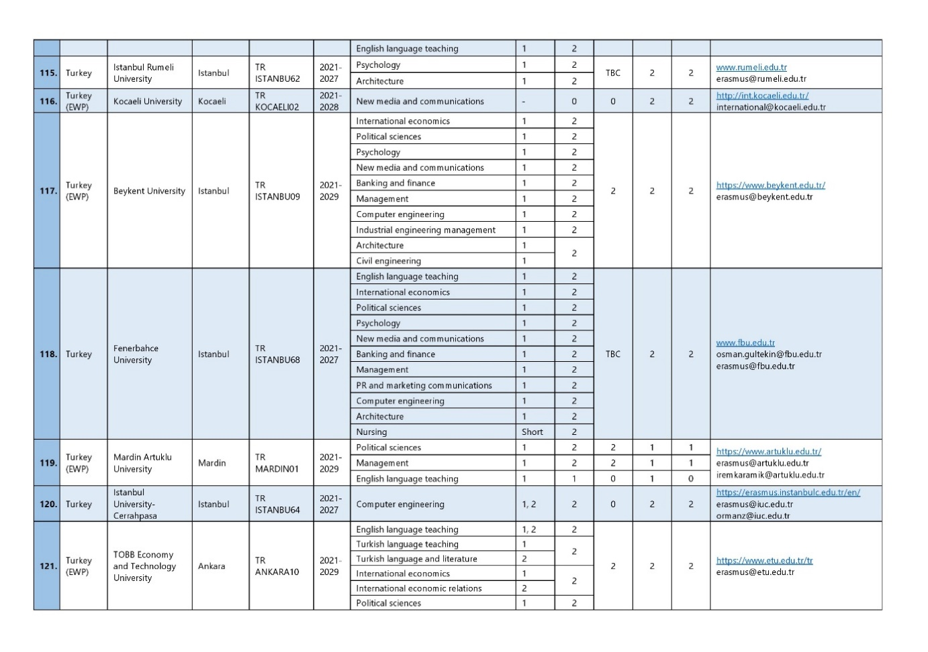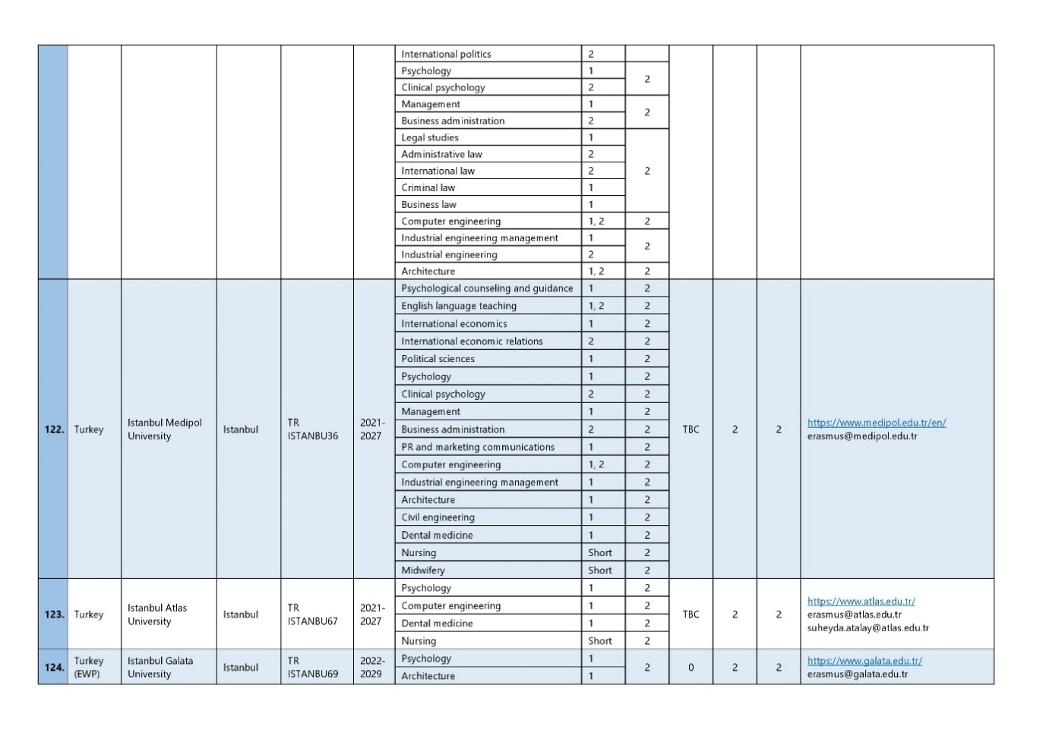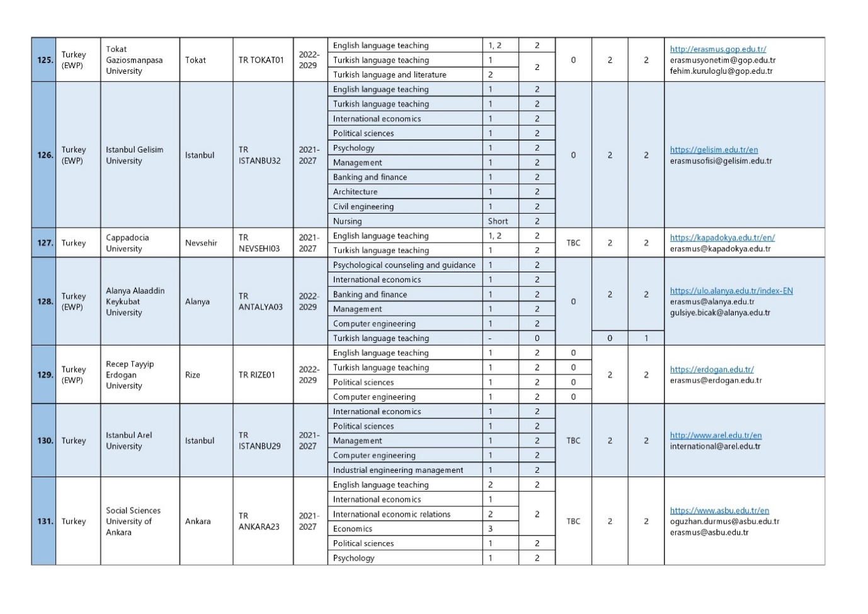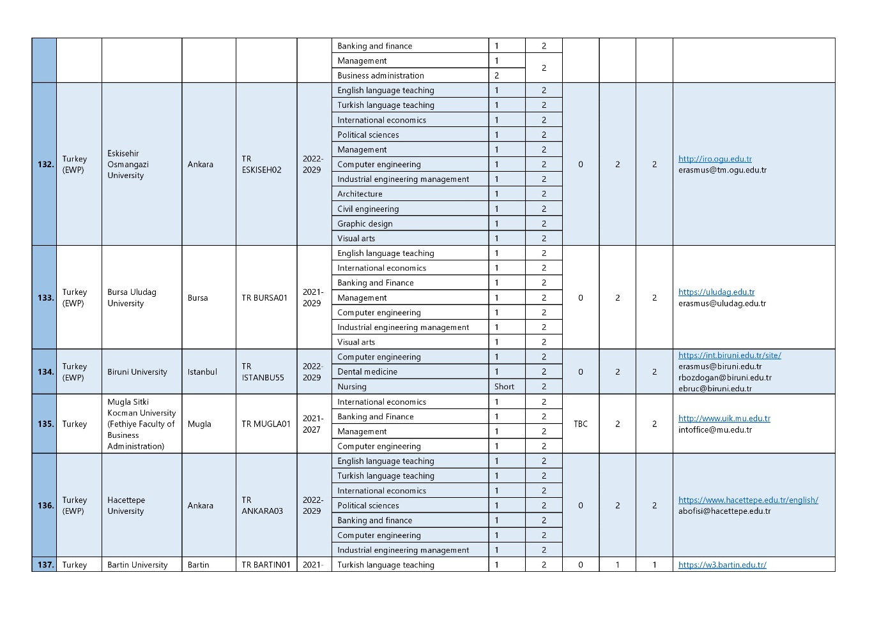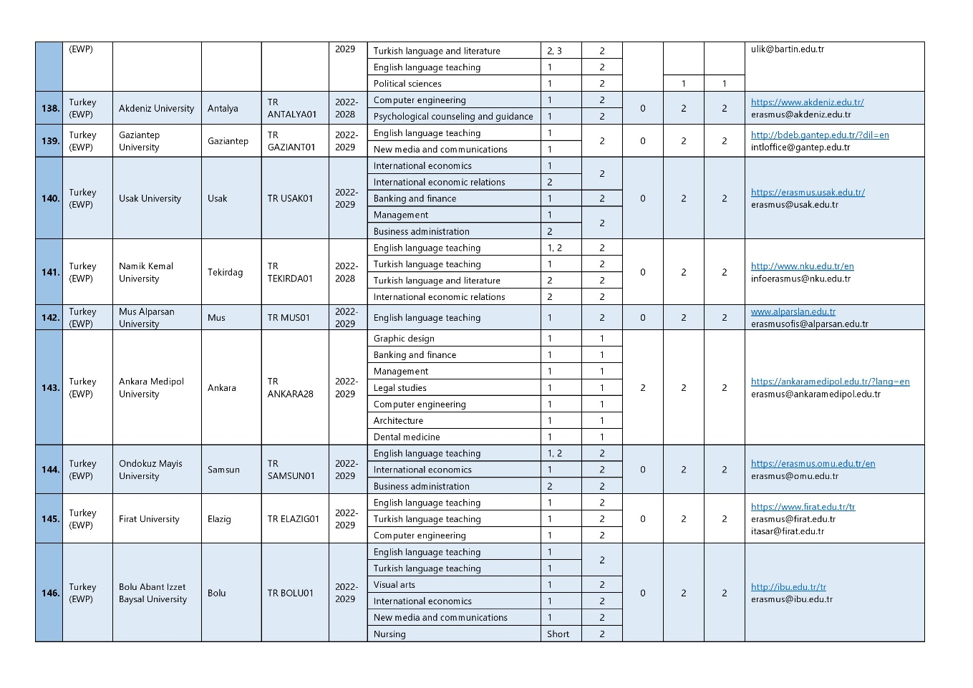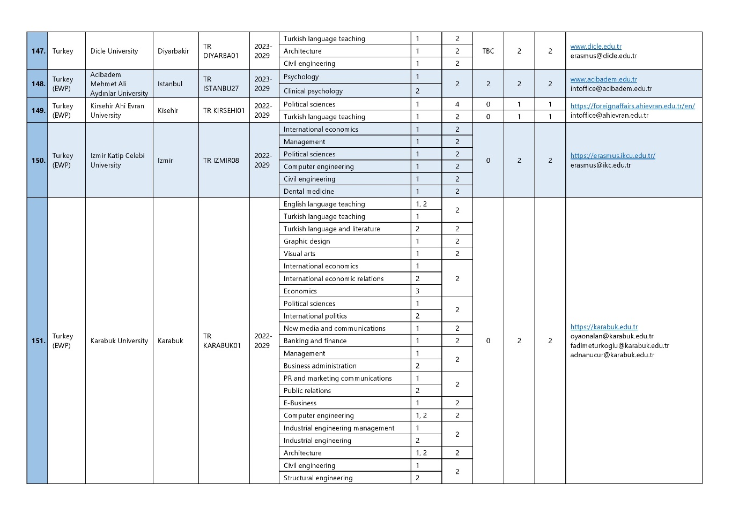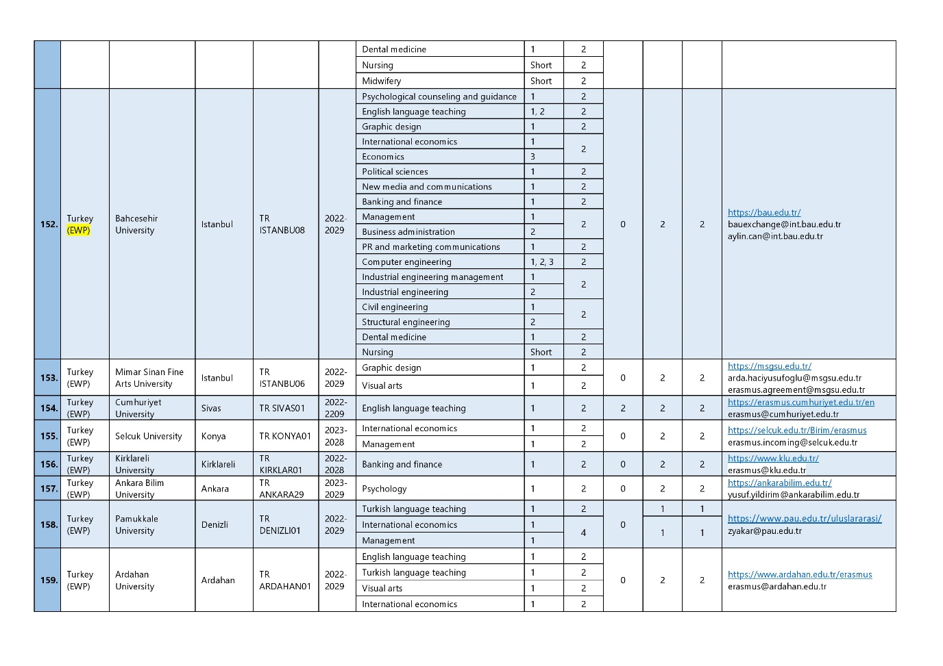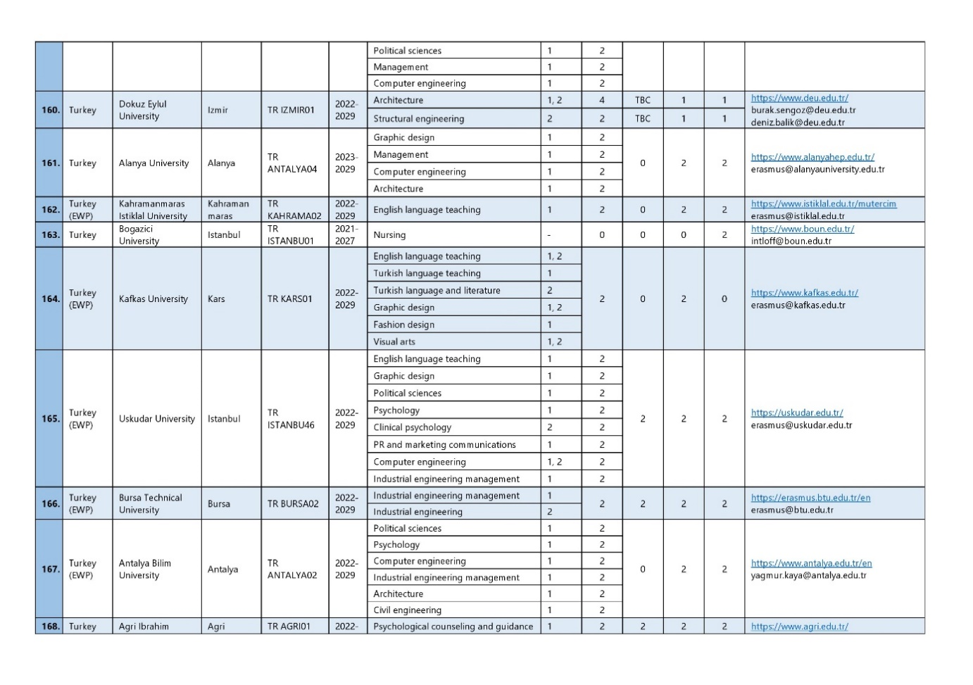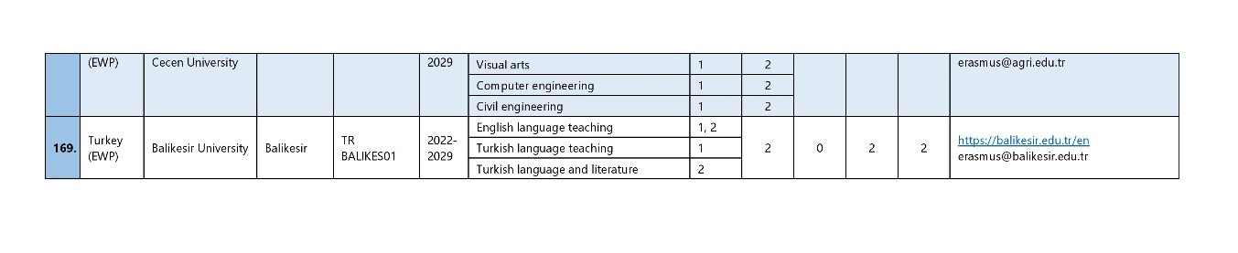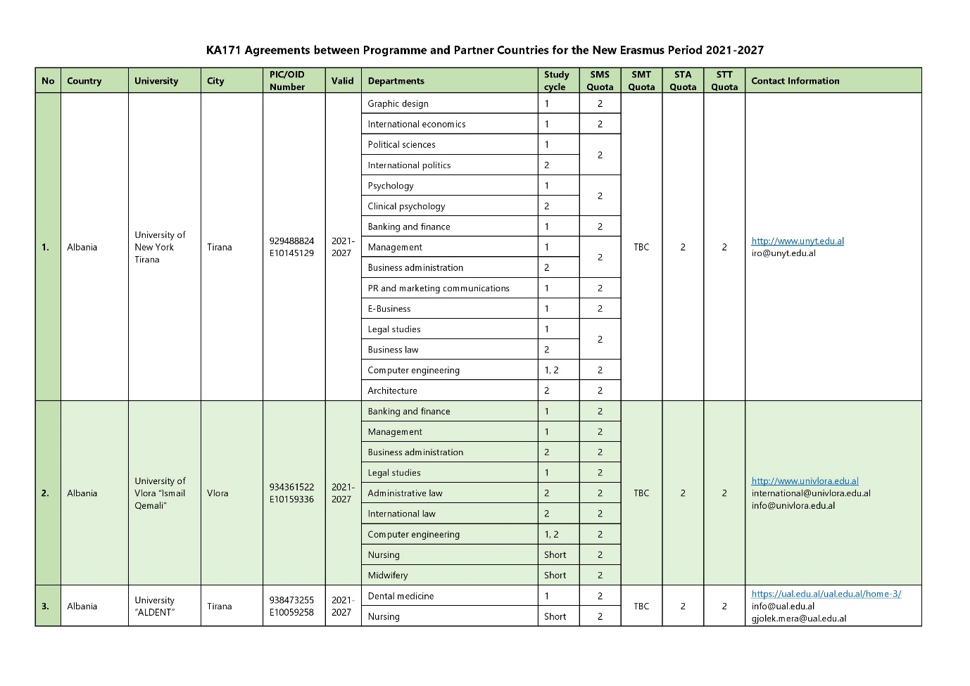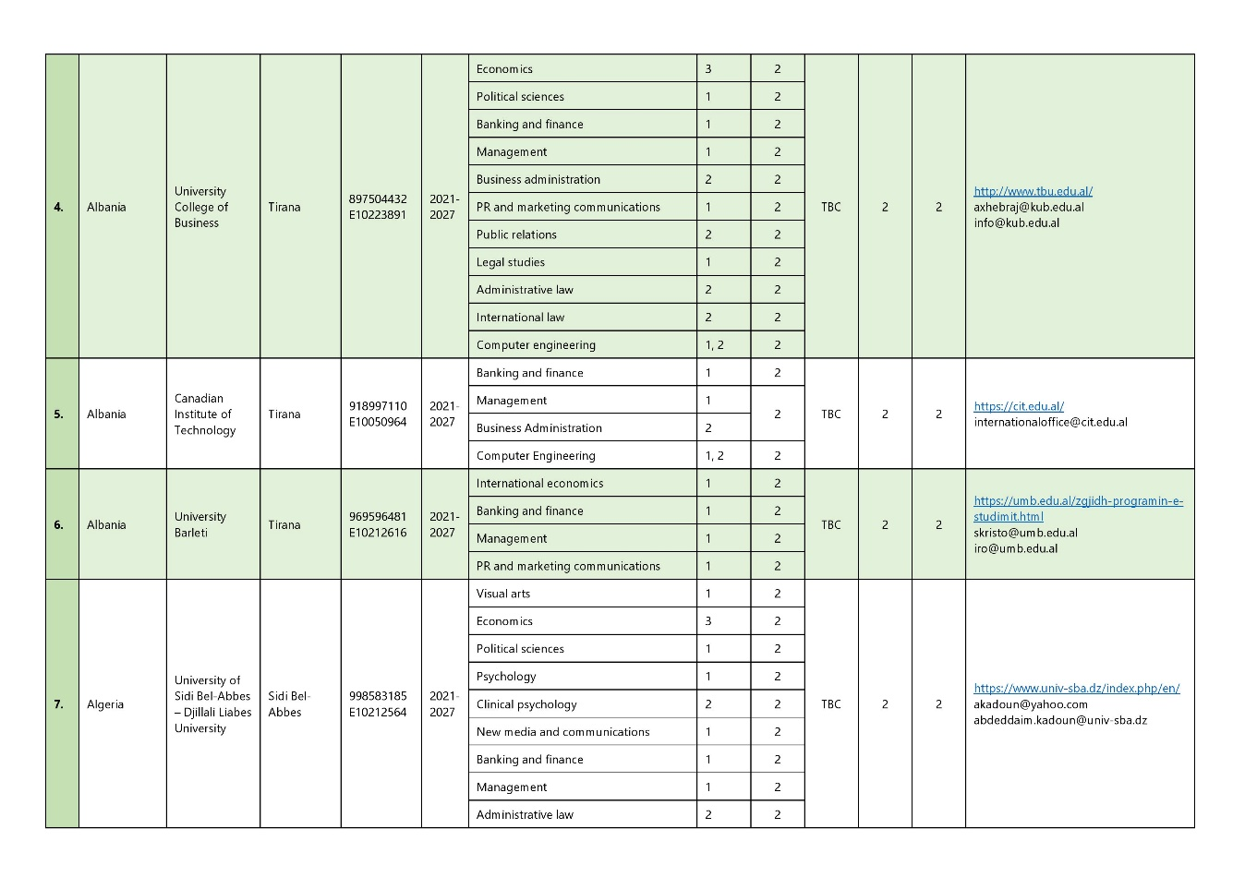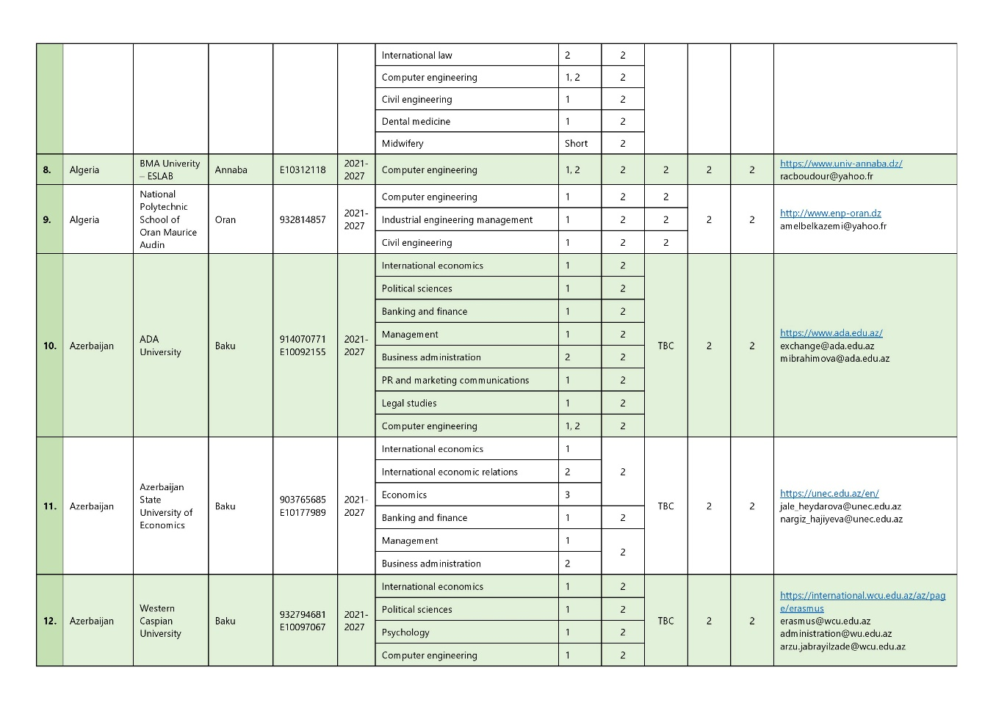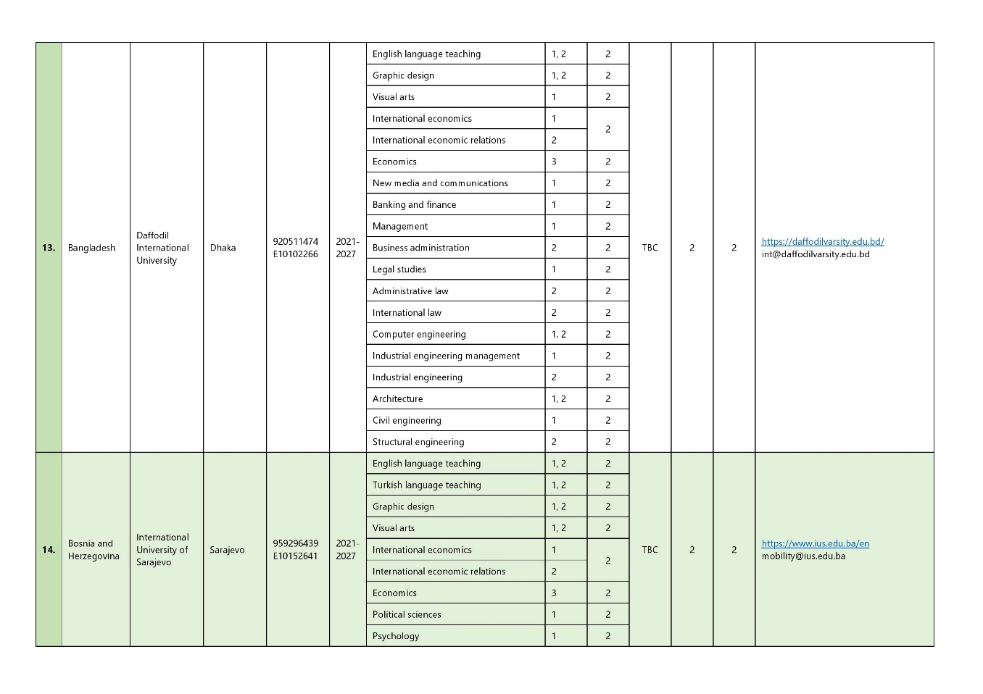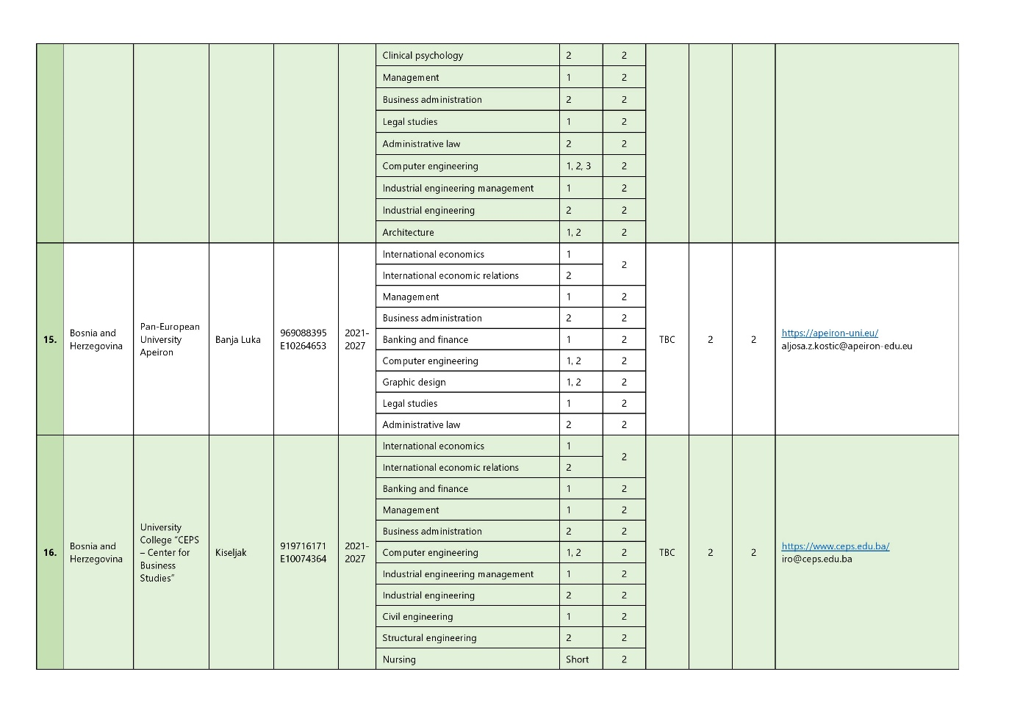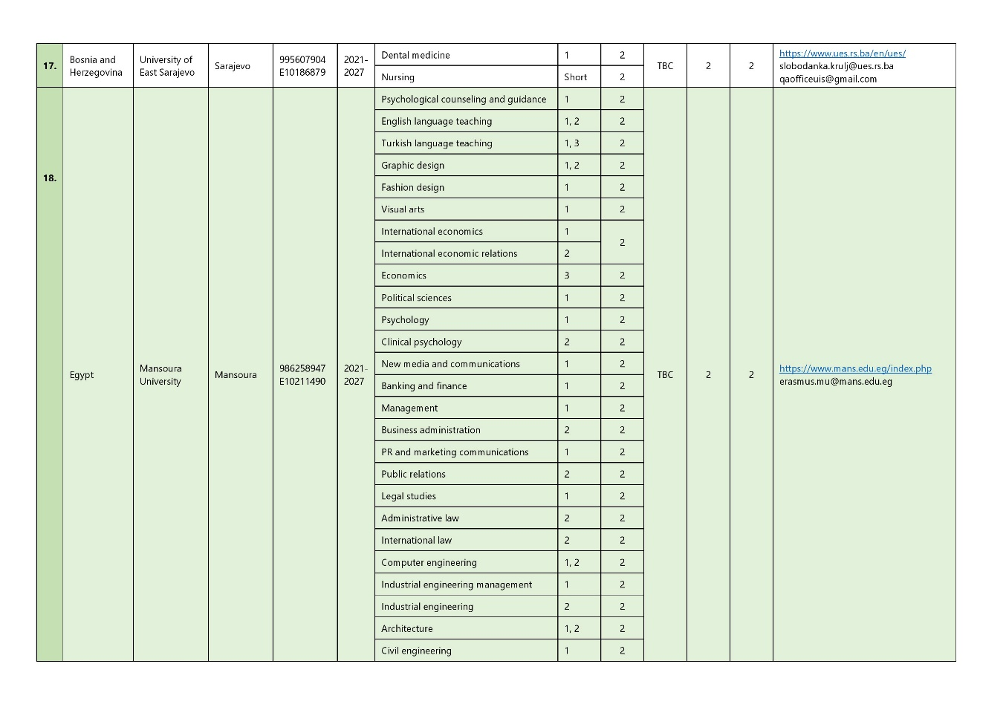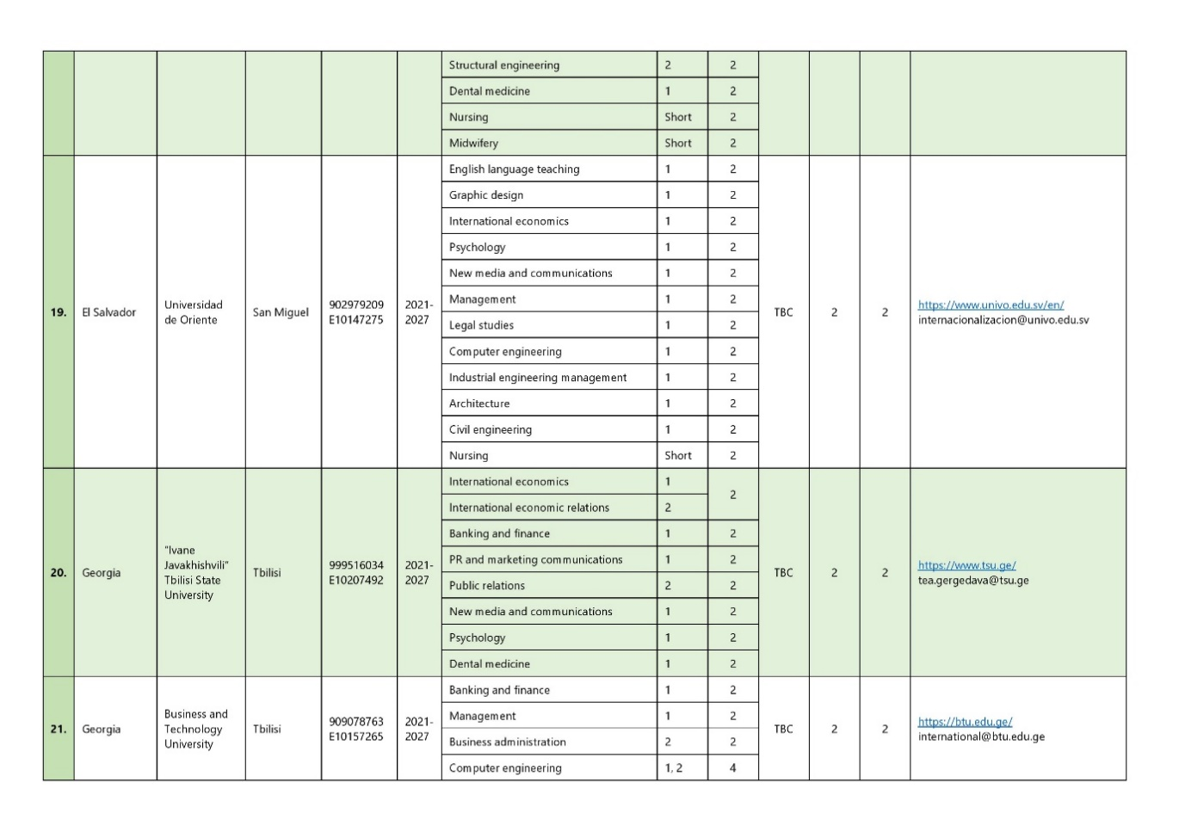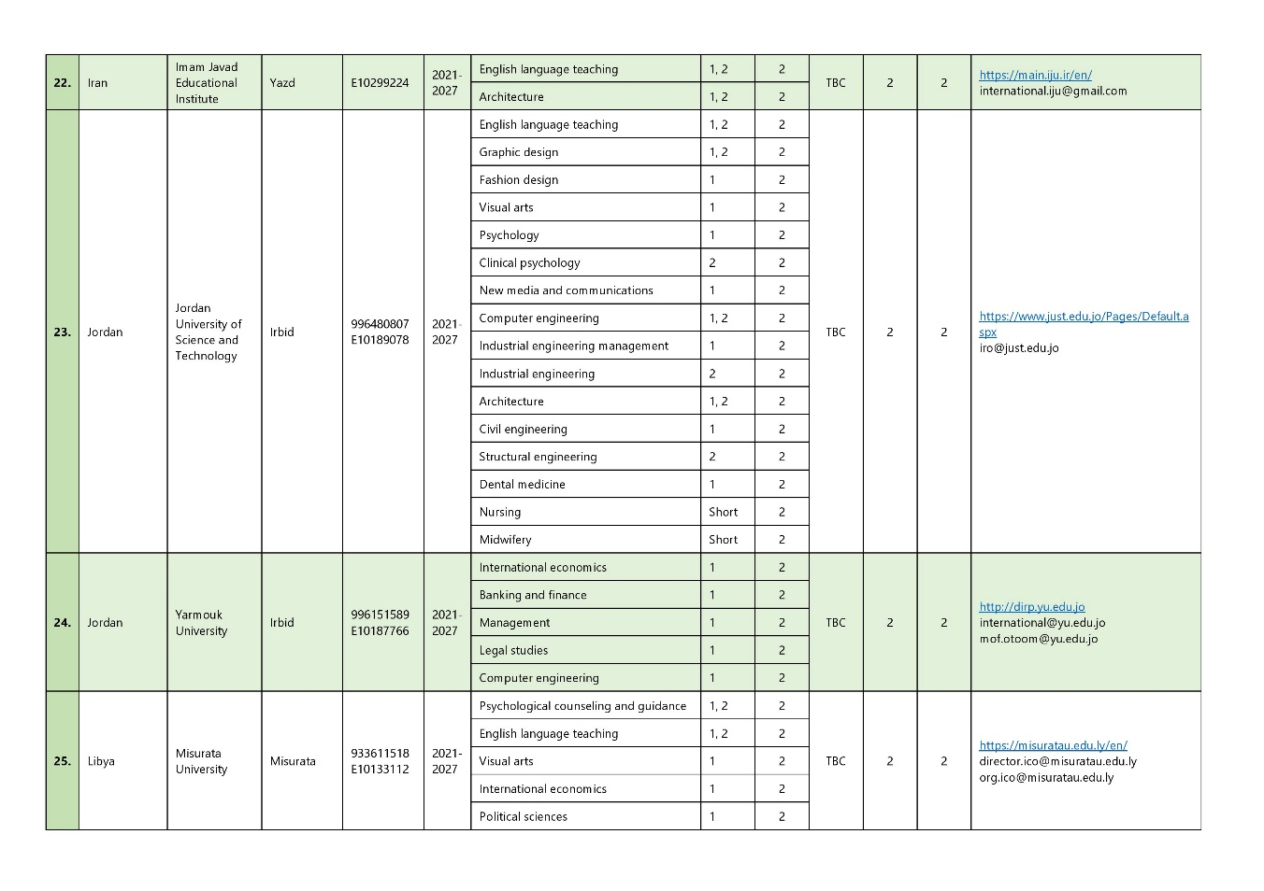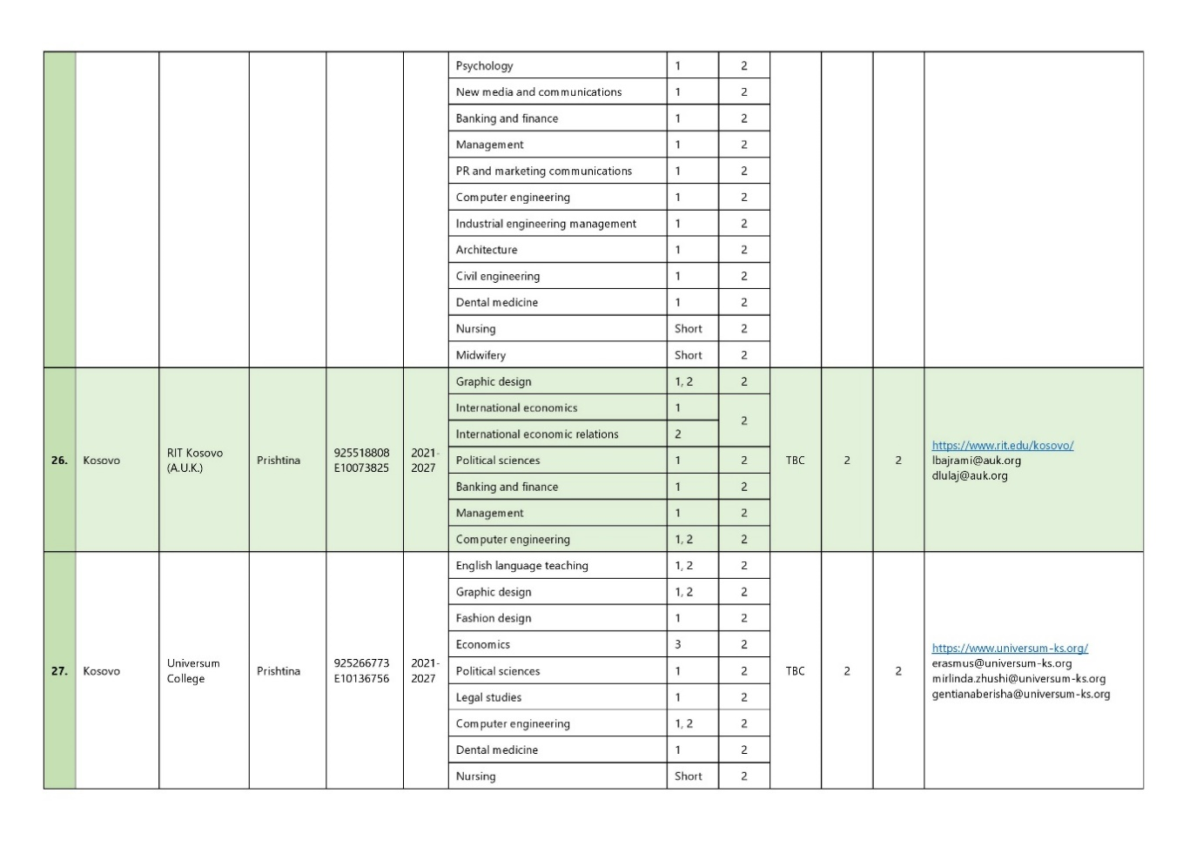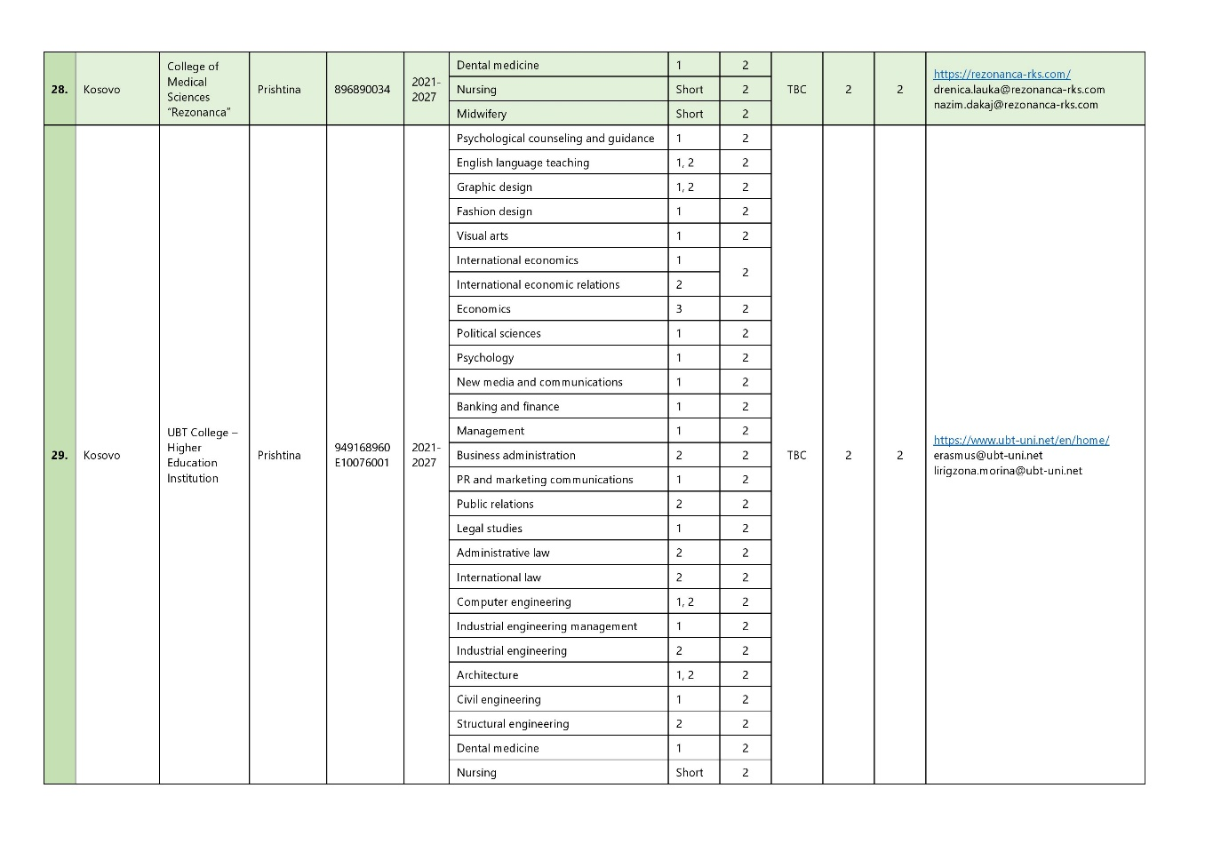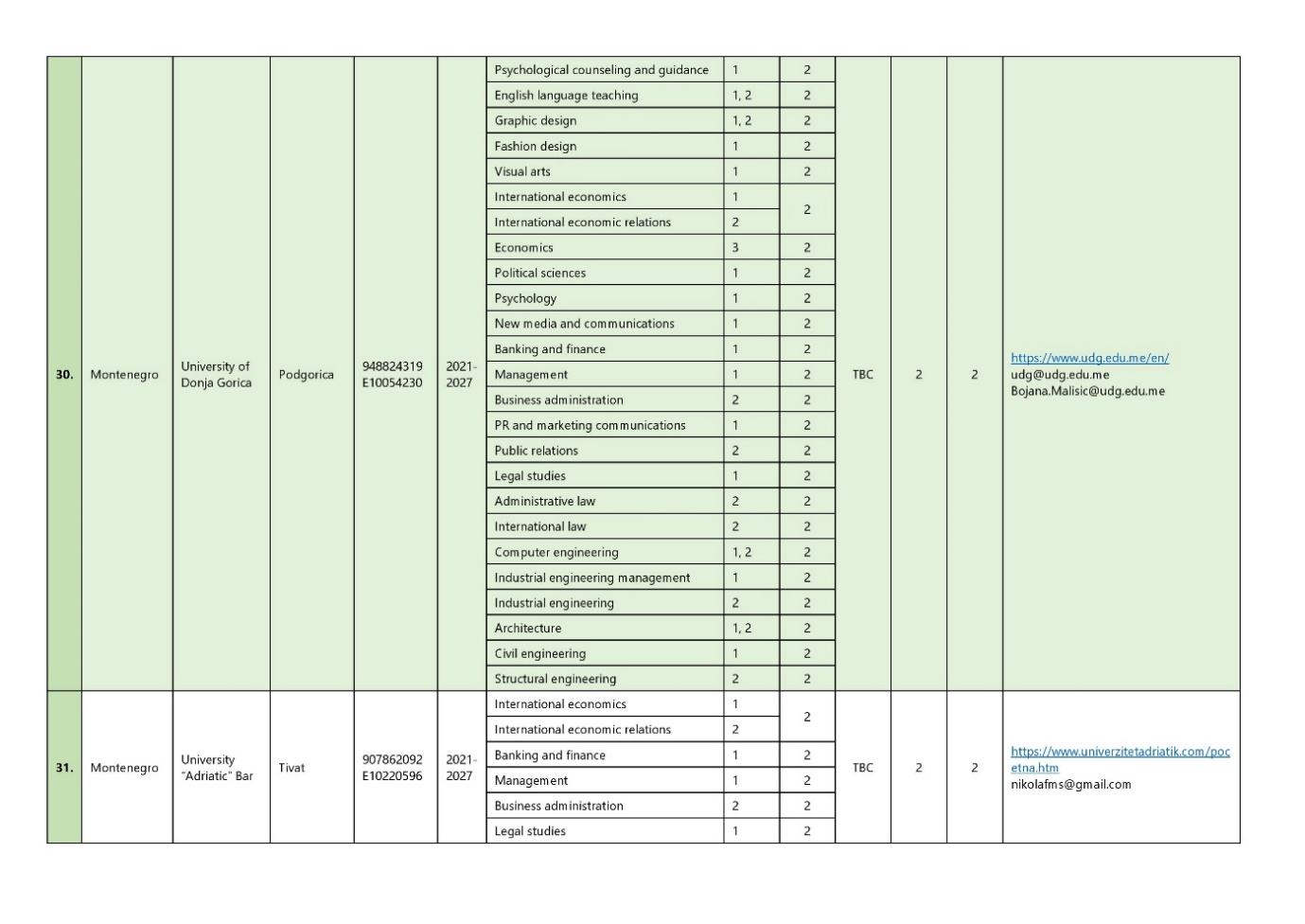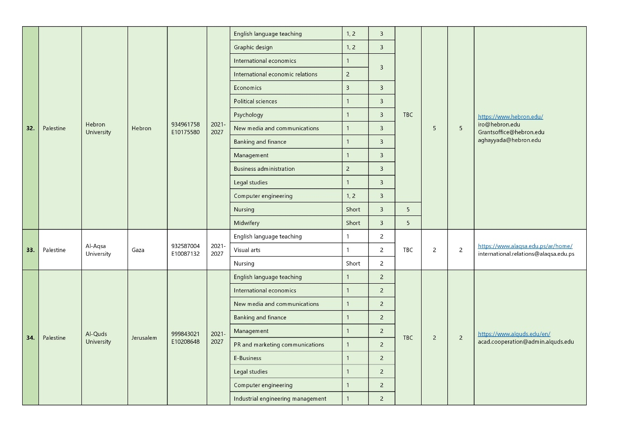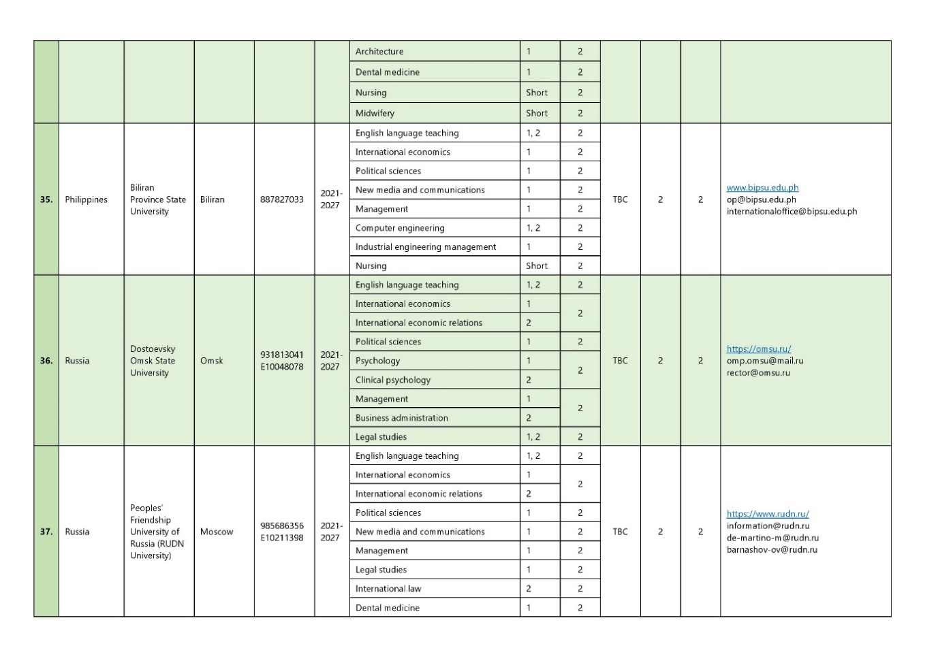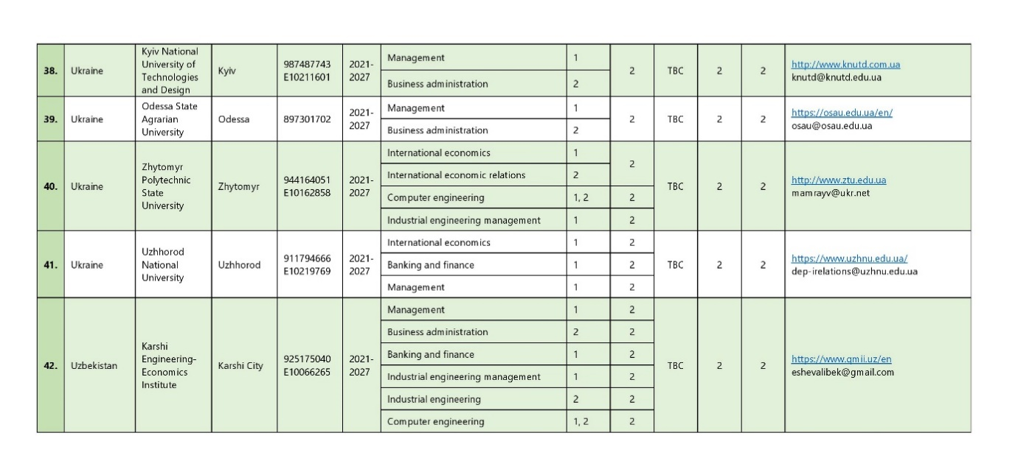

6.3.1 List of Erasmus+ Inter-Institutional Agreements with Companies and Organizations

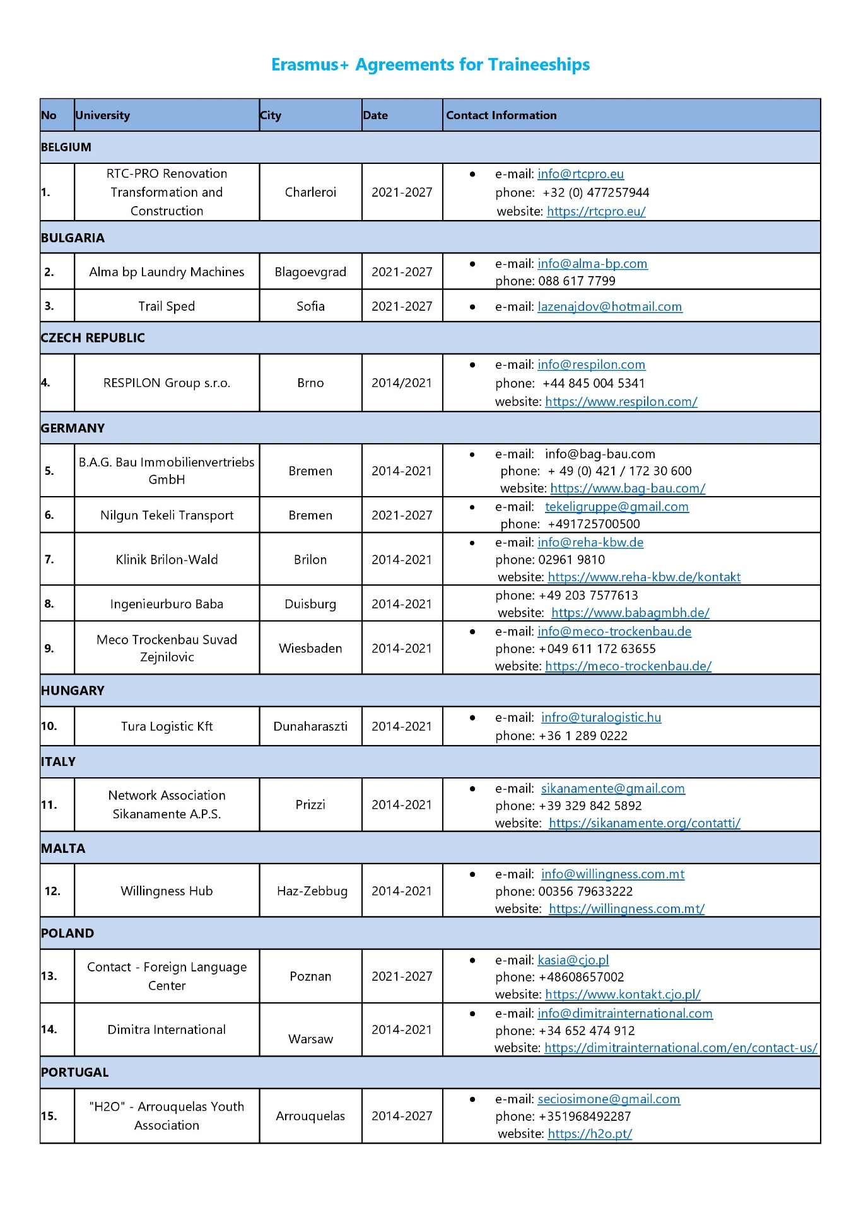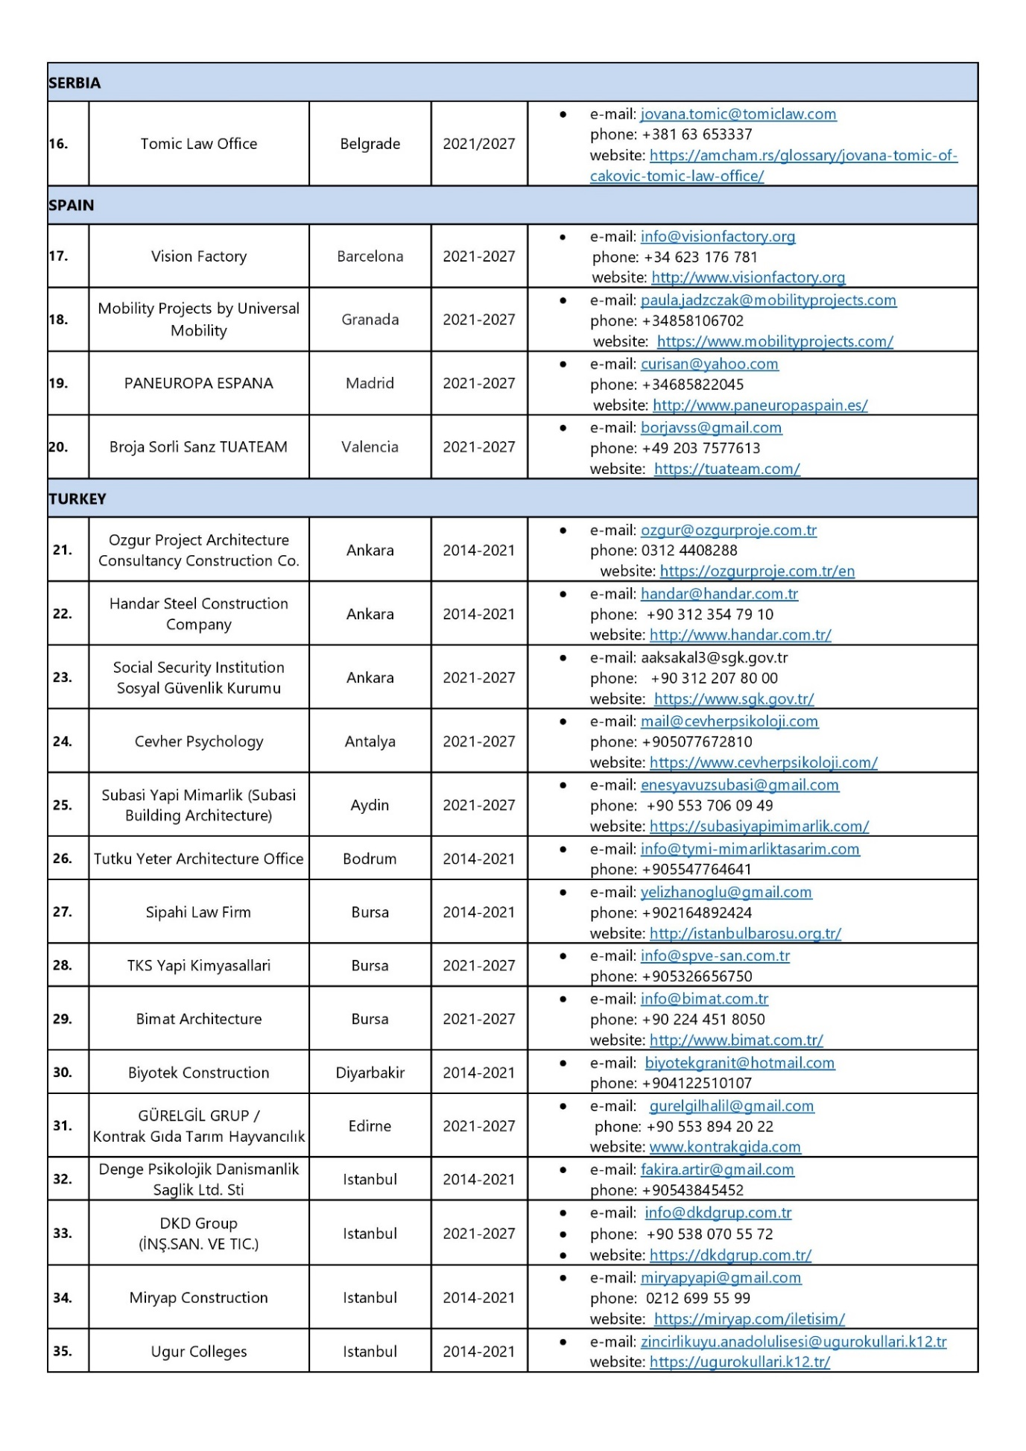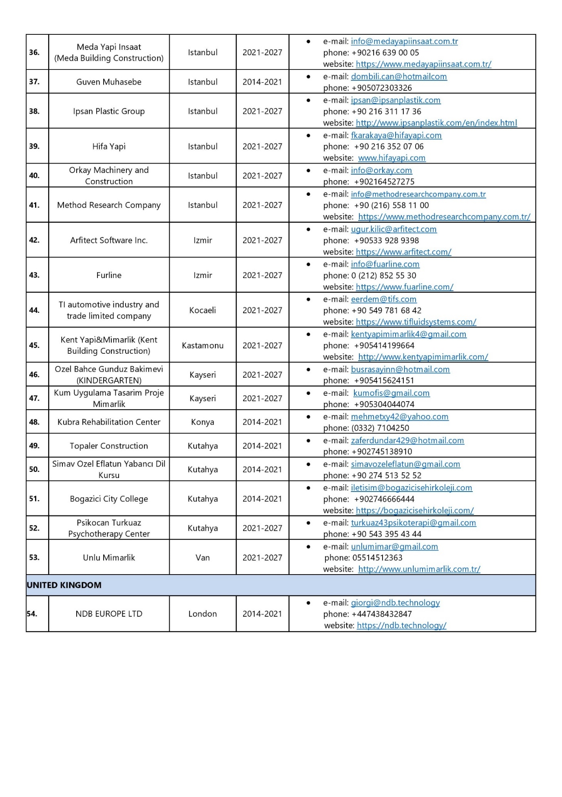

6.4 List of Mevlana Exchange Agreements
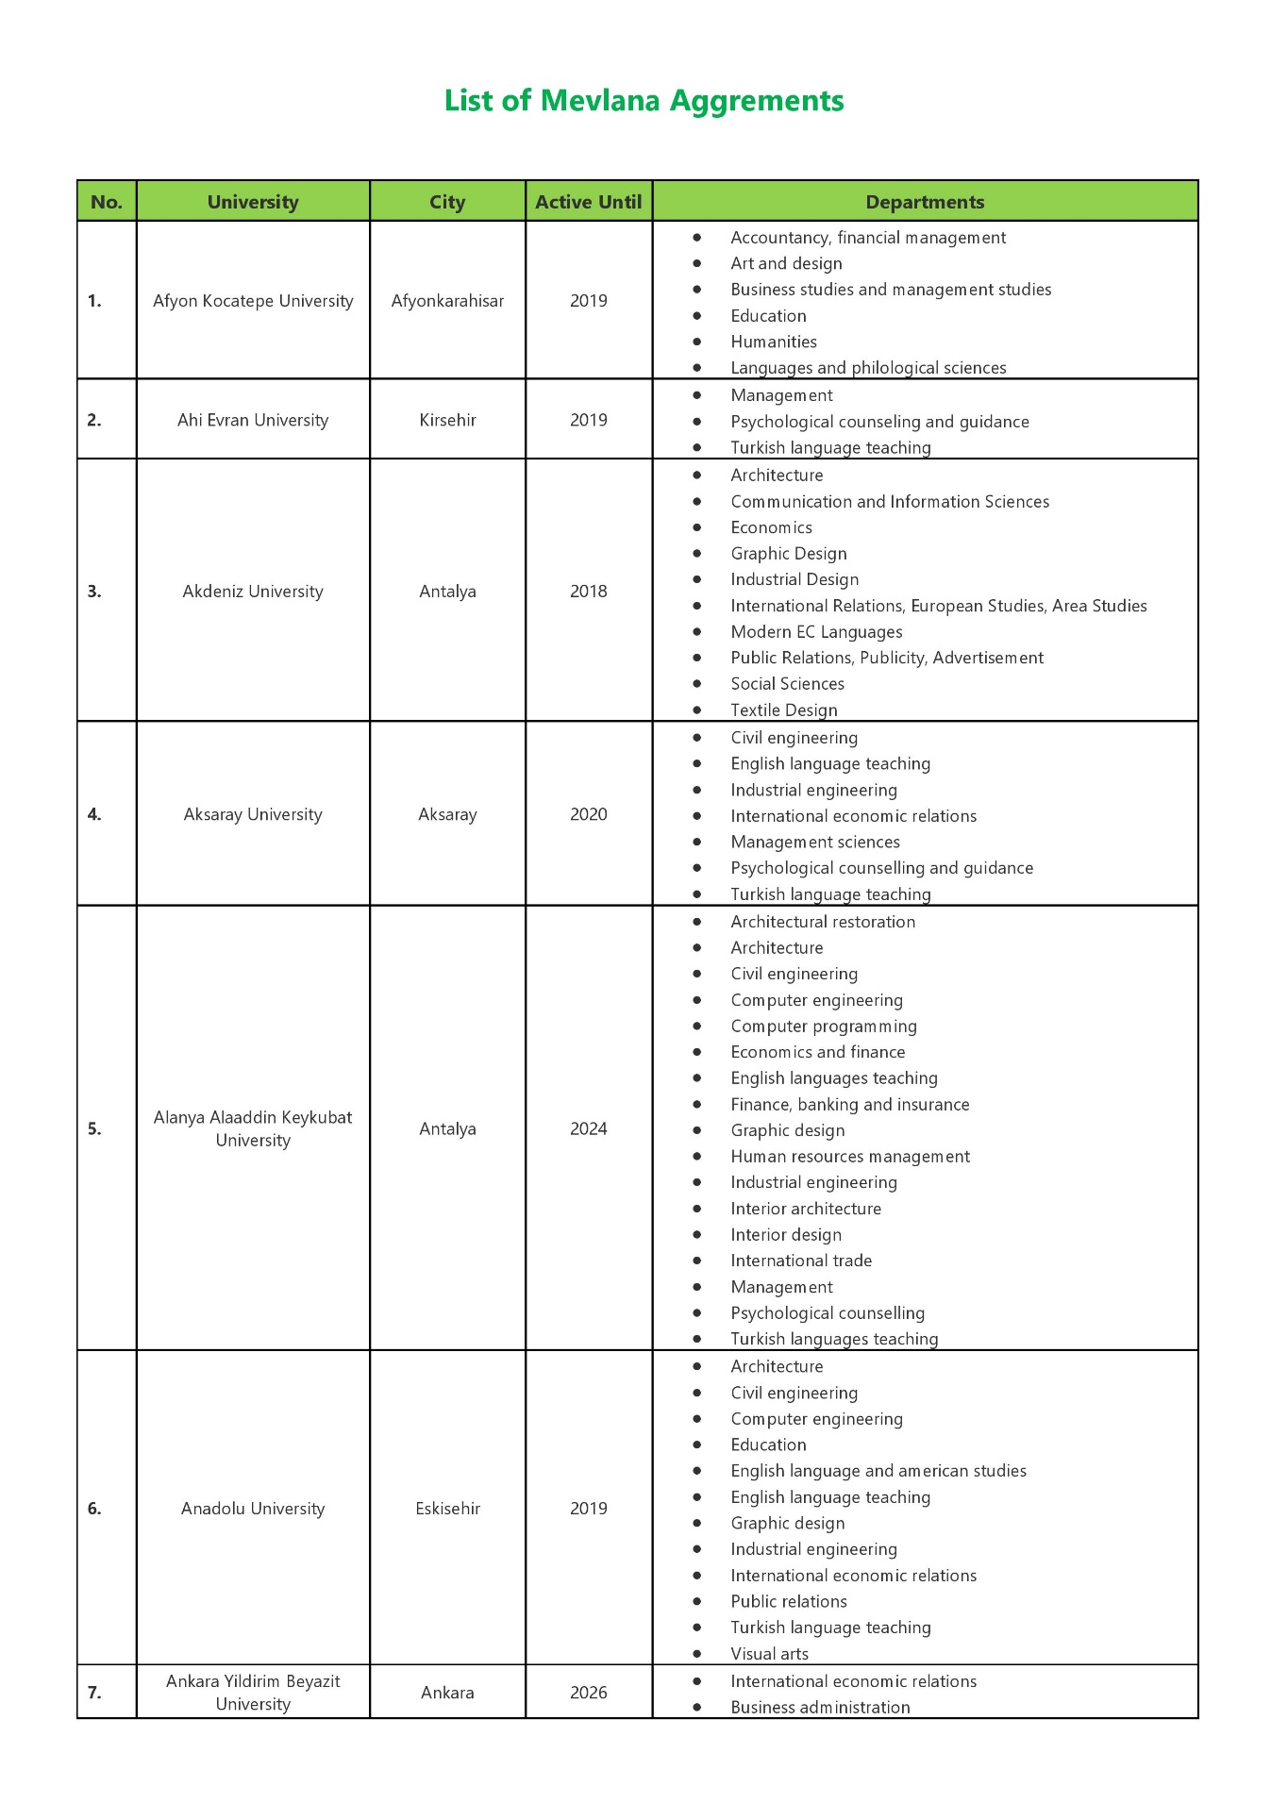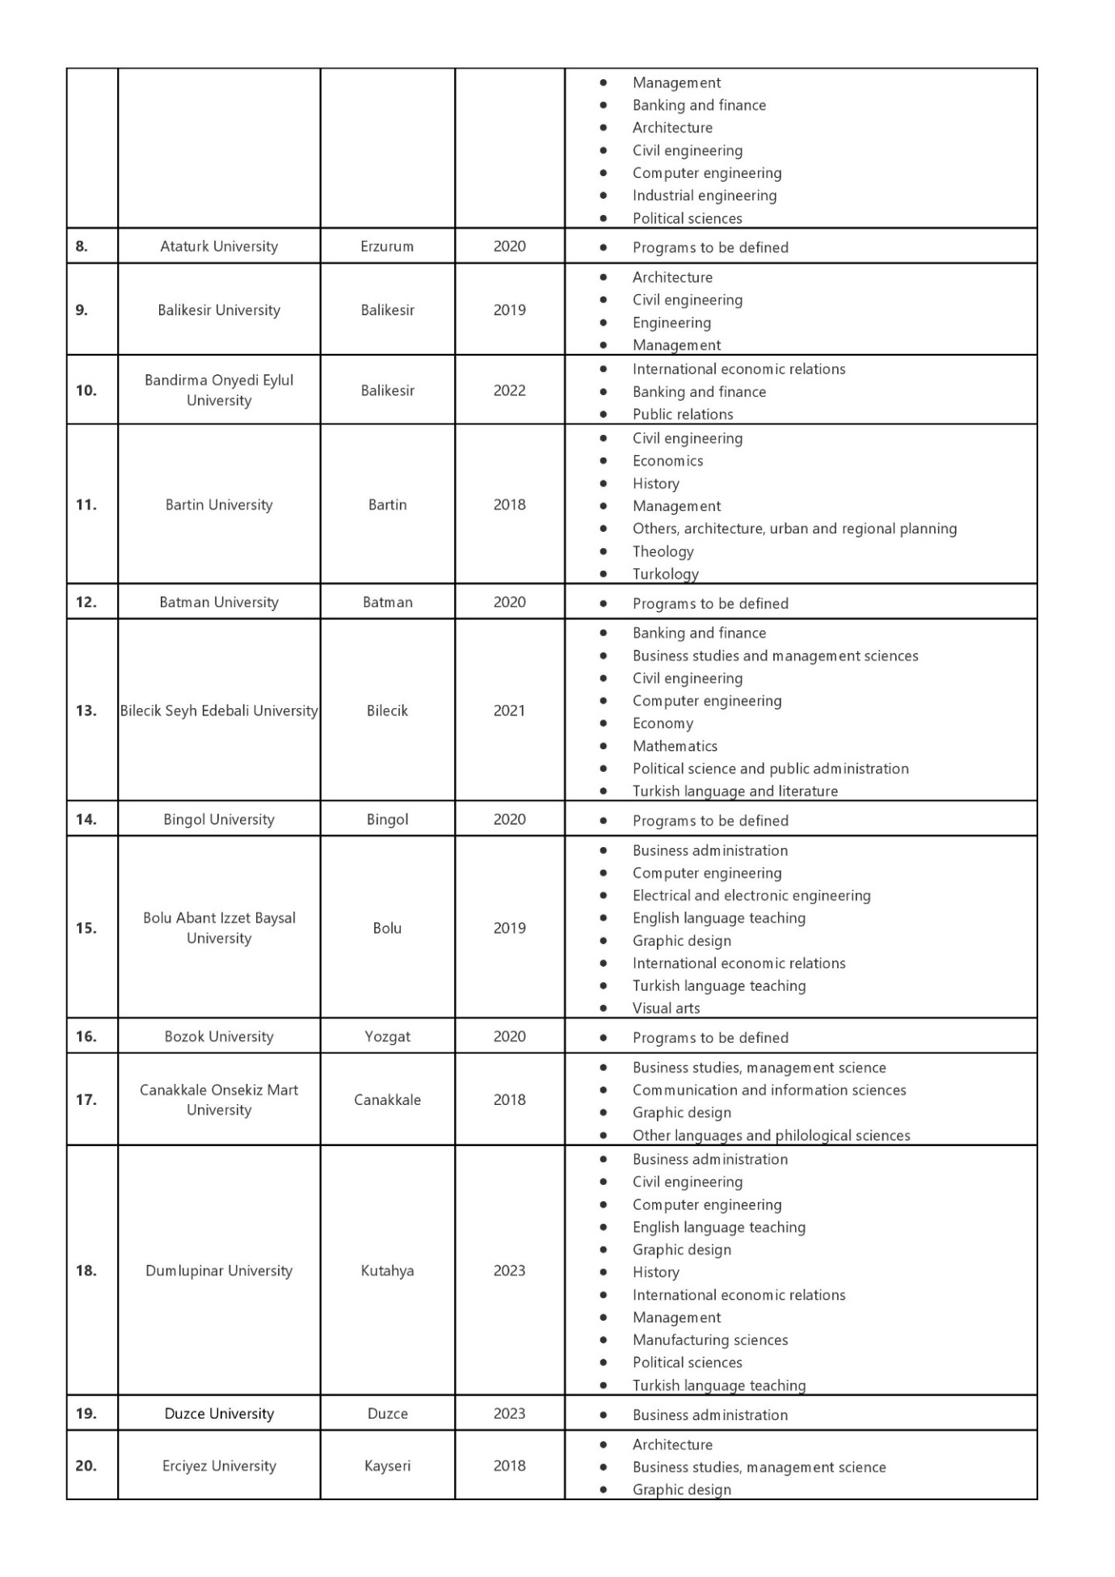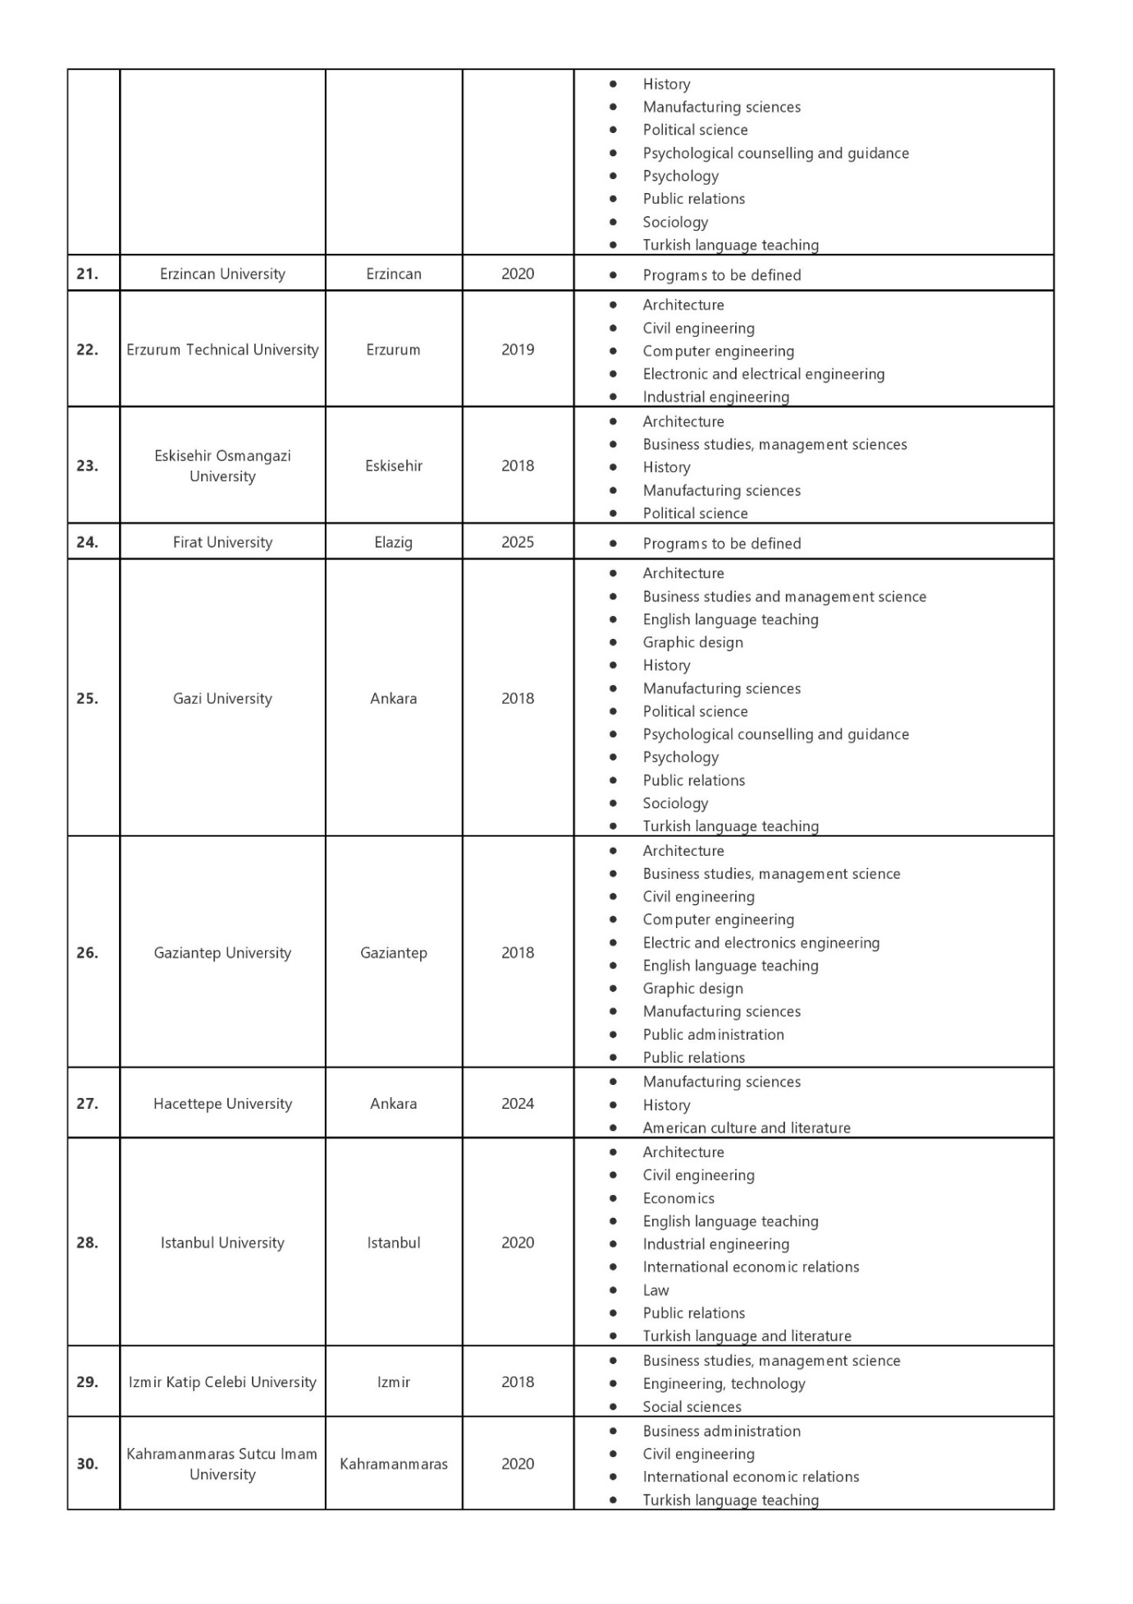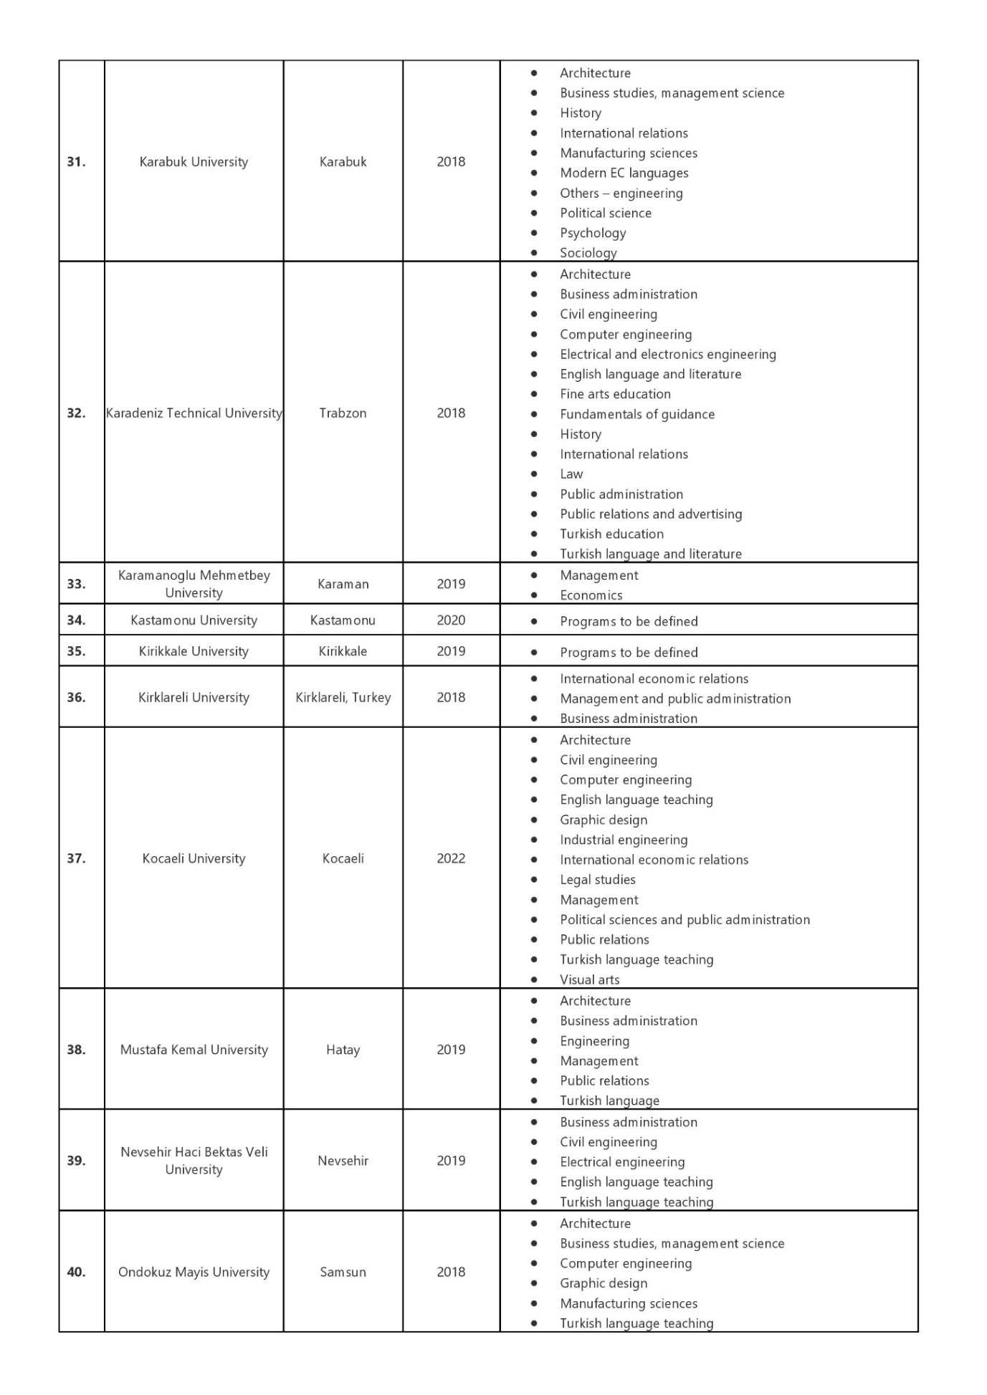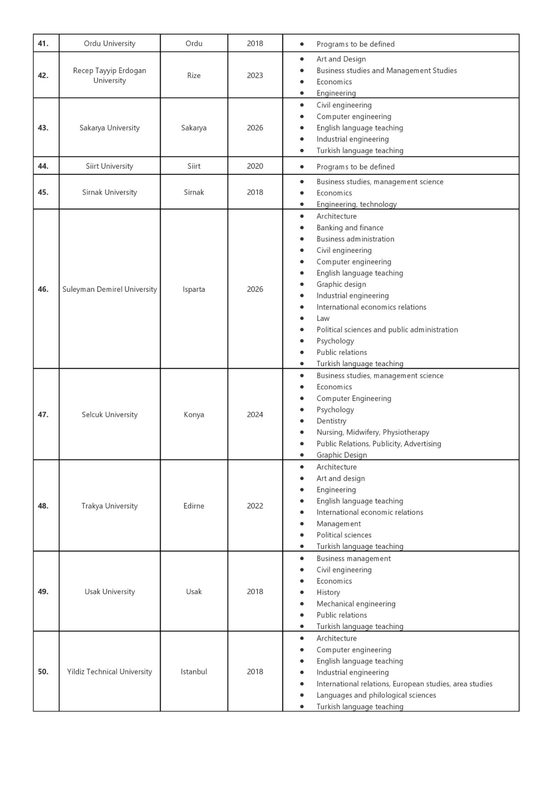

6.5 List of Bilateral Agreements and Protocols

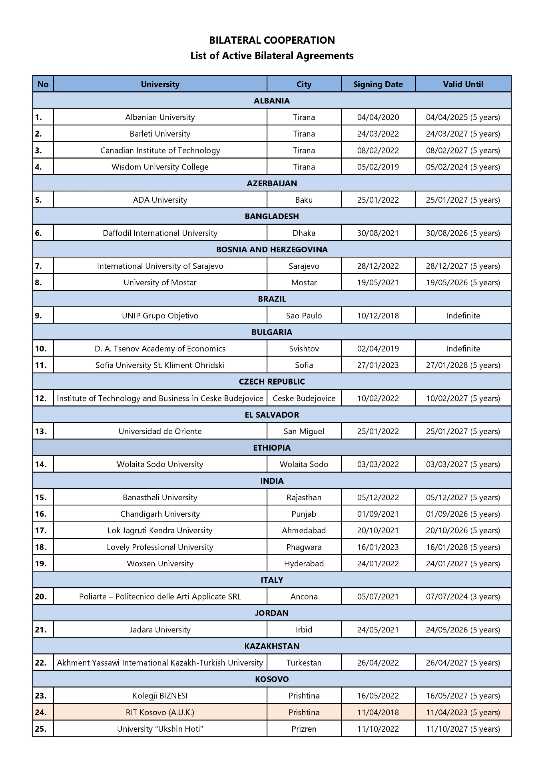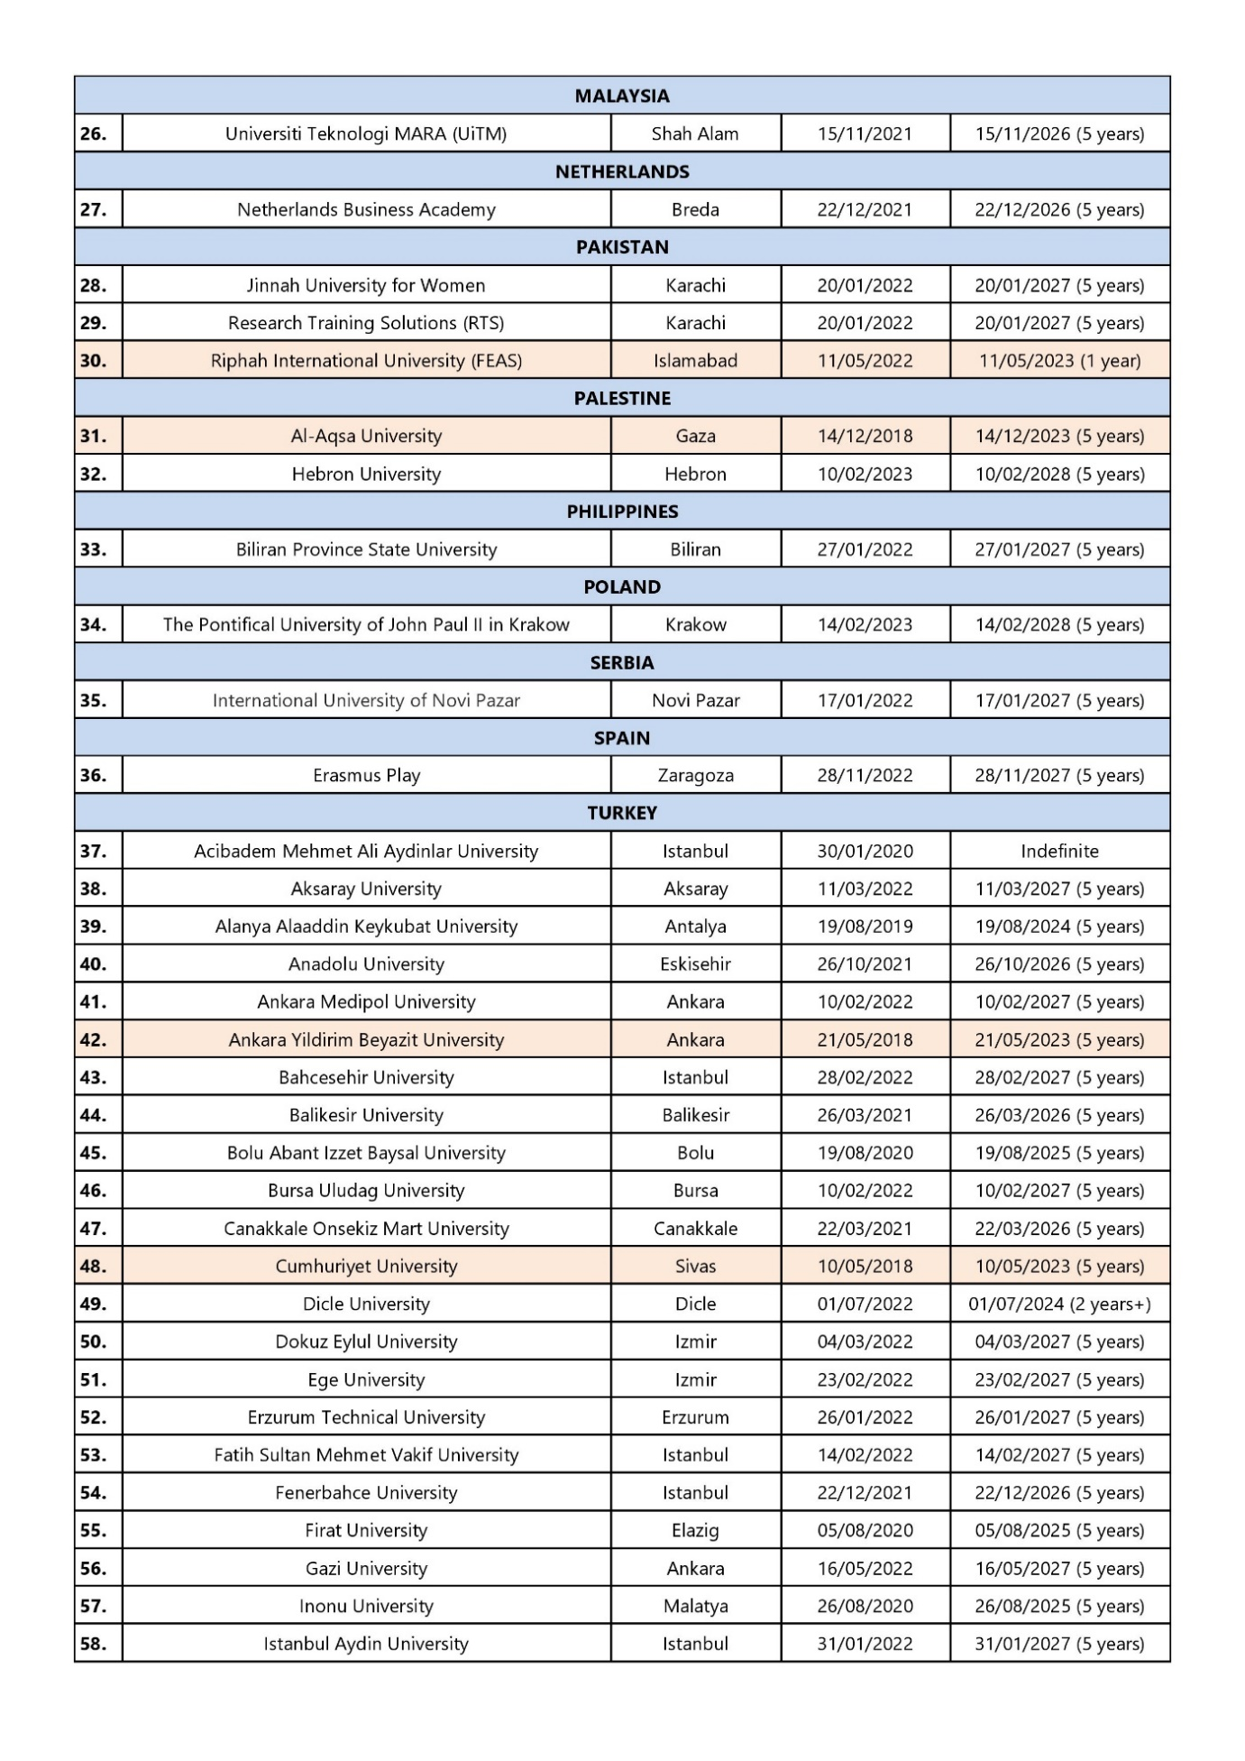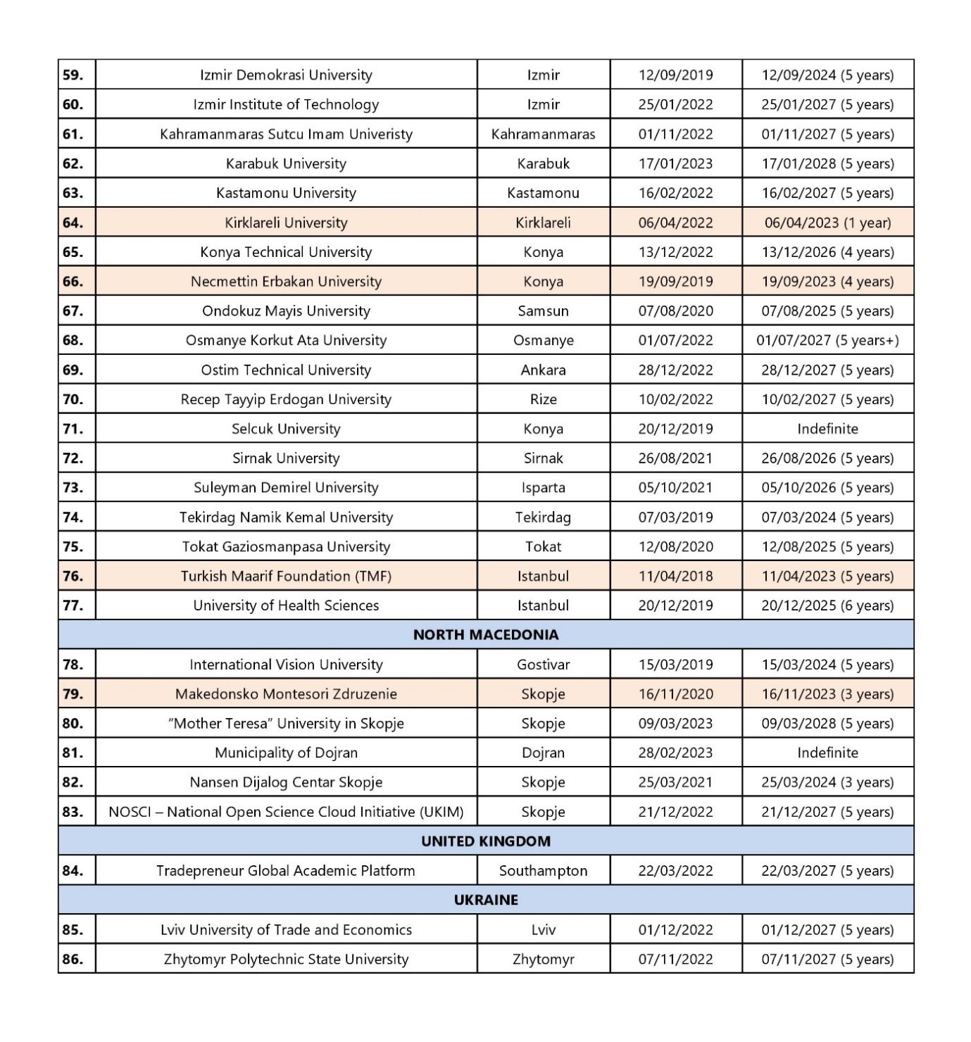

7. CONCLUSIONS
Dedicating its resources in expense of progresses in social and technical sciences at both national and international levels and also educating its students in order to be aware of the national and global issues, besides making them productive oriented and indoctrinate them with the ambition of augmenting the living standards of the society is the mission of the IBU University.
In order to increase the quality and quantity of these services, the University aims to:
- Improve the premises (purchasing new equipment),
- Improve the quality of studies,
- Increase the income of the University,
- Support IBU’s academic staff’s participation in scientific research projects,
- Increase IBU University’s involvement and participation in the national and EU Projects,
- Collaborate with world universities,
- Reach the European standards in undergraduate and graduate education.

8. REFERENCES

1. International Balkan University, Self- Evaluation Report (2012-2013), Skopje.
2. International Balkan University, Self-Evaluation Report (2013-2014), Skopje
3. International Balkan University, Self-Evaluation Report (2015-2016), Skopje
4. International Balkan University, Self-Evaluation Report (2016-2017), Skopje
5. International Balkan University, Self-Evaluation Report (2017-2018), Skopje
6. International Balkan University, Self-Evaluation Report (2018-2019), Skopje
7. International Balkan University, Self-Evaluation Report (2019-2020), Skopje
8. International Balkan University, Self-Evaluation Report (2020-2021), Skopje
9. International Balkan University, (2021-2022) Students’ Satisfaction Survey - Satisfaction Assessment Form (SAF). Skopje
10. International Balkan University, (2021-2022) Academic's Yearly Performance Reports. Skopje
11. International Balkan University, Strategic Plan (2021). Appendix 9.3., Skopje
12. International Balkan University, SWOT Analysis (2022). Appendix 9.2., Skopje
13. Stefanie Hofmann (2006), Mapping external quality assurance in Central and Eastern Europe -A comparative survey by the CEE. Available from: http://www.enqa.net/pubs.lasso. [Accessed 26/11/2014].
14. The UL Quality Assurance Report (2011). Available from https://www.uni-lj.si/university/quality/self_evaluation_report/.
15. Allen, I. E., Seaman, J., 2007, Online nation: Five years of growth in online learning. Newburyport, The Sloan Consortium, MA, USA.
http://www.sloan-c.org/publications/survey/online_nation
16. Universidade Nova de Lisboa Self-evaluation Report (2009). Available from http://www.itqb.unl.pt/about-us/organization/self-evaluation-report-unl.
17. Trends in Quality Assurance, A SELECTION OF PAPERS FROM THE 3RD EUROPEAN QUALITY ASSURANCE FORUM (2009). Available from https://enqa.eu/indirme/papers-and-reports/associated-reports/Trends_in_Quality_Assurance.pdf
18. EGE University - Self-Evaluation Report (2007). Available from http://euspk.ege.edu.tr/files/selfevaluationreport.pdf.
19. Andree Sursock and Hanne Smidt (2010) Trends 2010: a decade of change in European Higher Education European University Association. Available from http://www.eua.be.
20. Academic Workload Guidelines (2012) Available from http:// www.human-resources.utas.edu.au.
21. Rovai, A. P., 2002, Building sense of community at a distance, International Review of Research in Open and Distance Learning, 3 (1) pp.1-16.
https://doi.org/10.19173/irrodl.v3i1.79

9. APPENDIXES

9.1 Regulations and procedures
9.1.1 Statute
9.1.2 Senate Regulations
9.1.3 First Cycle Studies Regulations
9.1.4 Second Cycle Studies Regulations
9.1.5 Regulations on ECTS
9.1.6 Regulations on Evaluation of Transfer
9.1.7 Calculation of Average Points of Transcript
9.1.8 Regulations on Examinations
9.1.9 Student Disciplinary Regulations
9.1.10 Regulations on Student Advisory
9.1.11 Regulations on PhD students
9.1.12 Student ID Numbering Procedure
9.1.13 Projects 1 and 2 Regulations
9.1.14 Regulations on Attendance
9.1.15 For a Better Teaching Environment
9.1.16 Practical Training Regulations
9.1.17 Course Summary Catalog
9.2 IBU Strategic plan
9.3 University Self Evaluation Report 2018/2019- Tables
9.3.1 Part H - Equipment
9.3.2 Part G - Participation in projects
9.3.3 Part G - Total number of participants in conferences, symposia, seminars
9.3.4 Part G - Number of publications
9.3.5 A Compendium
9.3.6 Part F - Student's Activities
9.3.7 Proposal for Establishing Alumni Association at IBU
9.3.8 Alumni Addressing Letter
9.3.9 Application Form
9.3.10 Alumni addresses
9.3.11 Proposal for Establishing Career Center at IBU
9.3.12 Proposal for Establishing Student Support Service
9.4 Faculty Self Evaluation Report- Tables
9.4.1 Faculty of Economics
9.4.2 Faculty of Engineering
9.4.3 Faculty of Communications
9.4.4 Faculty of Humanities and Social Sciences
9.4.5 Faculty of Education
9.4.6 Faculty of Art and Design
9.4.7 Faculty of Law
9.5 SWOT Analysis
9.6 Student’s Satisfaction Survey - Final Report
9.6 Library Resources
9.7 Educational Laboratories
9.8.1 A project proposal on establishment and use of science and engineering laboratory for the Faculty of Engineering at the International Balkan University
9.8.2 Project proposal for the establishment of the Educational laboratory in Physics
9.8.3 IBU supercomputing centre of education and research
9.8.4 Proposal for acquiring necessary working conditions for the students of Architecture (Faculty of Engineering) in the facilities of IBU
9.8.5 Graphic Design Laboratory
9.9 Study programmes
9.9.1 Faculty of Economic and Administrative Sciences
9.9.1.1 International Economic Relations
9.9.1.2 Management
9.9.1.3 Banking and Finance
9.9.2 Faculty of Engineering
9.9.2.1 Industrial Engineering
9.9.2.2 Computer Engineering
9.9.2.3 Civil Engineering
9.9.2.5 Architecture
9.9.3 Faculty of Communication
9.9.3.1 Public Relations
9.9.3.2 New Media and Communications
9.9.4 Faculty of Humanities and Social Sciences
9.9.4.1 Psychology
9.9.4.2 Political Sciences
9.9.5 Faculty of Education
9.9.5.1 Psychological Counseling and Guidance
9.9.5.2 English Language Teaching
9.9.5.3 Turkish Language Teaching
9.9.6 Faculty of Fine Arts
9.9.6.1 Graphic Design
9.9.6.2 Visual Art
9.9.7 Faculty of Law
9.9.7.1 Legal Studies
9.10 Staff Engagement
9.11 Bulletins
9.12 Templates
9.12.1 Academic’s Yearly Performance Report- AYPERs
9.12.2 Assistant Evaluation Report
9.12.3 Semester Course Registration Form
9.12.4 Graduation Project Forms
9.12.5 Project Template
9.12.6 Course Success Report
9.12.7 Satisfaction of Students from Courses, Instructors and University
Satisfaction Assessment Form (SAF)
9.12.8 Faculty Staff Engagement
9.12.9 Department Staff Engagement
9.12.10 CV
9.12.11 Syllabus
9.12.12 Internship Work Book
9.12.13 Course Attendance Sign Up Sheet
9.12.14 Course Attendance Report Template
9.12.15 Daily Lecture Signature Schedule
9.12.16 Student Attendance Exam Template
9.12.17 Exam Report
9.12.18 Exam Documents Delivery Certificate
9.12.19 Excused Permit Document
9.12.20 Monthly Lecture Burden
9.12.21 Academic Staff Monthly Lecture Burden_Faculty Level
9.12.22 Midterm Exam Results Form
9.12.23 Excuse Exam Template
9.12.24 Final Exam Results Form
9.12.25 Makeup Exam Results Form
9.12.26 Upgrade Exam Results Form
9.12.27 Changing Grade Request
9.12.28 Student Certificate
9.12.29 Graduation Certificate
9.12.30 Transcript
9.12.31 Diploma supplement
9.12.32 Clinical Teaching Report
9.12.33 Exam Results Master

